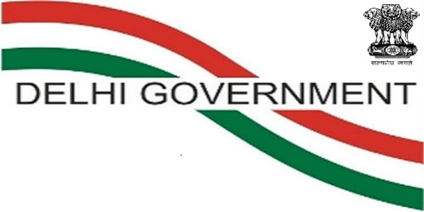

Government of NCT of Delhi
Department of Training & Technical Education
Muni Maya Ram Marg, Pitampura, Delhi-110034
E-mail: caoitiadmission@gmail.com
PROSPECTUS–2019
For
ONLINE ADMISSION FOR FULL TIME CERTIFICATE COURSES
Under
NATIONAL COUNCIL FOR VOCATIONAL TRAINING (NCVT)
&
STATE COUNCIL FOR VOCATIONAL TRAINING (SCVT)
In
DELHI GOVERNMENT INDUSTRIAL TRAINING INSTITUTES

DATE OF START OF ONLINE REGISTRATION : 10-JUNE-19
LAST DATE OF REGISTRATION : 07-JULY-19
LAST DATE OF VERIFICATION & CHOICE FILLING : 08-JULY-19

Online Admission 2019 Portal
https://itidelhiadmissions.nic.in
Helpline E-mail ID: caohelpline@gmail.com

Candidates are advised to visit the admission portal frequently for updates.

GOVERNMENT OF NCT OF DELHI
Department of Training & Technical Education
Muni Maya Ram Marg, Pitampura, Delhi-110034
http://tte.delhigovt.nic.in

Sh. Sheo Pratap Singh, IAS
Secretary

Sh. S.S. Gill, IAS
Director

Sh. Rajanish Kumar Singh
Joint Director, Chairman Online Admissions

Sh. Ajay Vashisht
Deputy Director (Trg.)

Sh. R.S Solanki Sh. R. K Gupta
Chief Admission Officer Deputy Chief Admission Officer
Principal, ITI Dheerpur. Principal, ITI for Women, Mori Gate.
Ph.011- 27608082, 27608083 Ph.: 011 – 23967449, 23929889
Email: iticvraman.delhi@gmail.com Email: itimg.delhi@gmail.com

CONTENT
- INTRODUCTION 1
- CONTACT DETAILS OF GOVERNMENT I.T.I/BTC AND DETAILS OF PVT ITIs 1-8
- TRADES/COURSES OFFERED & INTAKE CAPACITY IN ALL I.T.Is 9-12
- ADMISSION ELIGIBILITY QUALIFICATIONS 13-17
- ONLINE ADMISSION PROCEDURE 18-19
- ON-LINE ADMISSION REGISTRATION FORM SAMPLE 20-30
- INFORMATION ON SEAT RESERVATION 31-35
- REGISTRATION FEE, CAUTION MONEY &TUITION FEE 35
- CTS, DST, NSQF, MSDP SCHEMES 36-38
- IMPORTANT DETAILS FOR RANK GENERATION AND SEAT ALLOTMENT 39-40
- CRITERIA FOR CALCULATION OF MARKS PERCENTAGE 41
- TIE BREAKER RULE FOR ITI COUNSELING 42
- GENERAL RULES & INFORMATION, AGE LIMIT, PHYSICAL FITNESS 43-45
- CONDUCT OF EXAMINATION 46-50
- TRADES/COURSES IN Govt. I.T.I.s 51-60
- LATERAL ENTRY FOR ADMISSION IN DELHI POLYTECHNICS 61-62
- LIST OF RECOGNIZED BOARDS 63-65
- ACHIEVEMENTS OF DEPARTMENT 66-67
- MAP WITH ITIs LOCATION 82
- GOVT ITI DELHI ONLINE ADMISSION 2019 TENTATIVE SCHEDULE 83

ANNEXURES
- Form of Medical Certificate(Annexure-I) 68
- Certificate of Character of Candidate(Annexure-II) 69
- Prohibition of Ragging (Annexure-III) 70
- Undertaking (Annexure-IV) 71
- Certificate for availing admission against J&K Migrant Quota (Annexure-V) 72
- Certificate for availing admission against PWD Quota from NCS (Annexure-VI) 73
- Certificate for availing admission against Defense Quota (Annexure-VII) 74
- Certificate of 8th class from school (Annexure-VIII) 75
- Certificate for availing 5% weight-age for Rural Area (Annexure-IX) 76
- Certificate for availing admission against Staff Quota (Annexure-X) 77
- Choice Filling Pro-forma (Annexure-XI) 78
- Self-Declaration For Seeking Admission Against Minority Quota(Annexure-XII) 79
- Certificate for availing admission against DG/DP Quota (Annexure-XIII) 80
- Certificate for Admission in ITI’s under EWS Category (Annexure-XIV) 81

INTRODUCTION

Department of Training & Technical Education, Govt. of NCT of Delhi, in its endeavor to provide technical and skilled manpower suited to various needs of industry, is implementing various schemes. Craftsmen Training Scheme to impart training in technical and industrial skills through Industrial Training Institutes spread all over Delhi.
There are 19 Government ITIs (including Hastsal Extension Centre and Multi Sectorial Development Plan for minority women only at ITI, Nand Nagri) having 10292 seats for the session 2019-20 in 47 different trades affiliated with National Council for Vocational Training (NCVT) and State Council for Vocational Training (SCVT).

The Department of Training & Technical Education plans to admit students in one year/two years trade for the academic session 2019-20 for various Full-time Certificate courses (Engineering and non-Engineering) being offered at Institutes affiliated to the National Council for Vocational Training (NCVT) & State Council for Vocational Training (SCVT), Delhi, on merit basis through online admission in the institutes mentioned below.

CONTACT DETAILS OF GOVERNMENT I.T.I/BTC
(HELPDESK COUNTERS ARE OPERATIONAL IN ALL DELHI GOVT. ITIs. CANDIDATES MAYALSO CONTACT THE BELOW MENTIONED TELEPHONE NUMBERS AND EMAIL IDs FOR SEEKING INFORMATION)
S.  N. | Name & Address | Nearest Landmark | Principal / Vice Principal | Telephone No. | ITI  Abb. | Email & ITI Website
1 | ITI, Pusa,  New Delhi – 110012 (Co-educational) | Nearest Metro station : Rajindra Place  / Patel Nagar | Sh. Lok Pal | 25841477  25842833 | PUSA | Email: itipusa@hotmail.com; itipusa.delhi@gov.in  Website: www.itipusa.delhi.gov.in
2. | ITI, Arab-Ki-Sarai, Nizamuddin, Adjacent to Humayun Tomb, Opp Police Station Nizamuddin, New Delhi-110013 (Co-educational) | Nearest Metro station : Jawaharlal Nehru Stadium | Sh. Ram Gopal / Sh. P.R. Digwal | 24359531  24351667 | AKS | Email: itiaks2011@gmail.com; itiaks.delhi@gov.in  Website: www.itiaks.delhi.gov.in
3. | ITI Shahdara, Delhi-110095 (Co-educational) | Nearest Metro station: Jhilmil Colony | Ms. Kalpna Goyal | 22150343  22168727 | SH | Email: itishahdara.delhi@nic.in  Website: www.itishahdara.delhi.gov.in
4. | Sir C.V. Raman ITI, DheerPur, Delhi – 110009  (Co-educational) | Landmark: Nirankari Satsang Sarover  /Burari Crossing | Sh. R.S. Solanki / Sh.Jagdish Kumar | 27608082  27608083 | CVR | Email: iticvraman.delhi@gmail.comWebsite: www.scvriti.delhi.gov.in
5. | ITI, Malviya Nagar, New Delhi-110017 (Co-educational) | Nearest Metro station : Malviya Nagar/ Hauz Khaz | Sh. Vijay Kumar | 26687375  26682049 | MN | Email: itimvnagar@yahoo.co.in; itimn.delhi@gov.in  Website: www.mniti.delhi.gov.in
S.  N. | Name & Address | Nearest Landmark | Principal / Vice Principal | Telephone No. | ITI  Abb. | Email & ITI Website
6. | ITI, Jail Road, (Opposite Tihar Jail), New Delhi-110064 (Co-educational) | Nearest Metro station : Tilak Nagar | Sh. B.S. Negi/ Ms. Kamini | 28121086  28122402 | JLR | Email: itijritijr@yahoo.co.in; Itijr.delhi@gov.in  Website: www.itijr.delhi.gov.in
7. | ITI, Jahangir Puri, K- Block, Jahangir Puri,  Delhi-110033 (Co-educational) | Nearest Metro station : Jahangir Puri | Smt. Ratna Das /  Ms. Mini Sharma | 27637928  27634888 | JHP | Email: pplitijpuri@gmail.com  Website: www.itijp.delhi.gov.in
8. | ITI, Nand Nagri, Delhi-110093, (Co-educational) | Near Nand Nagri DTC Bus Depot, | Smt. Ratna Das | 22581299  22134850 | NN | Email: itinandnagri@yahoo.co.inWebsite: www.itinn.delhi.gov.in
9. | Dr. H.J. Bhabha ITI, Khichripur, Mayur Vihar Phase I,  Delhi-110091 (Co-educational) | Nearest Metro station : Mayur Vihar Phase I | Sh. S.  Augusthy | 22753998  22750621 | HJB | Email: hjbhabhaiti.delhi@yahoo.co.in  Website:  www.hjbhabhaiti.delhi.gov.in
10. | Ch. Brahm Prakash ITI, Jaffarpur,  New Delhi-110073 (Co-educational) | About 8Km from Najafgarh | Sh.M.N.  Sharma / Sh. Suresh Kumar | 25318190  25318035 | JFR | Email: itijaffarpur2010@gmail.com; Itijaff.delhi@nic.in  Website:  http://itijaffarpur.delhi.gov.in
11. | Lala Hans Raj Gupta ITI, DSIDC  Industrial Complex, Narela, Delhi-110040 (Co-educational) | About 5km from Alipur, Opp.DTC bus Depot Narela | Md. Hussain B. | 27781679  27782076 | NR | Email: itinarela.delhi@gmail.com  Website: www.lhrgiti.delhi.gov.in
12. | Veer Savarkar Basic Training Centre, Pusa,  New Delhi- 110 012 (Co-educational) | Nearest Metro station : Rajinder Place / Patel Nagar | Sh. Rajiva Malik / Sh.K. K Narwal | 25842952  25842762 | BTC | Email: btcpusa_2007@yahoo.comVsitibtcpusa2017@gmail.comWebsite: www.vsbtcpusa.delhi.gov.in
13. | ITI Mangolpuri, S- Block, Industrial Area Mangolpuri,  Delhi-110083 (Co-educational) | Nearest Metro station :Udyog Nagar | Sh. R. S. Solanki | 27918121,  27918122 | MGP | Email:  itimgpadmission2018@gmail.com  Website:  itimangolpuri.delhi.gov.in
S.  No | Name & Address | Nearest Landmark | Principal / Vice Principal | Telephone No. | ITI  Abb. | Email & ITI Website
14. | JijaBai ITI for Women Siri Fort (Near Siri Fort Auditorium) August Kranti Marg, New Delhi-110049  (Only for Women) Internationally Accredited by  APACC, Manila, Philippines | Nearest Metro station :Green Park | Sh. Vijay Kumar | 26491842  26494358 | SFW | Email: itisirifort@yahoo.com; Itijijabaiw.delhi@gov.in  Website: www.jbiti.delhi.gov.in
15. | Savitri Bai Phule ITI for Women, Gokhale Road, Mori Gate, Delhi –110006 (Only forWomen) | Nearest Metro station :Kashmiri Gate | Sh. R.K. Gupta | 23967449  23929889 | MGW | Email: itimg.delhi@gmail.com; itimgw.delhi@gov.in  Website: www.sbpiti.delhi.gov.in
16. | ITI for Women, Tilak Nagar  New Delhi – 110 018 (Only for Women) | Near Tilak Nagar, Metro Station | Sh. A. K Dhama | 25997035  25995158 | TNW | Email: itiwtn@rediffmail.com  Website:  www.itiwtn.delhi.gov.in
17. | ITI for Women, Vivek Vihar, Delhi – 110 095.  (Only for Women) | Nearest Metro station :Jhilmil Colony | Smt. KalpnaGoyal | 22165188 | VVW | Email: itivivekvihar@gmail.com; Itivvw.delhi@gov.in  Website:  www.vvwiti.delhi.gov.in
18. | Extension Centre of ITI Jail Road, Old Employment Exchange Building, Hastsal, New Delhi.- 110059  (Only for women) | Nearest Metro station : Uttam Nagar East | Sh. B.S. Negi / Smt. Shashi Lopes | 28121086  28122402 | HSW | Email: itijritijr@yahoo.co.in  :itihastsal2019@gmail.com  Website: www.itijr.delhi.gov.in
19 | ITI For Women (MSDP) ITI Nand  Nagari Campus, Delhi-110093 (Only forwomen) | Near Nand Nagri DTC Bus Depot | Smt. Ratna Das | 22581299  22134850 | NN | Email: itinandnagri@yahoo.co.in  Website: www.itinn.delhi.gov.in

Private ITIs registered with the Department having affiliation of NCVT/SCVT are given below. Admission to these private ITIs is not covered under Delhi Government ITI Online Admission 2019 process. However, prospective students into these institutes are advised to verify the affiliation status of trades before admission.
S. No | Name & Address | Principal / Vice Principal Telephone No. |  | Email & ITI Website | Trades *
A. Private ITI/ITC managed by other Govt. Departments
1 | C.R.P.F. Pvt ITI, 103 Bn. RAF Campus, Wazirabad delhi-110 94, Delhi-94 |  | Sh. A.K. Arora (Principal) 011-22960150, 9911179993, 011-22960150 | Email : crpfitcwazirabad@gmail.com  a.karora1965@gmail.com |  | Mech. Motor Vehicle, Electronic Mech. ,Electrician, Refrigeration & Air Conditioning
2 | ACMT Pvt. ITI Delhi,Flat No. 178,Dharam Kunj, Group Housing Society,Rithala, Delhi -110089 |  | Sh. Anil Yadav Ph. 22527707,911429597 | Email- acmtpvtitidelhi@gmail.com |  | Electrician, Fitter
3 | NSIC Tech. Services Centre Pvt. ITI, Okhla Ind. Estate, Ph-III Okhla, New Delhi-110020 (Land Mark: Adjacent to Govindpuri Metro Station pillar No. 165) |  | Sh.Khalid Shakil, Principal 011-26826801, Ext. 230  ,26826796,  9811540701 | email: -ntsccont@gmail.com website: anuragsociety.com |  | Computer Operator and Programming Assistant, Draughtsman mechanical, Fitter, Machinist. Turner
B. Privately Managed Pvt. ITI
4 | Akashline Pvt. ITI, 1449/21, Main 100 feet Road Durga Puri, Shahdra, Delhi-32  (Near Durga Puri Chowk) | Sh. Vikas Bhardwaj Ph. 22311603 , 9999113381, 9268213323, 9999002520 . |  | email: - aakashlineinstitute@yahoo.co.in, vikasaips@gmail.com | 1. COPA  2. Health Sanitary Inspector  3. Draughtsman Civil  4. Electrician
5 | Anurag Industrial Training Centre F -156/2 Lado Sarai, Mehrauli, South Delhi, New Delhi - 110030 | Ms. Shakti Pal, Principal 9555104072.  011-29523441 / 011-29521156 / 011-29523085 / 011-29521684 |  | email: -anuragho@rediffmail.com  anuragitc_1996@rediffmail.com website: anuragsociety.com | Sewing Technology
6 | Asha Sadan Pvt. ITI Najafgarh, New Delhi – 110 043. ( Holy Cross School Compound ) | Ms. Anna Rita  (Ph-9968489936, 8285335020) |  | email: - ashasadan07@gmail.com | 1 Sewing Technology  2. Dress Designing
S. No | Name & Address | Principal / Vice Principal Telephone No. |  | Email & ITI Website | Trades *
7 | Baba Saheb Ambedker Pvt. ITI, BSAITM Bhawan, Plot No. 13B, Budhella, Near C Block Bus Stand, Vikaspuri, New Delhi-110018 | Sh. Jaideep Das Gupta 011-28532959, 28532901, 7011291459, 7703917546, 9810509249 |  | EMAIL ID : info@bsates.com  WEBSITE : www.bsates.com | Electrician, Fitter ,Electronics, Draughtsman Mechanical , Refrigeration And AC Mechanic ,Dental Technician ,Computer Operator & Programming Assistant, Health & Sanitary Inspector
8 | DAV Pvt. ITI, 5A/15, Tilak Nagar, New Delhi-110018, (Opp Police & Metro Pillar No. 486) | Mr. Sunil Sharma 9810733451, 9871249149  011-47005568 |  | Email.:- dav.itc71@gmail.com | Computer Operator & Programming Assistant (COPA), IT &ESM , Health Sanitary Inspector
9 | Delhi Institute Of Fire Engineering G-579, Raj Nagar-II (Near Dada Dev Mandir Mela Ground), Opp. Sector-7, Dwarka, New Delhi- 110077 | Col V PrakashIyer (Retd) Ph. 9999055820,011-25366517 |  | Email:- contactdife@gmail.com | 1. Fire Fighting (6 Months)  2. Fire Technology & Industrial  Safety Management (1 years)
10 | DON BOSCO TECHNICAL Institute, Jamia Nagar, Okhla Road, New Delhi-110020. (Adjacent to SukhdevVihar Metro station) | Sh. Thomas C J  9431106403  (Ph.9643868820, 8527787221) |  | Email:- cjtomdb@gmail.com, principal@dbti.in | 1. D/Man Mechanical  2. Machinist Grinder  3. Turner  4. COPA  5. Machinist
11 | INDIAN INSTITUTE OF COMPUTER EDUCATION Pvt. ITI, C-574, Saraswati Vihar, PitamPura, Delhi-34 | Sh .Sudhanshu Malhotra 9250928432,9810291418, 011-2703240, (Ph. 27032404, 65378863) |  | Email:- itiiiceitc@gmail.com,  ceo@webcomtechnologies.in | Computer Operator & Programming Assistant (COPA)
12 | MERIT Pvt. ITI A-9, Qutab Institutional Area, USO Road, ShaheedJeet Singh Marg, New Delhi-110067 | Ms. RitikaJasrotia, Principal (Mobile No: 9717688149)  011-41325252, 26961182, 41610145, 26532492 |  | Email:contact@merit.ac.in Website: www.merit.ac.in | Computer Operator & Programming Assistant (COPA)
13 | NATIONAL Pvt ITI 30-34 Sewak Park, Dwarka Mor Metro Station, Opp. Metro Pillar No: 771,Nazafgarh Road, New Delhi 110059 | Dr. Anamika Singh  Principal  Ph No. :- 9315153644,  9315138815, 8800183233,011-25313737, 55473376 |  | website: www.nitcindia.com  email id: mail.nitcindia@gmail.com | Health Sanitary Inspector  Dental Lab Technician  Physiotherapy Technician  Radiology technician
S. No | Name & Address | Principal / Vice Principal Telephone No. |  | Email & ITI Website | Trades *
14 | RAJ SINGH Pvt. ITI, A-Block 13, Gali No. 11-12, Khajuri Colony, Delhi-110094 | Sh. Rakesh Nain  9968880020, 9868364868, 22962364, 9968880020. |  | email: rajsinghitc@gmail.com website: itirajsingh.com | Electrician, Draughtsman civil , Draughtsman Mechanical, Electronics Mechanic
15 | SAMPURNA Pvt. ITI, MaharanaPratap community centre, Rajapur village, sector-9, Rohini, Delhi-110085 | Ms. Indu Sharma Ph. 011-27556498.  8383908153  8447784806 |  | Email :- sampurna765@gmail.com | Basic Cosmetology
16 | SARASWATI MAHILA SHILP KALA KENDRA, 230/21 E-2 STREET NO. 6 RAILWAY COLONY MANDAWALI DELHI 110092 | Sh. Ramesh Chand SHARMA  Ph. 9968332693, 9811321455,011- 22477685 |  | Email.:- sharmapushpa1958@gmail.com, smskkitc03@gmail.com | Sewing Technology
17 | SARVODAYA Pvt. ITI, 1449/21A, Main 100 Ft.Road,Durgapuri, Shahdara, Delhi-93. | Sh.C.K.Sharma, Principal 011-22130322, 65940586, 9911028611 |  | Email.:- sarvodayainstitute@gmail.com Website:- sarvodayainstitute.com | Electrician , Computer Operator and Programing Assistance , Health and Sanitary Inspector
18 | SARVODAYA PVT. ITI, 1449/2, 100 Ft. Road,Durgapuri Ext.  Delhi-110093 | Sh. Himanshu Sharma 011-22800322 ,9354262170, 8750295007 |  | Email ID- Sarvodayaiti40@gmail.com  Website:- sarvodayainstitute.com | Draughtsman Civil, Draughtsman Mechanical , Radiology Technician
19 | Satyam Institute Of Computer Technology (ITC)  1449/73, Durga Puri, Near Laxmi Dairy. Shahdara,  Delhi-110093 | Sh. Pravesh Sharma  9310021022, 7982899894 |  | Email ID- satyaminst1610@gmail.com | Computer Operator and Programming Assistant ,
20 | SRI GURU HARKRISHAN PVT. INDUSTRIAL TRAINING INSTITUTE  Opposite 20 Block, Tilak Nagar, Tilak Vihar, New Delhi 110018. | Sh. Charanjeet Singh (Principal)  Phone: 25991249, 25990988, 25991249 Fax: 25999906,  987255006 |  | Email:-sghitc@gmail.com  chawlacj@gmail.com  website:- http://sghiti.weebly.com | Computer Operator and Programming Assistant , Electrician, Electronics Mechanic, Mechanic Motor Vehicle, Physiotherapy Technician, Mechanic Ref. & A/C
21 | ST. JOHNS PVT. ITI, 119, Anand gram TahirPur, Near Dilshad Garden, Shahdra, Delhi | Fr. Jaikumar  Ph. 9555576276,  011- 23913974,  23931432 |  | Email:-stjohnsdbs@yahoo.com,  delhibrotherhood@gmail.com | Electronics Mech.
S. No | Name & Address | Principal / Vice Principal Telephone No. |  | Email & ITI Website | Trades *
22 | SULABH PRIVATE INDUSTRIAL TRAINING INSTITUTE Rz-83 E&F, Mahavir Enclave, Palam, Dabri-Road, New Delhi-110045 | Dr. IndraniMazumdar  9868427214, 7906544452,  9871587668  Ph. 25038093, 25032043 |  | Email:- sicasmail@hotmail.com, indranimazumdar2006@gmail.com  website:-  www.sulabhcentre.org | 1. Sewing Technology  2. Stenographer & Secretarial Assistant (English)
23 | GAURI FOOD CRAFT Institute, WZ-54, Near Metro Pillar No. 219, ShadiKhampur, west Patel Nagar, New Delhi-110008 | Sh. R.S. Nirwal  011-25703361, 8826103456,8595122807 |  | Email-ID- gaurifoodcraftinstitute@gmail.com  Website - www.gouritechnicalinstitute.org | Food Production (General)  Draughtsman Civil
24 | CRADLE Pvt. ITI, 988/2, Mansa Enclave, Near Oberoi Farm, Kapashera , Delhi-110037. | Sh. Raguvinder Singh  08130146606  011-25066069 |  | Email:- cradledelhi@outlook.com, office@cmi-hm.com | Food Production (General)
25 | D. N. LAL SHARDA Private ITI  Sharda Institute Building, Main Road, 189 Kakrola Village, Near Metro Pillar 860, Dwarka Sector-16B, New Delhi-110078 | Sh. Anil Kumar Lal 9013217721 ,8505998880,  011-65945835 |  | Email:- dnlshardaiti@gmail.com ,  anillal_1968@yahoo.com. Website:- shardainstitute.com | Draughtsman Civil , Draughtsman Mechanical, Electrician, Fitter
26 | VISION Pvt ITI, khasra no.32/12/1,2nd,3rd floor,Punjabibasti village, nangloi, Opposite Metro Pillar no. 376, Delhi-41 | Sh.Praveen Gupta 9717976862,  9136451577,  011-64643617 |  | Email:- currentheight@gmail.com admissions.visioniti@gmail.com  Website:-www.visioniti.org  https://vision-iti.business.site | Health & Sanitary Inspector
27 | SHIKSHAITAN Private Iti, Plot No- 683, Gali No -3, Near SainiVihar, Mundka D-41 | Sh.Rajeev Kumar Singh 8587912904, 7838935434, 9871415795  7532807882  9852914070. |  | Email:- delhipti@gmail.com  rajeevkrsingh@gmail.com website:- www.delhiti.com | Fitter , Electrician
28 | SARASWATI Private ITI, B-12, M.B.R. Enclave, Pochanpur, Sec.23,Dwarka Delhi -75 | Sh. Vikas Gupta 9717976861, 9999423606,  8447668567,  011-64643617 |  | Email:- vips.vics@gmail.com admissions.saraswatiiti@gmail.com Website:- saraswatiinstitute.org | Electrician , Health Sanitary Inspector
29 | NIVS Private Industrial Training Institute, Janta Vihar, Near Jagram Chowk, Mukand Pur , Delhi-42 | Sh. GulamSharver Khan 9910846010, 7701999580 |  | Email:- nivspvtiti@gmail.com | Electrician
S. No | Name & Address | Principal / Vice Principal Telephone No. |  | Email & ITI Website | Trades *
30 | BRILLIANT PRIVATE I.T.I. 353 , Block-A, opp. Gali No.13 Shiv Mandir Road, Om Nagar School Road, Badarpur, New Delhi-110044 | Sh. Sushil Kumar  8375057195, 011-26660021. |  | Email.:- brilliantiti99@gmail.com | Electrician, Fitter, Health Sanitary Inspector, Fashion Design and Technology.
31 | SRI GURU HARKRISHAN Private ITI, Plot No.01, N-Block, PanchyattiGurudwara, Mangolpuri, Delhi-110083 (Code-PU07000058) | Sh.Jatinder Pal Singh 9911725119, 9910326066, 011-27911471, |  | E- Mail :- sghitimangolpuri@gmail.com , jpskhural@gmail.com | Computer Operator & Programming Assistant , Human Resources Executive (HR)
32 | SHARDA PRIVATE ITI  189, Main Road,Kakrola Village, Sec-16B, Near Barat Ghar, Dwarka  New Delhi-110078 | Sh. Subodh Karan 8505998883, 9958188890,  011-65060170 |  | E mail :- shardaiti@gmail.com website:- www.shardainstitute.com | Draughtsman Civil , Draughtsman Mechanical, Electrician
33 | DELHI COLLEGE OF FIRE & SAFETY ENGG.  Plot no. 975,khasra no. 298,NH-10,Mundka,ND-41 | Mr. Zile Singh Lakra 28344240/41  9811110534 |  | E mail :- admin@dcfse.com | Fire Fighting (6 Months),Fire Tech. & Industrial Safety management(12 months) , Health Safety Environment (18 Months)
34 | Women Technical Institute(NDMC),Near Hyatt Regency,Netaji Nagar,New Delhi 110023 | Ms. Komal Pathak  011-24881084,  24105206,  9899000482 |  | E mail :- komalpathak11@gmail.com  wtindmc@yahoo.com | Sewing Technology, Stenographer and Secretarial Assistant (Hindi), Stenographer and Secretarial Assistant (English),COPA, Surface Ornamentation Techniques(EMB),Beautician & Hair Dressing, Cooking Catering & Home Management, Dress Designing
*The correct status regarding number of seats & affiliation may be verified from respective Principal of the Institute/Centre.

TRADES/COURSES OFFERED & INTAKE CAPACITY IN ALL ITIs

The institutes and trade wise intake capacity for admission 2019 is given below.
S.N. | ITI → | NSQF Level | Unit strength | ITI PUSA |  | ITI ARAB-KI-SARAI |  | ITI SHAHDARA | SIR CV RAMAN ITI |  | ITI MALVIYA NAGAR |  | ITI JAIL ROAD |  | ITI JEHANGIR PURI |  | ITI NAND NAGARI |  | Dr. H J BHABHA ITI, MAYUR VIHAR |  | CH. BRAHM PRAKASH ITI, JAFFARPUR | LALA HANS RAJ GUPTA ITI, NARELA | VEER SAVARKAR BTC | ITI Mangolpuri | JIJA BAI ITI FOR WOMEN , SIRIFORT |  | SAVITRI BAI PHULE ITI FOR WOMEN, MORI GATE |  | ITI TILAK NAGAR FOR WOMEN | ITI VIVEK VIHAR FOR WOMEN | EXTENSION CENTRE OF ITI JAIL ROAD , HASTSAL | MSDP,ITI NandNagri | Total |  | Grand Total
 | Trades |  |  | NCVT | SCVT | NCVT | SCVT | NCVT | NCVT | SCVT | NCVT | SCVT | NCVT | SCVT | NCVT | SCVT | NCVT | SCVT | NCVT | SCVT | NCVT | NCVT | NCVT | NCVT | NCVT | SCVT | NCVT | SCVT | NCVT | NCVT | NCVT | NCVT | NCVT | SCVT
1 | Architectural Draughtsman | L5 | 24 |  |  | 48 |  |  |  |  |  |  |  |  |  |  |  |  |  |  |  |  |  |  | 48 |  |  |  |  | 24 |  | 24 | 144 | 0 | 144
2 | Basic Cosmetology | L4 | 24 |  |  |  |  |  |  |  |  |  |  |  |  |  |  |  |  |  |  |  |  | 48G | 48 |  | 48 |  | 48 |  | 48 | 48 | 288 | 0 | 288
3 | Carpenter | L4 | 24 |  |  |  |  |  |  |  |  |  | 24 |  |  |  | 24 | 24 |  |  |  |  |  |  |  |  |  |  |  |  |  |  | 48 | 24 | 72
4 | Commercial Art | NA | 20 |  | 20 |  |  |  |  |  |  | 20 |  |  |  |  |  |  |  |  |  |  |  |  |  |  |  |  |  |  |  |  | 0 | 40 | 40
5 | Computer Hardware & Network Maintenance | L4 | 24 | 48 |  | 48 |  |  | 48 |  |  |  |  |  |  |  |  |  |  |  | 48 | 48 | 48 | 48 | 48 |  |  |  |  | 48 |  |  | 432 | 0 | 432
6 | Computer Operator and Programming Assistant | L4 | 24 | 48 |  | 96 |  |  | 96 |  | 48 |  | 144 |  | 48 |  | 48 |  | 48 |  | 48 | 48 | 48 | 48 | 48 |  | 48 |  | 48 | 144 | 48 | 48 | 1152 | 0 | 1152
7 | Desk Top Publishing Operator | L4 | 24 |  |  |  |  |  |  |  |  |  |  |  |  |  |  |  |  |  |  |  | 48 |  | 48 |  |  |  |  | 48 |  |  | 144 | 0 | 144
8 | Digital Photographer | L4 | 24 |  |  |  |  |  | 48 |  |  |  |  |  |  |  |  |  |  |  |  |  |  |  |  |  |  |  |  |  |  |  | 48 | 0 | 48
9 | Draughtsman (Civil) | L5 | 24 | 48 |  | 48 |  | 24 | 48 |  | 24 |  | 24 |  | 24 |  | 24 |  | 24 |  | 24 | 24 | 24 | 24 |  |  | 24 |  |  |  |  | 48 | 456 | 0 | 456
10 | Draughtsman (Mechanical) | L5 | 20 | 40 |  | 40 |  | 20 | 40 |  |  |  |  |  | 20 |  |  |  |  |  | 20 | 20 |  | 20 |  |  |  |  |  |  |  |  | 220 | 0 | 220
11 | Dress Making | L4 | 20 |  |  |  |  |  |  |  |  |  |  |  |  |  |  |  |  |  |  |  |  | 40 | 40 |  |  |  |  |  |  |  | 80 | 0 | 80
12 | Electrician | L5 | 20 | 80 |  | 60 |  | 40 |  | 40 | 40 |  | 20 |  | 20 | 20 | 40 |  | 40 |  | 20 | 20 | 20 | 40 |  |  |  |  |  |  |  |  | 440 | 60 | 500
S.N. | ITI → | NSQF Level | Unit strength | ITI PUSA |  | ITI ARAB-KI-SARAI |  | ITI SHAHDARA | SIR CV RAMAN ITI |  | ITI MALVIYA NAGAR |  | ITI JAIL ROAD |  | ITI JEHANGIR PURI |  | ITI NAND NAGARI |  | Dr. H J BHABHA ITI, MAYUR VIHAR |  | CH. BRAHM PRAKASH ITI, JAFFARPUR | LALA HANS RAJ GUPTA ITI, NARELA | VEER SAVARKAR BTC | ITI Mangolpuri | JIJA BAI ITI FOR WOMEN , SIRIFORT |  | SAVITRI BAI PHULE ITI FOR WOMEN, MORI GATE |  | ITI TILAK NAGAR FOR WOMEN | ITI VIVEK VIHAR FOR WOMEN | EXTENSION CENTRE OF ITI JAIL ROAD , HASTSAL | MSDP,ITI NandNagri | Total |  | Grand Total
 | Trades |  |  | NCVT | SCVT | NCVT | SCVT | NCVT | NCVT | SCVT | NCVT | SCVT | NCVT | SCVT | NCVT | SCVT | NCVT | SCVT | NCVT | SCVT | NCVT | NCVT | NCVT | NCVT | NCVT | SCVT | NCVT | SCVT | NCVT | NCVT | NCVT | NCVT | NCVT | SCVT
13 | Electronic Mechanic | L5 | 24 | 48 |  | 48 |  | 24 | 48 |  | 24 |  | 24 |  | 24 |  | 48 |  | 24 |  | 24 | 24 | 24 | 24 | 24 |  | 24 |  |  |  |  |  | 456 | 0 | 456
14 | Fashion Design & Technology | L4 | 20 |  |  | 40 |  |  | 80 |  |  |  | 40 |  |  |  |  |  | 40 |  | 40 |  | 40 | 40 | 40 |  |  |  |  |  |  | 40 | 400 | 0 | 400
15 | Fitter | L5 | 20 | 20+ 40* |  | 60 |  | 40 | 60 |  | 20 |  | 40 |  | 40 |  | 40 |  | 40 |  |  | 40 | 20 |  |  |  |  |  |  |  |  |  | 460 | 0 | 460
16 | Food & Beverages Service Assistant | L4 | 20 |  |  |  |  |  |  |  |  |  | 20 |  |  |  |  |  |  |  |  |  | 40 | 40 |  |  |  |  |  |  |  |  | 100 | 0 | 100
17 | Food Production (General) | L4 | 24 |  |  |  |  |  |  |  |  |  | 24 |  |  |  |  |  |  |  |  |  | 48 | 48 | 48 |  |  |  |  |  |  |  | 168 | 0 | 168
18 | Health Sanitary Inspector | L4 | 24 |  |  | 48 |  |  |  |  |  |  | 48 |  |  |  |  |  |  |  |  |  |  |  |  |  |  |  |  |  |  |  | 96 | 0 | 96
19 | Information & Communication Technology System Maintenance | L5 | 24 |  |  | 24 |  |  |  |  |  |  |  |  |  |  |  |  | 24 |  |  |  |  |  | 48 |  |  |  |  |  |  |  | 96 | 0 | 96
20 | Information Technology | L5 | 24 |  |  |  |  |  |  |  |  |  | 24 |  |  |  |  |  |  | 48 |  |  |  |  |  |  |  |  |  |  |  |  | 24 | 48 | 72
21 | Instrument Mechanic | L5 | 24 | 24 |  | 24 |  |  |  |  |  |  |  |  |  |  |  |  |  |  |  |  |  |  |  |  |  |  |  |  |  |  | 48 | 0 | 48
22 | Interior Design and Decoration | L4 | 24 | 48 |  |  |  |  | 48 |  |  |  |  |  |  |  |  |  | 24 |  |  |  |  |  | 48 |  |  |  |  |  |  |  | 168 | 0 | 168
23 | Machinist | L5 | 20 | 20+  20* |  | 40 |  | 40 |  |  | 40 |  | 20 |  | 40 |  | 20 |  |  |  |  |  | 20 |  |  |  |  |  |  |  |  |  | 260 | 0 | 260
24 | Machinist (Grinder) | L5 | 20 |  |  | 20 |  | 20 |  |  |  |  |  |  |  |  |  |  |  |  |  |  |  |  |  |  |  |  |  |  |  |  | 40 | 0 | 40
25 | Mechanic Auto Body Painting | L4 | 20 | 40 |  | 40 |  |  | 40 |  |  |  |  |  |  |  |  |  |  |  |  |  |  | 40 |  |  |  |  |  |  |  |  | 160 | 0 | 160
26 | Mechanic Auto Body Repair | L4 | 20 | 40 |  | 40 |  |  | 40 |  |  |  |  |  |  |  |  |  |  |  |  |  |  | 40 |  |  |  |  |  |  |  |  | 160 | 0 | 160
27 | Mechanic Auto Electrical & Electronics | NA | 20 |  |  |  | 40 |  |  | 40 |  |  |  | 20 |  |  |  |  |  |  |  |  |  |  |  |  |  |  |  |  |  |  | 0 | 100 | 100
S.N. | ITI → | NSQF Level | Unit strength | ITI PUSA |  | ITI ARAB-KI-SARAI |  | ITI SHAHDARA | SIR CV RAMAN ITI |  | ITI MALVIYA NAGAR |  | ITI JAIL ROAD |  | ITI JEHANGIR PURI |  | ITI NAND NAGARI |  | Dr. H J BHABHA ITI, MAYUR VIHAR |  | CH. BRAHM PRAKASH ITI, JAFFARPUR | LALA HANS RAJ GUPTA ITI, NARELA | VEER SAVARKAR BTC | ITI Mangolpuri | JIJA BAI ITI FOR WOMEN , SIRIFORT |  | SAVITRI BAI PHULE ITI FOR WOMEN, MORI GATE |  | ITI TILAK NAGAR FOR WOMEN | ITI VIVEK VIHAR FOR WOMEN | EXTENSION CENTRE OF ITI JAIL ROAD , HASTSAL | MSDP,ITI NandNagri | Total |  | Grand Total
 | Trades |  |  | NCVT | SCVT | NCVT | SCVT | NCVT | NCVT | SCVT | NCVT | SCVT | NCVT | SCVT | NCVT | SCVT | NCVT | SCVT | NCVT | SCVT | NCVT | NCVT | NCVT | NCVT | NCVT | SCVT | NCVT | SCVT | NCVT | NCVT | NCVT | NCVT | NCVT | SCVT
28 | Mechanic Consumer Electronic Appliances | L 5 | 24 |  |  |  |  |  | 24 |  |  |  |  |  |  |  |  |  |  |  |  |  |  |  |  |  |  |  |  |  |  |  | 24 | 0 | 24
29 | Mechanic Diesel | L 4 | 24 | 48 |  |  |  |  |  |  |  |  | 24 |  |  |  |  |  |  |  |  |  |  |  |  |  |  |  |  |  |  |  | 72 | 0 | 72
30 | Technician Medical Electronics | L 5 | 24 |  |  |  |  |  |  |  |  |  |  |  |  |  |  |  |  |  |  |  |  |  | 24 |  |  |  |  |  |  |  | 24 | 0 | 24
31 | Mechanic Two And Three Wheeler | L 4 | 20 |  |  |  | 40 |  |  | 20 | 40 |  | 40 |  |  |  | 40 |  |  |  | 40 |  |  |  |  |  |  |  |  |  |  |  | 160 | 60 | 220
32 | Mechanic Motor Vehicle | L 5 | 24 | 72 |  | 48 |  | 72 | 72 |  |  |  | 48 |  | 48 |  | 48 |  | 24 |  |  | 24 | 24 |  |  |  |  |  |  |  |  |  | 480 | 0 | 480
33 | Mechanic Refrigeration and Air-Conditioning | L 5 | 24 | 72 |  | 48 |  | 24 | 96 |  | 24 |  | 24 |  | 24 |  | 24 |  | 24 |  | 24 | 24 | 48 | 48 |  |  |  |  |  |  |  |  | 504 | 0 | 504
34 | Plumber | L 4 | 24 |  |  | 48 |  |  |  |  |  |  | 24 |  | 48 |  |  |  | 48 |  | 48 | 48 |  |  |  |  |  |  |  |  |  |  | 264 | 0 | 264
35 | Secretarial Practice (English) | L 4 | 24 |  |  |  |  |  | 48 |  |  |  |  |  |  |  |  |  |  |  |  |  |  |  |  |  |  |  |  |  |  |  | 48 | 0 | 48
36 | Sewing Technology | L 4 | 20 | 40 |  |  |  | 20 | 40 |  |  |  | 40 |  | 40 |  | 40 |  |  |  |  | 40 | 40 |  | 40 |  | 40 |  | 40 |  | 40 | 40 | 500 | 0 | 500
37 | Stenographer Secretarial Assistant (English) | L 4 | 24 | 48 |  | 96 |  |  |  |  |  |  | 48 |  | 48 |  | 48 |  | 48 |  |  |  |  |  | 48 |  | 48 |  | 48 |  |  | 48 | 528 | 0 | 528
38 | Stenographer Secretarial Assistant (Hindi) | L 4 | 24 | 48 |  |  |  |  |  |  |  |  |  |  |  |  |  |  |  |  | 48 |  |  |  | 48 |  |  |  |  |  |  |  | 144 | 0 | 144
S.N. | ITI → | NSQF Level | Unit strength | ITI PUSA |  | ITI ARAB-KI-SARAI |  | ITI SHAHDARA | SIR CV RAMAN ITI |  | ITI MALVIYA NAGAR |  | ITI JAIL ROAD |  | ITI JEHANGIR PURI |  | ITI NAND NAGARI |  | Dr. H J BHABHA ITI, MAYUR VIHAR |  | CH. BRAHM PRAKASH ITI, JAFFARPUR | LALA HANS RAJ GUPTA ITI, NARELA | VEER SAVARKAR BTC | ITI Mangolpuri | JIJA BAI ITI FOR WOMEN , SIRIFORT |  | SAVITRI BAI PHULE ITI FOR WOMEN, MORI GATE |  | ITI TILAK NAGAR FOR WOMEN | ITI VIVEK VIHAR FOR WOMEN | EXTENSION CENTRE OF ITI JAIL ROAD , HASTSAL | MSDP,ITI NandNagri | Total |  | Grand Total
 | Trades |  |  | NCVT | SCVT | NCVT | SCVT | NCVT | NCVT | SCVT | NCVT | SCVT | NCVT | SCVT | NCVT | SCVT | NCVT | SCVT | NCVT | SCVT | NCVT | NCVT | NCVT | NCVT | NCVT | SCVT | NCVT | SCVT | NCVT | NCVT | NCVT | NCVT | NCVT | SCVT
39 | Surface Ornamentation Techniques (Embroidery) | L4 | 20 |  |  |  |  |  |  |  |  |  |  |  |  |  |  |  |  |  |  |  |  |  | 40 |  |  |  |  |  |  | 20 | 60 | 0 | 60
40 | Surveyor | L5 | 24 | 24 |  |  |  |  |  |  |  |  |  |  |  |  |  |  |  |  |  |  |  |  |  |  |  |  |  |  |  |  | 24 | 0 | 24
41 | Technician Power Electronic Systems | L5 | 24 |  |  |  |  |  | 24 |  |  |  |  |  |  |  |  |  |  |  |  |  |  | 48 |  |  |  |  |  |  |  |  | 72 | 0 | 72
42 | Textile Designing | NA | 20 |  |  |  |  |  |  |  |  |  |  |  |  |  |  |  |  |  |  |  |  |  |  | 20 |  | 20 |  |  |  |  | 0 | 40 | 40
43 | Tool & Die Maker (Die &moulds) | L5 | 24 |  |  |  |  | 48 |  |  |  |  |  |  |  |  |  |  |  |  |  |  |  |  |  |  |  |  |  |  |  |  | 48 | 0 | 48
44 | Tool & Die Maker (Press Tools, Jigs & Fixtures) | L5 | 24 | 24 |  |  |  |  | 48 |  |  |  |  |  |  |  | 24 |  |  |  |  |  |  |  |  |  |  |  |  |  |  |  | 96 | 0 | 96
45 | Tool & Die Maker (Press Tools, Jigs & Fixtures) DST | L5 |  |  |  | 24* |  |  |  |  |  |  |  |  |  |  |  |  |  |  |  |  |  |  |  |  |  |  |  |  |  |  | 24 | 0 | 24
46 | Turner | L5 | 20 | 40 |  | 40 |  | 40 |  |  | 20 |  | 20 |  | 20 |  | 20 |  | 20 |  |  | 20 |  |  |  |  |  |  |  |  |  |  | 240 | 0 | 240
47 | Welder | L4 | 20 | 40 |  | 80 |  |  | 40 |  | 40 |  | 40 |  | 40 |  | 40 |  | 40 |  | 40 | 40 | 40 |  |  |  |  |  |  |  |  |  | 480 | 0 | 480
48 | Wireman | L4 | 20 |  |  | 20 |  |  |  |  |  |  |  |  |  |  |  |  |  |  |  | 20 |  |  |  |  |  |  |  |  |  |  | 40 | 0 | 40
TOTAL VACANCY |  |  |  | 1020 | 20 | 1128 | 80 | 412 | 988 | 100 | 320 | 20 | 760 | 20 | 484 | 20 | 528 | 24 | 468 | 48 | 424 | 440 | 532 | 596 | 688 | 20 | 232 | 20 | 184 | 264 | 136 | 316 | 9920 | 372 | 10292
 |  |  |  | 1040 |  | 1208 |  | 412 | 1088 |  | 340 |  | 780 |  | 504 |  | 552 |  | 516 |  | 424 | 440 | 532 | 596 | 708 |  | 252 |  | 184 | 264 | 136 | 316 | 10292

G: These trade/seats are only for female candidates only

* This trades/seats are available under DST Scheme.

ADMISSION ELIGIBILITY QUALIFICATIONS

Admission eligibility qualification, Trade name, NSQF level, Duration of course, unit strength for full time certificate courses (1Year/2years) in Industrial Training Institutes (ITIs) under National Council for Vocational Training (NCVT) & State Council for Vocational Training (SCVT) are given in the following table alphabetically.

S.No. | Name of the Trades (Alphabetically) | NSQF Level $ | Duration |  | Current Entry Qualification | Strength / unit | Engg /  Non Engg
TRADES UNDER CRAFTSMAN TRAINING SCHEME
1 | Architectural Draughtsman | L 5 |  | 2 Yrs. | Passed 10th class examination under 10+2 system of education with Science and Mathematics. | 24 | Engg.
2 | Basic Cosmetology | L 4 |  | 1 Yr | Passed 10th class examination. | 24 | Non Engg.
3 | Carpenter | L 4 |  | 1 Yr. | Passed 10th class Under 10+2 System of examination or its equivalent | 24 | Engg.
4 | Commercial Art | NA |  | 1 Yr | Passed 10th class Under 10+2 System of examination or its equivalent | 20 | Non Engg.
5 | Computer Hardware & Network Maintenance | L 4 |  | 1 Yr. | Passed 10th class examination under 10+2 system of education with Science and Mathematics. | 24 | Non Engg.
6 | Computer Operator and Programming Assistant | L 4 |  | 1 Yr. | Passed 10th class examination. | 24 | Non Engg.
7 | Desktop Publishing Operator | L4 |  | 1 Yr. | Passed 10th class examination under 10+2 System of education. | 24 | Non Engg.
8 | Digital Photographer | L4 |  | 1 Yr. | Passed 10th class examination under 10+2 System of education. | 24 | Non Engg.
9 | Draughtsman (Civil) | L5 |  | 2 Yrs | Passed 10th class examination under 10+2 system of education with Science and Mathematics. | 24 | Engg.
10 | Draughtsman (Mechanical) | L5 |  | 2 Yrs. | Passed 10th class examination under 10+2 system of education with Science and Mathematics or its equivalent. | 20 | Engg.
11 | Dress Making | L 4 |  | 1 Yr. | Passed 10th class examination under 10+2 system of education. | 20 | Non Engg.
12 | Electrician | L 5 |  | 2 Yrs | Passed 10th class examination under 10+2 system of education with Science and Mathematics or its equivalent. | 20 | Engg.
13 | Electronic Mechanic | L 5 |  | 2 Yrs | Passed 10th class examination under 10+2 System of education. | 24 | Engg.
S.No. | Name of the Trades (Alphabetically) | NSQF Level $ |  | Duration | Current Entry Qualification | Strength / unit | Engg / Non Engg
14 | Fashion Design & Technology | L 4 |  | 1 Yr | Passed 10th class Under 10+2 System of examination or its equivalent | 20 | Non Engg.
15 | Fitter | L 5 |  | 2 Yrs | Passed 10th class examination under 10+2 system of education with Science and Mathematics or its equivalent. | 20 | Engg.
16 | Food and Beverages Service Assistant | L 4 |  | 1 Yr. | Passed 10th examination. | 20 | Non Engg.
17 | Food Production (General) | L 4 |  | 1 Yr. | Passed 10th class examination under 10+2 System of education. | 24 | Non Engg.
18 | Health Sanitary Inspector | L 4 |  | 1 Yr | Passed 10th class examination under 10+2 System of education. | 24 | Non Engg.
19 | Information & Communication Technology System Maintenance | L 5 |  | 2 Yrs | Passed 10th class examination under 10+2 system of education with Science and Mathematics. | 24 | Engg.
20 | Information Technology | L 5 |  | 2 Yrs | Passed 10th class examination under 10+2 system of education with Science and Mathematics. | 24 | Engg.
21 | Instrument Mechanic | L 5 |  | 2 Yrs. | Passed 10th class examination under 10+2 system of education with Science and Mathematics or its equivalent. | 24 | Engg.
22 | Interior Design & Decoration | L 4 |  | 1 Yr | Passed 10th class examination under 10+2 system of education with Science and Mathematics or its equivalent. | 24 | Engg.
23 | Machinist | L 5 |  | 2 Yrs. | Passed 10th class examination under 10+2 system of education with Science and Mathematics or its equivalent. | 20 | Engg.
24 | Machinist  Grinder | L 5 |  | 2 Yrs. | Passed 10th class examination under 10+2 system of education with Science and Mathematics or its equivalent. | 20 | Engg.
25 | Mechanic Auto Body Painting | L 4 |  | 1 Yr. | Passed 10th class examination under 10+2 System of education or its equivalent | 20 | Engg.
26 | Mechanic Auto Body Repair | L 4 |  | 1 Yr. | Passed 10th class examination under 10+2 System of education. | 20 | Engg.
S.No. | Name of the Trades (Alphabetically) | NSQF Level $ |  | Duration | Current Entry Qualification | Strength /unit | Engg / Non Engg
27 | Mechanic Auto Electrical & Electronics | NA |  | 1 Yr. | Passed 10th class examination with Science and Maths. | 20 | Engg.
28 | Mechanic Consumer Electronic Appliances | L 5 |  | 2 Yrs. | Passed 10th class examination under 10+2 System of education. | 24 | Engg.
29 | Mechanic Diesel | L 4 |  | 1 Yr. | Passed 10th class examination under 10+2 system of education with Science and Mathematics. | 24 | Engg.
30 | Mechanic Two and Three Wheeler | L 4 |  | 1 Yr. | Passed 10th class examination under 10+2 system of education with Science and Mathematics. | 20 | Engg.
31 | Mechanic Motor Vehicle | L 5 |  | 2 Yrs. | Passed 10th class examination under 10+2 system of education with Science and Mathematics or its equivalent. | 24 | Engg.
32 | Mechanic Refrigeration and Air-Conditioner | L 5 |  | 2 Yrs. | Passed 10th class examination. | 24 | Engg.
33 | Painter  (General)* | L 5 |  | 2 Yrs. | Passed 10th class examination under 10+2 System of education. | 20 | Engg.
34 | Plumber | L 4 |  | 1 Yr. | Appeared 10th class Under 10+2 System of education. | 24 | Engg.
35 | Secretarial Practice (English) | L 4 |  | 1 Yr. | Passed 10th class examination under 10+2 System of education. | 24 | Non Engg
36 | Sewing Technology | L 4 |  | 1 Yr. | Passed 10th class Under 10+2 System of examination. | 20 | Non Engg.
37 | Stenographer Secretarial Assistant (English) | L 4 |  | 1 Yr. | Passed 10th class examination under 10+2 System of education. | 24 | Non Engg.
38 | Stenographer Secretarial Assistant (Hindi) | L 4 |  | 1 Yr. | Passed 10th class examination under 10+2 System of education. | 24 | Non Engg.
39 | Surface Ornamentation Techniques (Embroidery) | L 4 |  | 1 Yr. | Passed 10th class. | 20 | Non Engg.
40 | Surveyor | L 5 |  | 2 Yr. | Passed 10th class examination under 10+2 System of education. | 24 | Engg.
S.no | Name of the Trades (Alphabetically) | NSQF Level $ |  | Duration | Current Entry Qualification | Strength / unit | Engg / Non Engg
41 | Technician Medical Electronics | L 5 |  | 2 Yrs. | Passed 10th class examination under 10+2 systems of education with Science & Mathematics. | 24 | Engg.
42 | Technician Power Electronics Systems | L 5 |  | 2 Yrs. | Passed 10th class examination under 10+2 System of education. | 24 | Engg.
43 | Textile Designing | NA |  | 1 Yr. | Passed 10th class Under 10+2 System of examination or its equivalent | 20 | Non Engg.
44 | Tool & Die Maker (Dies & Moulds) | L 5 |  | 2 Yrs. | Passed 10th class examination under 10+2 system of education with Science and Mathematics or its equivalent. | 24 | Engg.
45 | Tool & Die Maker (Press Tools, Jigs & Fixtures) | L 5 |  | 2 Yrs. | Passed 10th class examination under 10+2 system of education with Science and Mathematics or its equivalent. | 24 | Engg.
46 | Turner | L 5 |  | 2 Yrs. | Passed 10th class examination under 10+2 system of education with Science and Mathematics or its equivalent. | 20 | Engg.
47 | Welder | L 4 |  | 1 Yr. | Passed 10th class examination | 20 | Engg.
48 | Wireman | L 4 |  | 2 Yrs. | Passed 8th Class. | 20 | Engg.
TRADES UNDER DUAL SYSTEM OF TRAINING(DST)**
49 | Fitter | L 5 | 2 Yrs. |  | Passed 10th class examination under 10+2 system of education with Science and Mathematics or its equivalent. | 20 | Engg.
50 | Machinist | L 5 | 2 Yrs. |  | Passed 10th class examination under 10+2 system of education with Science and Mathematics or its equivalent. | 20 | Engg.
51 | Tool & Die Maker(Press Tools, Jigs & Fixtures) | L 5 | 2 Yrs. |  | Passed 10th class examination under 10+2 system of education with Science and Mathematics or its equivalent. | 24 | Engg.

$ NSQF level application for NCVT Trades
*Admission in the trade is not available in current session 2019.
** Admission to DST scheme is subject matter of concerned ITI policy

DST DETAILS AT ITI AKS

S.  N. | HEAD | DETAILS
1 | TRADE NAME | Tool & Die Maker (Press Tools, Jigs & Fixtures), NSQF Level 5, 2 Years Duration
2 | INDUATRIAL TRAINING AT  M/S MINDA, GRATER NOIDA | 2nd Year - 9 Months Duration.
3 | STIPEND | Equal to 70 % of minimum wages for semiskilled worker notified by state government or the U.T. as payable to apprentices (as per section 13 rule 7a and rule 11 0f Apprenticeship Rule 1992)
4 | CERTIFICATION | NTC mentioning Dual Mode with Industry Name.

DST DETAILS AT ITI PUSA
S.N. | HEAD | DETAILS
1 | TRADE NAME | Fitter , NSQF Level 5, 2 years
 |  | Machinist, NSQF Level 5, 2 years
2 | INDUSTRY TRAINING AT MARUTI SUZUKI | 6 to 9 Months Duration
3 | CERTIFICATION | NTC mentioning Dual Mode with Industry Name.
4 | STIPEND DURING OJT AND OTHER BENEFITS | Rs. 9000 + 2000 (attendance bonus) /month + uniform + group insurance +Diwali gift
5 | OTHER CONDITIONS | Age should be more than 18 years at the time of OJT in Maruti Suzuki India Limited (1ST Aug 2020).  Medically Fit –Basic Medical check up  One to one interaction – Small Interview.

ONLINE ADMISSION PROCEDURE
- The candidates can register for online admission from any of the internet access points through the Admission Portal https://itidelhiadmissions.nic.in.
- The Registration form should be filled-up carefully in ENGLISH language only as per the instructions. Mobile number is compulsorily for registration.
- Only single Registration form is to be filled to apply in different trades/ITIs. One mobile number can be used for only single registration.
- For Registration, the candidate will have to click the “NEW REGISTRATION” tab available on the home page of the admission portal. A Registration number will be generated after successful submission of registration form.
- After generating registration number candidate needs to log in and select “FEE PAYMENT” link and select “Pay Registration fee” option and then select “Make Payment” option and then select the mode of payment from the window of On Line Portal and pay the registration amount of Rs. 200/- by Credit Card, Debit Card, Debit+ ATM Card or Internet Banking.
- After paying the fee candidate needs to log in and click on “CHOICES” tab, then select “FILL AND EDIT CHOICES”. Choice filling guidelines are available on the admission portal. Candidate must read them carefully before filling choices.
- Candidate needs to fill the various Trade/ITI choices available as per his/her eligibility in order of preference (i.e. more preferred Trade/ITI choice to be given higher preference and followed by lower preferred ITI/Trade choices. There is no restriction in number of choices and a candidate can fill as many choices as she/he likes from the available choices.
- It is advised that the candidate should make a list of trades/ITI choices beforehand in preference order as per Performa attached (Annexure XI) before filling online registration form, to avoid confusion/filling up of undesirable trade/ITI. Divyang candidates must fill choices in the trades in which they are certified as fit for undergoing the trade by NCS (Formerly VRC) 9-11 Vikas Marg, Karkardooma, Delhi. If due to wrong filling of choices a seat is allotted to the divyang candidate in which he/she is not fit for trade, then the same would get cancelled and candidate would be responsible for the same.
- After filling the choices, the candidate must save the filled choices by clicking on the” Save Choice or Save & Exit button” and take a print out of saved choices.
- Candidate can re-shuffle their Trade/ITI choices after registration and after each round of counseling, (if required) during stipulated time.
- The candidate should take the printout of the filled Registration Form. The candidate has to remember the registration number allotted and password during registration.
- The Registration form should be filled-up carefully as per the instructions provided in prospectus and candidate manual.
- Name of candidate, Father’s Name, Mother’s Name and Date of Birth must be written as given in School/Board Certificate.
- “Region” in the Registration form must be filled-up. Select “Delhi” if you have passed your qualifying examination from a school located in Delhi. Select “Outside Delhi” if you have passed your qualifying examination from a school located outside Delhi.
For National Institute of Open Schooling, the state of location of the study centre (school) will be considered as the state of the candidate.
- The candidates who have passed qualifying examination through distance education /open education system of any recognized board/ university will have produce a proof issued by the respective board/ university regarding his /her study center being located in Delhi for claiming seats under Delhi region seats. If candidate fails to produce the proof regarding his/her study center then the candidate would be considered for seats under outside Delhi quota.
- The candidates who have passed their qualifying exam through Patrachar / Correspondence shall have to produce proof of residence for verifying the State of Eligibility.
- Candidate should mention his/her religion carefully as it would be used for allotment of seats under minority quota in ITI for women MSDP, Nand Nagri.
- Before verification candidate can correct his/her particulars in Registration Form, by clicking “Already registered candidates” and using the option “Edit Registration Module”.
- Candidate need to visit any Govt. ITI for the verification. Candidate should carry his original documents for verification along with a set of photo-copy of all the relevant documents
(self-attested to be submitted at the time of verification and admission).
- Verification is one time process and it will be valid for all rounds of counseling. Registration without verification is incomplete and would not be considered for counseling.
- Thereafter, tentative rank list will be prepared on the basis of Marks / Grades obtained by the Candidate in the qualification exam & using tie breaker criteria as given in prospectus. The candidate must thoroughly check his/her details in the list and if he/she finds any discrepancy then he/she must come in person at Help-Desk of the ITI wherever he has verified & submitted his/her documents. Corrections / Objection if any are to be submitting within stipulated time as per schedule provided on the website.
- Final rank list will be displayed after incorporating the valid correction. Candidate must note his rank for future reference.
- No separate intimation will be sent to candidates regarding declaration of result. Intimation regarding declaration of result would be intimated on the admissions website.
- Thereafter, in the First Round of Counseling, seats will be allotted to the candidates by considering their rank, category, sub-category and gender as per choice filled by the candidate in preferred order.
- Counseling Result will be published on the online admission website.(Admission Schedule is given in the prospectus.)
- The allotted candidates should take a printout of his/her Allotment Letter by logging on the website and must report to the allotted ITI within stipulated time.
- If the candidate is satisfied with the allotted seat, he/she can opt for freezing his/her allotted seat by visiting the allotted ITI with all original certificates and photocopy of all relevant documents along with full course fee within stipulated time.
- If the candidate wants to compete for higher preference seat in next counseling round, then he/she will have to visit the allotted ITI with copy of allotment letter and opt for the Up-Gradation. Upgraded candidate would be considered for next higher preference seats in the second round of counseling subject to availability of seats. Candidate would retain his/her previously allotted seat if new upgraded seat is not allotted to him during next counseling. However, If he/she is allotted a new seat as per his/her re-choice, then he/she will have no claim over his/her previously allotted seat. Retained /Upgraded candidates needs to compulsorily visit the ITI after every counseling for further Up-gradation/Freezing of seat within stipulated time otherwise his/her retained seat/newly allotted seat would get cancelled and candidate will not be able to participate in next counseling rounds.
- In case NO SEAT is allotted, then the candidate will automatically participate in the next Round of Counseling.
- If there is mistake in filling details by the candidate then it will be his/her own responsibility and DTTE/ITI cannot be held responsible for the same. However he/she is advised to report the same at our email id caohelpline@gmail.com within stipulated time of admission.
- If due to some unforeseen reason wrong allotments are made then DTTE/ITI reserve the right to take suitable corrective measures including cancelling and reallocation of wrongly allotted seats in the same or subsequent counseling rounds. In this case, the decision of DTTE/ITI will be final and binding to all parties.
- All disputes will be subject to Delhi jurisdiction only.
ONLINE REGISTRATION FORM SAMPLE

STEPS FOR FILLING UP THE ADMISSION ONLINE REGISTRATION FORM

- Registration and Online Fee Deposit.

- Fill Choice
- Choice Locking/ Saving

- Document Verification

- Seat Allotment
- Reporting

After logging into the website: http://www.itidelhiadmissions.nic.in the candidate will see the following web page.

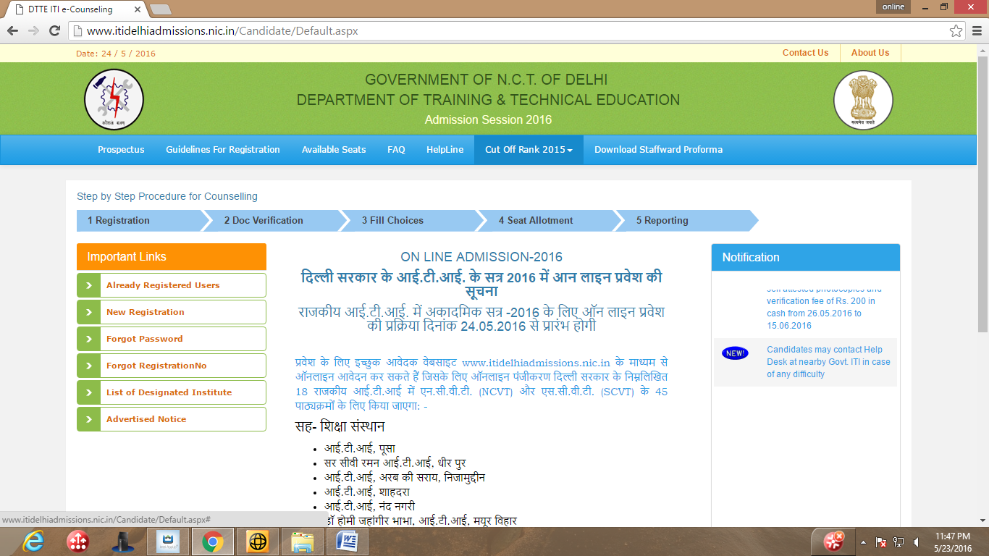

For registering click on the “New Registration” link as shown above. There after candidate needs to read the instructions and then click on the “Click here to proceed” button given at the bottom of page.
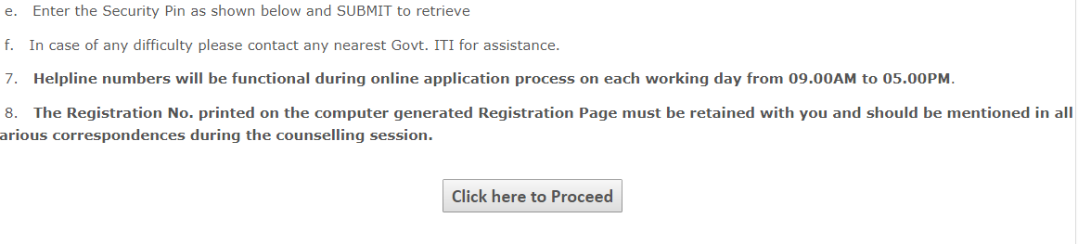

Fill candidate’s name, father’s name, date of birth as given in the qualifying certificate.

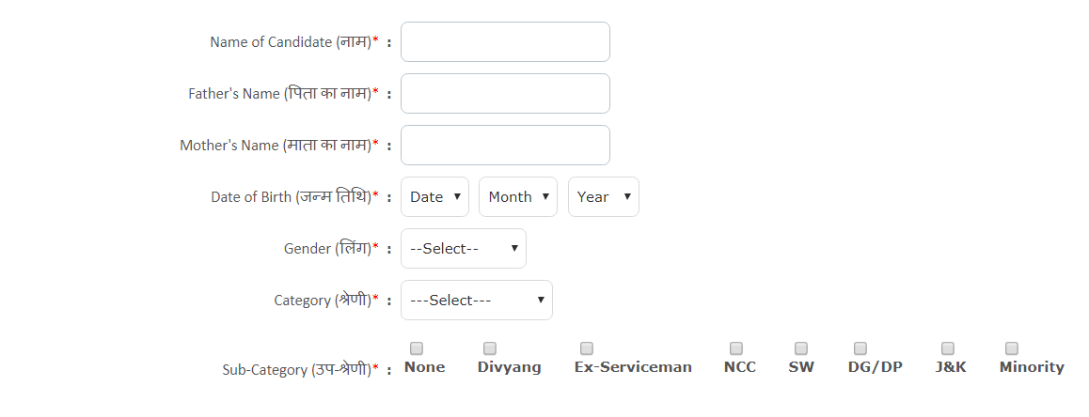The “Gender AND CATEGORY” of the candidate needs to be selected from the given choices in the drop down menu.

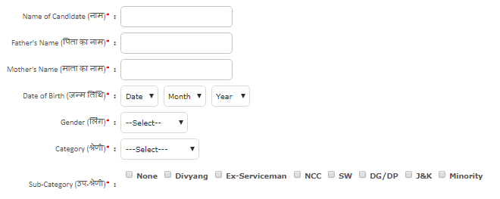

After that candidate needs to fill his sub cat (if any). Multiple subcategories are allowed. If candidate does not have any sub cat then select “none”. Further instructions are given in the prospectus.

A general candidate whose family has gross annual income is below 8 Lakh rupees and fulfill other terms and conditions of Economically Weaker Section (EWSs) are eligible for 10 percent reservation in ITI Admission. For availing reservation candidates needs to produce a certificate as per Annexure XIV of prospectus from competent authority as given in the prospectus.

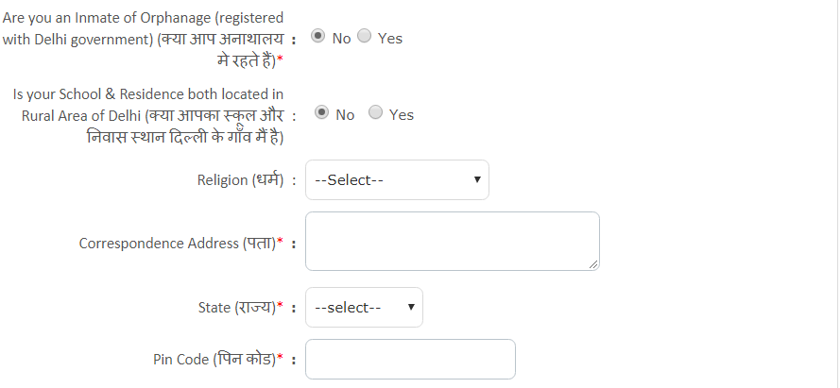

If the Candidate is “inmate of an orphanage, registered with Delhi Government” then select “Yes” otherwise select “NO”

If both the candidate’s qualifying school and residence are located in rural area of Delhi then click “YES” other-wise select “NO”.

Religion of the candidate must be selected in the drop down menu. If candidate religion is not in above list then click “others”.

Fill the Correspondence address of the candidate.

Select “Delhi” If candidate’s residence is located in Delhi otherwise select “Other State”.

Candidate must give his /her contact address :”PIN CODE”.

Give the mobile number on which candidate could be contacted. One mobile number could be used for only one registration.

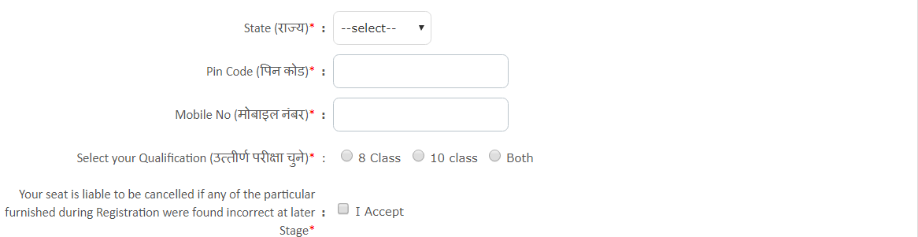

Select Your Qualification: You need to choose the Qualification option on basis of which you want to seek admission and fill his /her marks as per instructions given in prospectus.

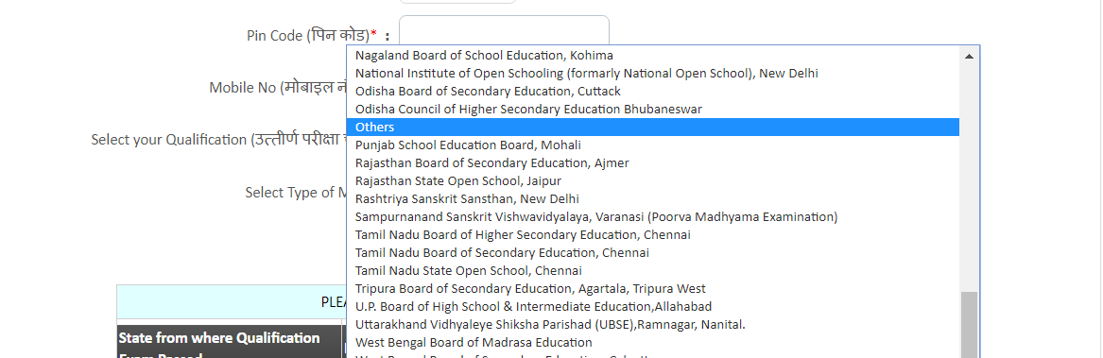

Select your qualifying board from the list of valid boards. If your board is not in the list of qualifying boards then you may select “others” option. Candidate must ensure that his/her qualifying board is “Recognized” for admission.

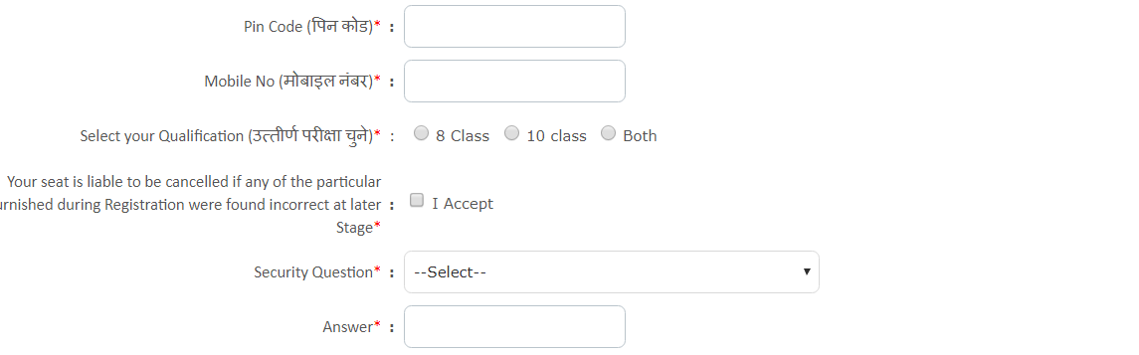
Candidate needs to “Accept” the statement by clicking on the check box.

Note : In case you do not find any subject or subjects name which you have passed, in Drop down Menu as shown below, then select “Other Subject 1” if one subject is not there, select “Other Subject 1” and “Other Subject 2” if two subjects are not there and so on, and fill their respective marks etc. Maximum four Subjects can be selected which are not in the list. In case you find that more than four subjects name are missing from the list, you are required to intimate the same through Email or visit nearest Govt. ITI along with your Mark sheet.

Candidate can select his /her board in the drop down menu. If the candidate’s board is not available in dropdown then he/she may select other board option.

SECURITY QUESTION: The candidate will be prompted to select a security Question and its answer. It will be helpful in case if she/he forgets his/her Registration Number or Password. The candidate is advised not to share the same with anyone.

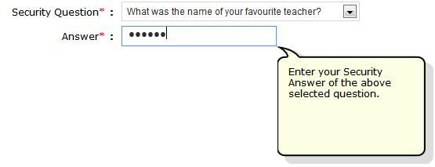

NOTE: The answer to the Security Question must be at least 6 Characters size without any space or special character.

CREATE A PASSWORD: The candidate will be prompted to generate his own 'PASSWORD'. Password should be at least minimum 8 characters long and should contain at least one Uppercase character(s) (A-Z), at least one Lowercase character(s) (a-z) and at least one special character(s) (i.e.! $ % ^ * @ # &etc.). The candidate is advised to keep his/her Online Registration Password secure and not to share as it can be misused by others. Maintaining the secrecy of the password will be the sole responsibility of the candidate himself/herself.
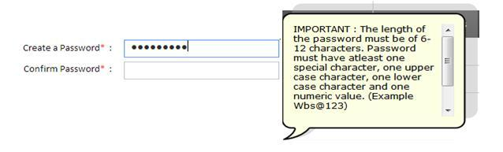

Examples Valid Passwords (Abcd@123, Suman$85, 123RKsha*98 etc.)

SECURITY PIN: Please enter the Green Text as shown below as Security Pin.

“Please type the same characters in same format (as it is Case Sensitive)”

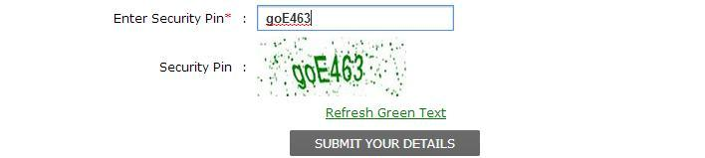

REGISTRATION SLIP: As soon as you will submit you’re Details. The System will generate your Registration Slip along with the Registration No.

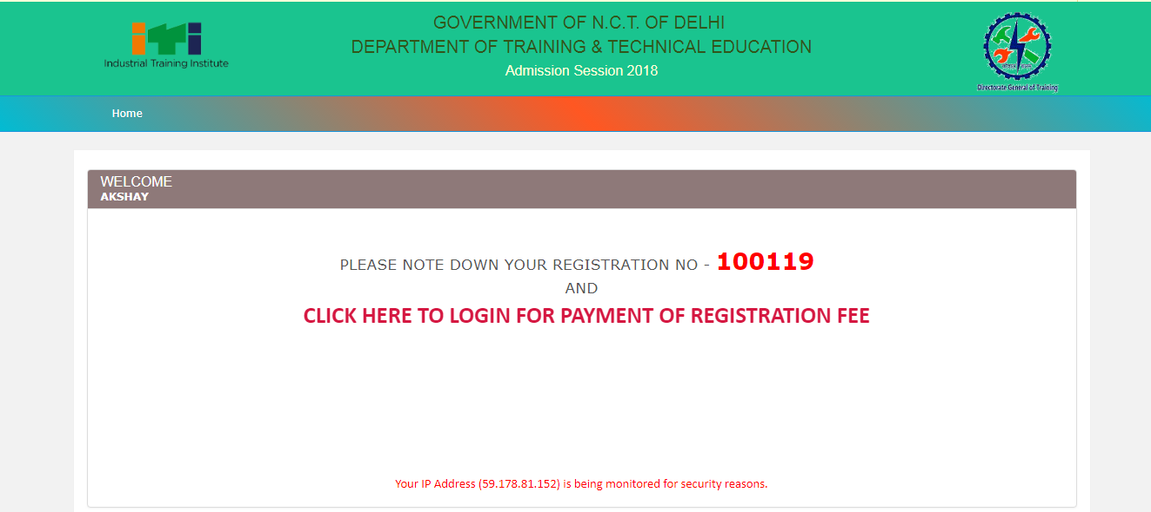

NOTE: Now along with this registration slip, you need to report at the Designated Institute (Govt. ITI) for further verification along with all your relevant documents in original.

For Online Registration Fee payment
After generating registration number candidate needs to log in and select “FEE PAYMENT” link and select “Pay Registration fee” option and then select “Make Payment” option.
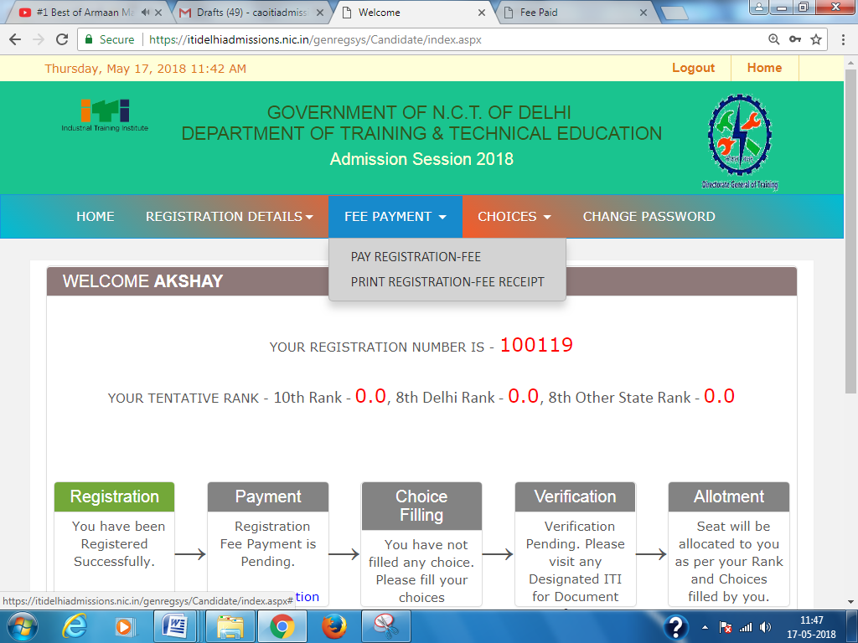

The following page will appear. Check the details and click “Make Payment” button:-

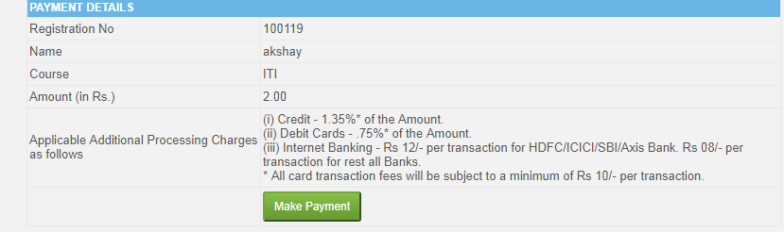
Then the payment gateway page will appear and select the mode of payment from the window of On Line Portal and pay the registration amount of Rs. 200/- plus charges as applicable by Credit Card, Debit Card, Debit+ ATM Card or Internet Banking by filling all the required details and clicking on ”Make Payment”” option.
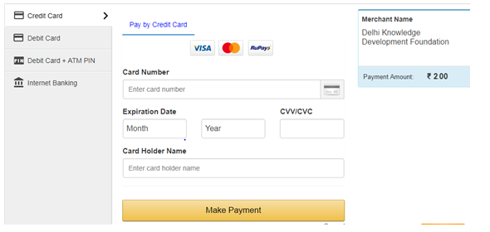
After Successful payment take the print of Fee receipt.

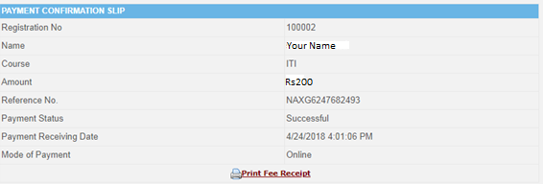

CHOICE FILLING GUIDELINES AFTER REGISTARTION FEE PAYMENT

For First time choice filling Candidates for verification.
- All registered candidates need to fill their choices for the Trades/ITI’s in which he/she desires admission before going for verification .
- Candidate should fill as many choices as possible to increase his/her chances of getting a seat allotted.
- The location of various ITI’s is available in prospectus. Candidates may use this information to find out the distance of ITI from his/her place of residence.
- Helpdesks are available at various I.T.I in case candidate needs any help.
- The higher choice seat would be first considered for allotment to the candidate and if that seat is not available then the next lower choice seat would be considered and so on. Choice number “1” would be the highest choice in order of preference.
The candidate needs to follow the following procedure for filling choices during online admission:-
- Open the homepage of ITI online admission i.e. http://www.itidelhiadmissions.nic.in/Candidate/login.aspx.

- Log in to website using your registration number and password. Using “Already Registered Users” link.

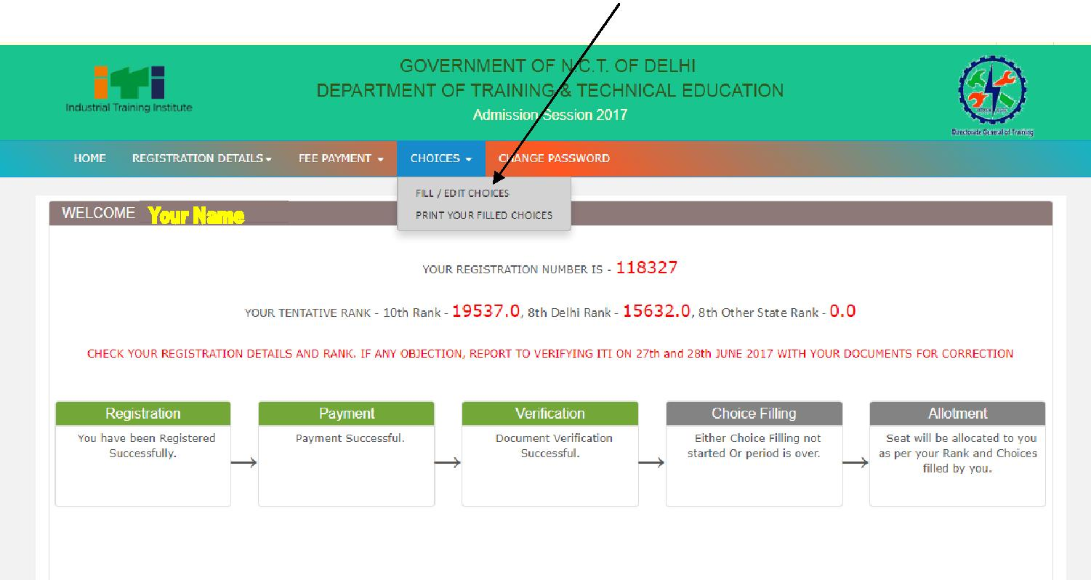
- After successfully logging into the website click on the “CHOICES” option available on the blue color menu line displayed on the top of online admission software.

- After that the following choice filling option will open for the candidate for filling choices.

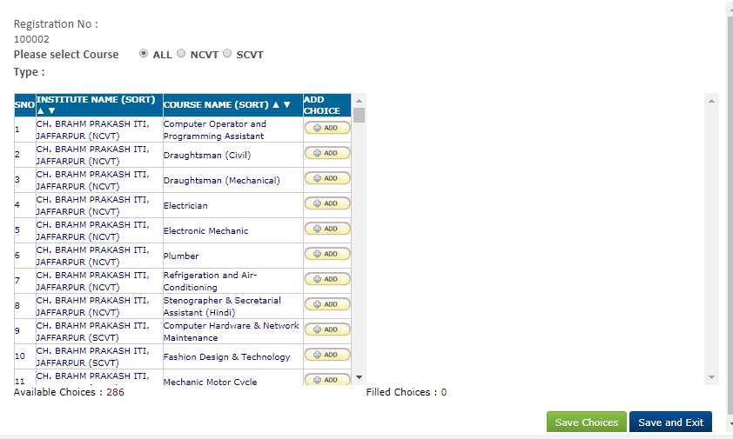

- On the left side of screen the trades/ITI for which candidate is eligible would be shown. The Trades/ITI’s for which a candidate is not eligible would not be shown in the “add choice column“. Eg. If a candidate is male then he would not be shown “all women courses in coed ITI’s” and “all trades of women ITI’s”. Similarly if a candidate does not have math /science in qualifying exam then trades which had entry qualification of mathematics and science would not be displayed to him.

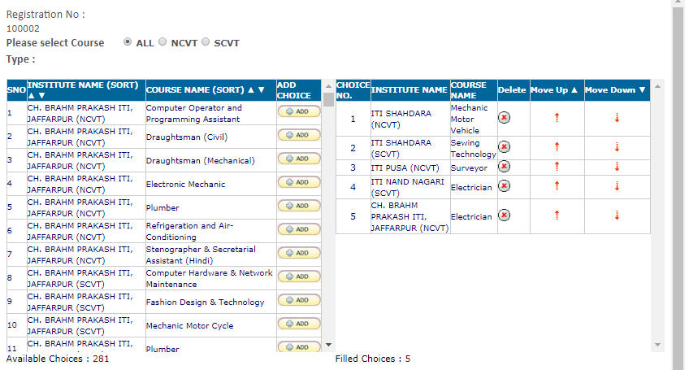
- Candidate has the option to sorting the options of trades/ITI choices for which he is eligible to apply either Institute Name wise or course name wise.
- When the candidate clicks on sort by “INSTITUTE NAME” the Trades/ITI available to the candidate would be sorted according to the name of ITI in alphabetical order. i.e. All the trades of one ITI for which candidate is eligible would be shown first and then all the eligible trades of next ITI and so on in alphabetical order .

- If the candidate sorts by” Course Name” then Trades/ITI available to the candidate would be sorted according to the name of Trade in alphabetical order. i.e. All the ITI’s which have particular trade for which candidate is eligible would be shown first and then followed by next trade in alphabetical order

- The candidate needs to fill the various trade/ITI choices by clicking on the” ADD button” in front of Trade/ITI Choice. After pressing the button the trade/ITI choice will move from right side column to left hand side.

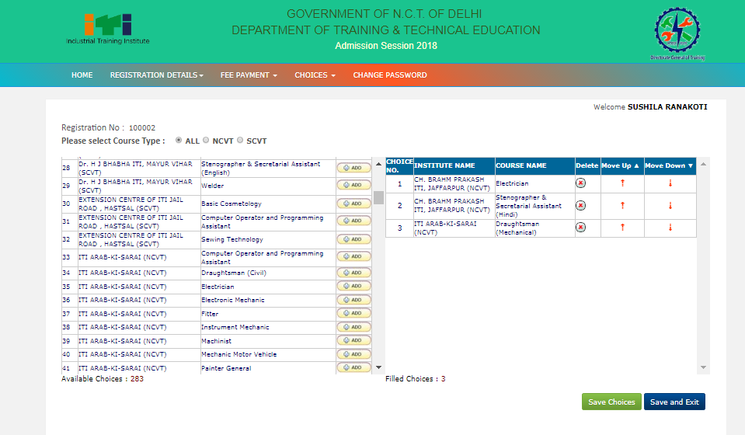
- Only the choices which the candidate has added and saved would be considered for admission in order of preference i.e. most preferred trade/ITI choice to be given as 1st preference and followed by least preferred choices.

- There is no restriction in number of choices and a candidate can fill as many choices as she/he likes from the available choices.
- The candidate can change the choice number of his added Trade/ITI choices by clicking on the “Move up” or “Move Down” button as applicable. The higher choice seat would be first considered for allotment to the candidate and if that seat is not available then the next lower choice seat would be considered. Choice number “1” would be the highest choice in order of preference.
- After filling the choices and setting the preferences, the candidate must compulsorily save the filled choices by Save Choice or Save & Exit button. The choices which are not saved would not be considered for admission.
- During choice filling days already filled choices can also be edited. Same procedure as given above has to be followed for editing.
- Candidate should take a print out after filling /editing his choices by clicking on “ Print your filled choices” button on the MENU BAR available on top and the Clicking on Print option.

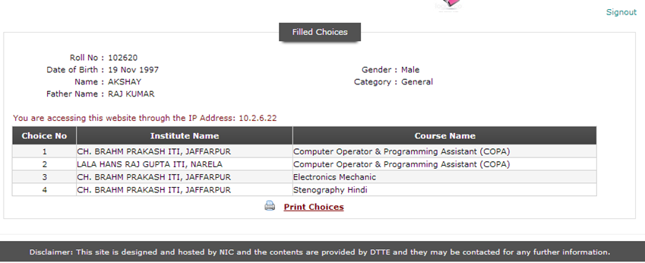

SEATS RESERVATION
SEATS RESERVATIONS
- Candidates passing qualifying examination from Delhi Schools. 90%
- Candidates passing qualifying examination from other states Schools. 09%
- Wards of J&K migrants, (has to be registered with D.C. Office Delhi). 01%
RESERVATION CATEGORY WISE:
Applicable for all ITI’s and Non-Minority Seats of MSDP Centre for Women at ITI Nand Nagri for Delhi and Other State category separately (except wherever mentioned otherwise.)

- Female Candidates (all Co-ed ITI’s only) 30%
Horizontally reserved across all categories except J&K & minority
- Scheduled Castes(Vertically Reserved) 15%
- Scheduled Tribes(Vertically Reserved) 7.5%
- Other Backward Class Non Creamy Layer (Vertically Reserved) 27%
For availing reservation under OBC category candidate is required to bring OBC Certificate from competent authority and valid non-creamy layer certificate.

If validity is not mentioned on NCL certificate thenit would be deemed to be valid for period of 1 year from date of issue of certificatei.e for admission in Delhi Govt. ITI’S such OBC (Non Creamy Layer) certificate is to be issued on or after 1st August, 2018. If it is issued prior to 1st August, 2018, then it should be accompanied by income certificate for securing seats in the quota reserved for socially economical backward classes issued on or after 1st August, 2018from the competent authority mentioned in the list of approved authorities.

- Economically Weaker Sections (EWS) 10%
Will have to submit Income and asset certificate from competent authority as per Annexure XIV

- Divyang/ Person with Disabilities(PwD) 04%
(As per Rights of Persons with Disabilities Act, 2016)
(Candidate should fill trade choices as per fitness certificate by National Career Service, 9-11 Vikas Marg, Karkardooma, Delhi–110092)in the Prescribed Pro-forma, given at Annexure VI.https://www.ncs.gov.in)& have to produce certificate at time of Admission.

- Defense Personnel(Horizontally Reserved): reserved for widows / wards of Military / Para Military personnel (CRPF, ITBP, BSF, CISF, NSG & Assam Rifles) in the following order of
preference: 05%
- Widows/wards of defense personnel killed in action.
- Wards of serving personnel & ex-servicemen disabled in action and boarded out from service.
- Widows/wards of defense personnel who died in peacetime with deathattributable to military service.
- Wards of disabled in services and boarded out with disability attributable to military service.
- Wards of ex-servicemen and serving personnel who are in receipt of Gallantry Awards:
  - ParamVir Chakra
  - Ashok Chakra
  - MahaVir Chakra
  - Kirti Chakra
  - Vir Chakra
  - Shaurya Chakra
  - Sena, NauSena, VayuSena Medal
  - Mention-in-Despatches
- Wards of ex-servicemen.
- Wives of:
  - Defense personnel disabled in action and boarded out from services.
  - Defense personnel disabled in services and boarded out with disability attributable to military services.
  - Ex-servicemen and serving personnel who are in receipt of gallantry awards.
- Wards of serving personnel.
- Wives of serving personnel.

Note: -Candidates seeking admission under Defense Personnel quota will have to get their candidature certified by any of the following authorities in the prescribed Pro-forma given at Annexure VII:
(i) Secretary, Kendriya Sainik Board, Delhi.
(ii) Secretary, Rajya/Zila Sainik Board.
(iii) Officer-in-Charge, Record Office of concerned service for serving personnel.

- NCC Cadets: (Horizontally Reserved): These seat are reserved on the basis of inter-se merit among the National Cadet Corps certificate holders of a given certificate L. Candidates with ‘C’ Certificate will be given higher priority over those candidates having ‘B’ certificate, which in-turn, will be given a higher priority over those with ‘A’ Certificate 01%**

- Staff Wards: (Horizontally Reserved):of non-transferrable staff of all institutions functioning under Department of Training and Technical Education. 01%*#

- Wards of Delhi Police and Govt. of NCT(Horizontal Reserved )
Only for candidates who have passed their qualifying exams from Delhi only): 2.5%
Certificate as per Annexure XIII required for admission under this quota.

- Minority Candidates as per Section 2(c) of National Commission
for Minorities Act, 1992 (only applicable in ITI for Women, Nand Nagri) 50%
Self -declaration as per Annexure no XII of prospectus
(Minorities reservation on request of principal of ITI concerned)

- Direct admission to inmates of Social Welfare licensed institutes including Bal Sahyog.

WEIGHTAGE
- Rural Area candidate subject to condition that 5% of marks obtained
Both the school and residence of the candidate should be
Located in Rural Area of Delhi (as per Annexure IX)

- Defense Personnel Quota. 5% of marks obtained
* Subject to maximum one seat per unit per I.T.I.
** Subject to maximum one seat in each trade and each I.T.I.
# Under staff ward quota all the non-transferable staff working under this Directorate whether serving/retired or died during the service (irrespective of State)
$ Reservation of wards of Delhi Police and Delhi Govt. employees will be considered subject to completion of essential qualification from Delhi Only.
## Admission will be given only in Trades for which the person certified to be able by
the National Career Service (NCS) of the Govt. of NCT of Delhi.

NOTE: The above reservations are subject to change without notice but duly communicated prior to counseling as per the decision of the Government of N.C.T. of Delhi.

APPROVED, CERTIFICATE ISSUING AUTHORITIES FOR CATEGORY,EWS ANDINCOME
For admission to a seat reserved for Scheduled Castes/Scheduled Tribes/OBCs/EWS, the candidate should submit a certificate in original at the time of admission(Both Verification and Counseling) from the approved district authority, indicating the Scheduled Caste/Tribe/OBC/EWS to which the candidate belongs. A list of approved authorities is given below:-
(a) District Magistrate / Additional District Magistrate / Deputy Commissioner / Collector /Additional Deputy Commissioner / Deputy Collector / 1st Class Stipendiary Magistrate / City Magistrate (not below the rank of First Class Stipendiary Magistrate), Sub-Divisional Magistrate / Taluka Magistrate / Executive Magistrate /Extra Assistant Commissioner.
(b) Chief Presidency Magistrate / Additional Chief Presidency Magistrate / Presidency Magistrate.
(c) Revenue Officer not below the rank of Tehsildar.
(d) Administrator/Secretary to Administrator/Development Officer (Lakshadweep & Minicoy Island)
ADDITIONAL INFORMATION REGARDING RESERVATION:

- The vacant seats (not taken by any candidate) will be converted as per Conversion Rules. However, the seats are allotted against a category/sub category and got cancelled due to non-reporting of candidate at reporting center or vacated due to withdrawal in respective category will be available in the respective category for the next allotment round.
- All subcategory seats will be first converted to their respective main categories. Example
- EX serviceman seat will be converted to General
- Unfulfilled Divyang seats for which there is no demand from PWD candidates would be converted into general seats towards the end of last round of counseling.
- After allotment and exhaustion of candidates application of OBC/EWS Category Seats will be converted to General Category Seats.
- Any unfilled seat reserved for Scheduled Castes will be treated as reserved for Scheduled Tribes and vice-versa. The seats will be de-reserved for General Category only after exhausting applications of all SC/ST candidates.
- Persons belonging to SC, ST OBC & EWS who are selected on the basis of merit and not on account of reservation will not be counted towards quota meant for reservation.
- Any seat (reserved or general) remaining unfilled in Outside Delhi category will be transferred to Delhi seat of the same category. The order of conversion shall be Outside Delhi (Reserved Category) to Delhi (Reserved Category) & Delhi Reserved category to Delhi (General).
- Benefit of reservation shall be available only if the category to which a candidate belongs is mentioned in On Line registration form. If nothing is indicated by the candidate in On Line registration form, he/she may not be considered in reserved category.

- All Reservation shall be as per the Delhi Government policy at the time of counseling and would be subject to any change/amendment made by the Delhi Government.
- Seats of boys/girls are inter-transferable within ITI, if sufficient numbers of girls are not available in Co-Ed Sections.
- No request for change of category would be attended after verification of documents as per verification schedule for whatsoever reason.
- Certificate of category candidate claiming reservation under Delhi category seats will be from the competent authority of Delhi jurisdiction only. Certificate of category candidates claiming reservation against seats allocated for outside Delhi candidates, will have to furnish the certificate from the competent authority, to establish their eligibility for reservation under the concerned reservation category.
- Divyang candidates must produce a certificate of medical fitness from National Carrier Service for Disabled (Formally Vocational Rehabilitation Center), Plot No. 9, 10 & 11, Karkardooma, Vikas Marg, Delhi-110 092
- Candidates seeking admission under Defence Personnel Quota should produce a certificate from Distt. Sainik Board in the standard format i.e. (i) Secretary, Kendriya Sainik Board, Delhi. (ii) Secretary, Rajya / Zila Sainik Board., (iii) Officer-in-Charge, Record Office of concerned service for serving personnel.
- Candidates seeking admission under Staff Ward Quota must produce a certificate on
Annexure-X from Head of Office for proof of being staff ward.
- Candidates seeking admission on the basis of 8th class pass should get a certificate attested by the principal from the school from where he/she passed class 8th (Annexure VIII.)
- Candidates seeking weight-age under Rural Area will have to get their Rural Area certified by BDO in the prescribed Pro-forma given at Annexure IX.
- For claiming the marks benefit of rural area both the qualifying school and residence of candidate should be located in rural area of Delhi.
- In case there is any clarification sought by the verifying Government ITIs regarding equivalency of the eligibility qualification certificate furnished by the candidate, the same must be produced by the candidates from the appropriate authority in the matter. In absence of the equivalency certificate, no confirmation of registration shall be given to the candidate and the responsibility of the same shall solely be of the candidate.
- Candidate who have been earlier expelled or rusticated from any of the institutes/ITIs due to any reasons is not eligible for fresh admission.
- Candidates to specifically note that if any incident of ragging comes to the notice of the authorities, the concerned trainee shall be given liberty to explain and if the explanation is not found satisfactory, the authority would expel them from the institution as directed by the Hon’ble Supreme Court of India SLP (c) nos. 24295 and 24296-99 of 2004 dated 10.12.2007.
REGISTRATION FEE, CAUTION MONEY & TUTION FEE

Registration fee Rs. 200/- to be deposited by all candidates irrespective of cat/gender at the time of registration through online means (credit card/debit cards/online banking.)
FEE STRUCTURE OF GOVERNMENT ITI’s/BTC.
Category | Government Component |  | Non-Govt. Component  (Per Annum) | Caution Money | Total Fee to be Deposited
 | Tuition Fee | Non-Tuition Fee | Pupil’s Fund |  | At the time of Admission | Half Yearly Payment
A. For all ITIs/BTC Engineering Trades
SC/ST (Boys)* | NIL | Rs.100/- per month | Rs. 200/- | Rs. 500/-** | Rs. 1300/- | Rs. 600/-
Girls, Divyang (PwD) and inmates of Orphanages*** | NIL | NIL | Rs. 200/- | Rs. 500/-** | Rs. 700/- | NIL
All other Category (Boys) | Rs.100/- per month | Rs.100/- per month | Rs. 200/- | Rs. 500/-** | Rs. 1900/- | Rs. 1200/-
B. For all ITIs/BTC Non-Engineering Trades
SC/ST(Boys)* | NIL | Rs.75/- per month | Rs. 200/- | Rs. 500/-** | Rs.1150/- | Rs.450/-
Girls, Divyang and inmates of Orphanages*** | NIL | NIL | Rs. 200/- | Rs. 500/-** | Rs. 700/- | NIL
All other Categories (Boys) | Rs.75/- per month | Rs.75/- per month | Rs. 200/- | Rs. 500/-** | Rs. 1600/- | Rs. 900/-

* The exemption from payment of Tuition Fee component under Government Account in ITIs/BTC for the SC/ST trainees.
** Caution Money is refundable only after successful completion of the Training WITHIN 3 YEARS OF COMPLETION OF COURSE otherwise same will be forfeited.
*** The exemption from payment of Government component of feein ITIs/BTC for the Girls and Physically Handicapped &inmates of Orphanages (Inmates from the Institutes licensed by Social Welfare Deptt. including BalSahyog of Govt. of Delhi)”.

Note: Candidate shall not be entitled for the refund of fee under any circumstances except
caution money as stated above.
CRAFTSMEN TRAINING SCHEME (CTS)
The Craftsmen Training Scheme was introduced by the Government of India in 1950 to ensure a steady flow of skilled workers in different trades for the domestic industry, to raise quantitatively and qualitatively the industrial production through systematic training, to reduce unemployment among the educated youth by providing them employable training.

Salient Features of the Craftsmen Training Scheme:-
- ITIs are functioning under the administrative control of the respective State Govt. /UTs.
- The period of training for various trades varies from one year to two years and the entry qualification varies from 8th &10th class pass, depending on the requirements of admission in different trades.
- These institutes are required to conduct training courses as per the curriculum prescribed by National Council for Vocational Training (NCVT). The admission to the new courses is made in the month of July/August every year.
- The trainees are required to appear in the Final Trade Tests conducted under the aegis of National Council for Vocational Training/State Council of Vocational Training. The successful trainees are awarded National Trade Certificate/State Trade Certificate which has been recognized by Govt. of India/State Govt. for the purpose of recruitment to subordinate posts and services under the Central Govt./State Govt./PSUs/Private Sectors.
- Syllabi of various trades are periodically revised to keep pace in tune with changes in technology.

CERTIFICATION ON SUCCESSFUL COMPLETION OF TRAINING
  - A trainee admitted in NCVT designated trade/course with affiliation from NCVT will have to undergo a regular training of the trade concerned as per the syllabus laid down by the Directorate General Training (DGT), Government of India and shall be eligible to get the N.C.V.T. certificate on passing all examinations.
- A trainee admitted in SCVT designated trade/course will have to undergo a training of the trade concerned as per the syllabus lay down by the Board of Technical Education, Delhi and shall be eligible to get the S.C.V.T. Certificate on passing all examinations.
- All the SCVT designated trades and NCVT designated trades running under SCVT affiliation. A trainee on successful completion of these trades would receive a SCVT certificate.

DUAL SYSTEM OF TRAINING (DST)

Ministry of Skill Development &Entrepreneurship has implemented the scheme named
“Dual System of Training” (DST) w.e.f. August 2016. DST has been approved during 40th meeting of National Council of Vocational Training (NCVT).
The courses will be conducted to meet the workforce requirement of the industry so that after the completion of training in dual system, the trainee having NTC with dual mode will get better employment opportunities in industry.
The ITI and Industry will have the freedom to choose the training pattern either in Block mode (few months in ITI and few months in industry) or mixed mode( i.e. few days in a week shared between ITI and Industry.
TRADE THEORY AND SOME PORTION OF PRACTICAL: The theory portion and basics about safety and tools, equipment along with foundation practical will be conducted by ITI.
INDUSTRY TRAINING PORTION: The remaining portion of training shall be conducted in the industry/organization. For a two year course it is expected that nine months (i.e. ~1560 hrs.) training would be in the industry and remaining portion would be in the ITI. For one year course it is expected that five months training would be in the industry.
Assessment and Certification: Assessment and certification of all the trainees will be carried out as per DGT/NCVT norms for Trade theory including practical portion conducted in ITI workshop. Industrial training of the trainees shall be accessed by the industry partner. After successfully completion of training, National Trade Certificate (NTC) (mentioning dual model) shall be awarded to the trainee.
For stipend, industry, and additional information the candidate may contact ITI offering the said trade in Dual System of Training and/or refer orders issued by MSDE (DGT) in this regard (http://dget.nic.in/content/innerpage/dual-system-of-training.php).
National Skills Qualifications Framework (NSQF)

The National Skills Qualifications Framework (NSQF) is a competency-based framework that organizes all qualifications according to a series of Level of knowledge, skills and aptitude. These levels, graded from one to ten, are defined in terms of learning outcomes which the learner must possess regardless of whether they are obtained through formal, non-formal or informal learning. NSQF in India was notified on 27th December 2013. All other frame works, including the NVEQF (National Vocational Educational Qualification Framework) released by the Ministry of HRD, stand super ceded by the NSQF.
Under NSQF, the learner can acquire the certification for competency needed at any L through formal, non-formal or informal learning. In that sense, the NSQF is a quality assurance framework. Presently, more than 100 countries have, or are in the process of developing national qualification frameworks.
The NSQF is anchored at the National Skill Development Agency (NSDA) and is being implemented through the National Skills Qualifications Committee (NSQC) which comprises of all key stakeholders. The NSQC's functions amongst others include approving NOSs/QPs, approving accreditation norms, prescribing guidelines to address the needs of disadvantages sections, reviewing inter-agency disputes and alignment of NSQF with international qualification frameworks.

Specific outcomes expected from implementation of NSQF are:

- Mobility between vocational and general education by alignment of degrees with NSQF
- Recognition of Prior Learning (RPL), allowing transition from non-formal to organized job market
- Standardized, consistent, nationally acceptable outcomes of training across the country through a national quality assurance framework
- Global mobility of skilled workforce from India, through international equivalence of NSQF
- Mapping of progression pathways within sectors and cross-sectional
- Approval of NOS/QPs as national standards for skill training

Multi-Sectoral Development Programme
The Multi-Sectoral Development Programme (MsDP) was conceived as a special initiative of the follow up action on the Sachar Committee recommendations. It is a Centrally Sponsored Scheme (CSS) approved by the Government in the beginning of the 11th five Year Plan and launched in the year 2008-09 in 90 Minority Concentrations Districts (MCDs). It is an area development initiative to address the development deficits of minority concentration areas by creating socio-economic infrastructure and providing basic amenities. The scheme aims at focused development programs for backward minority concentration areas to help reduce imbalances and speed up development. Muslims, Sikhs, Christians, Buddhists and Zoroastrians (Parsis) have been notified as minority communities under Section 2 (c) of the National Commission for Minorities Act, 1992.
ASIA PACIFIC ACCREDITATION AND CERTIFICATION COMMISSION,
MANILA, PHILIPPINES ACCREDIATION

Jija Bai ITI for Women, Siri Fort is internationally accredited with APACC, Manila, Philippines for scope of activities under governance and management, Teaching and learning, Human Resources, Research and development, Image and sustainability, other resources and support to students.

Accredited institutions and stakeholders enjoy the following benefits:
- Greater workforce mobility and mutual recognition of qualifications in Asia and the Pacific region;
- Quality and employable workforce in member countries through APACC coordination among its network of institutions, agencies and other stakeholders;
- Employer confidence on the selection of employees coming from accredited institutions. Accreditation status is important to employers when evaluating credentials of job applicants and when deciding to provide support for current employees seeking further education;
- International recognition of the institutions' quality, accountability, and public trust;
- Eligibility and reliability of TVET institutions for funding support from donors and other lending agencies;
- Part of a regional network of quality institutions that expand schooling and learning opportunities for students; and
- Transferability of credits earned by a student among educational institutions. Receiving institutions take note of whether or not the credits a student needs to transfer have been earned from an accredited institution.

IMPORTANT DETAILS FOR RANK GENERATION AND
SEAT ALLOTMENT
The candidate should be careful while filling the following details as these details would be used for calculating his/her rank and for allotment of seat. If any erroneous/incorrect information is later found, it could lead to cancellation of seat allotted to the candidate and other necessary actions may be taken against him/her as deemed fit by the ITI/CAO/DTTE.
- Qualifying Board of the candidate: List of recognized boards for secondary exams is provided in the prospectus. Candidate must check the validity of his qualifying board before registering. If the Qualifying board of candidate is not included in the list, then candidate may choose other board option (After ascertaining the validity of his/her qualifying board). In case, there is any clarification sought by the verifying Government ITI /DTTE /CAO regarding equivalency of the eligibility qualification certificate furnished by the candidate, the same must be produced by the candidates from the appropriate authority in the matter. In absence of the equivalency certificate, candidate credentials may not get verified/seat allotted to the candidate may get cancelled/candidate may not participate in counseling (depending on the case) and the responsibility of the same shall solely be of the candidate. If board is found fake then suitable action may be initiated against the candidate and Fee once paid would not be refunded under any circumstances.

- Candidates qualifying Marks/Grade: While registering the candidate should first click on the correct radio button according to whether his/her certificates are in grades (for CBSE Only) or marks. Grades for other Boards are to be converted into marks as per criteria for calculation of marks percentage given in the prospectus. Under no circumstances, the candidate should fill marks in grades column or vice a versa. For more information, go through the Criteria for marks calculation in the prospectus.
For ascertaining the eligibility conditions, combination of mark sheet shall be allowed only and only if mark sheet are from same board. If a candidate changes board e.g. From CBSE to NIOS then appropriate proof of accepting the marks of earlier board is required i.e. such candidate should produce one complete mark sheet making him eligible.
- State of Candidate: As per I.T.I admission policy, the state of candidate will be considered on the basis of his/her state of Qualifying Examination. For e.g.: if a candidate stays in Delhi but has passed his qualifying exam from Other State then he/she would be considered outside Delhi candidate and vice versa.
- DUAL category candidates:-A category candidate could have dual category on the basis of his/her qualifying state of 8th and 10th class.
- Date of Birth of Candidate should be entered correctly and exactly as mentioned in his qualifying certificate/ age proof.
- Gender information of the candidate has a very high significance in allotment of seat. Wrongly filled gender, if found at the time of counseling can lead to the cancellation of allotted seat and further action as deemed fit by CAO/DTTE.
- Religion: Minority seats are offered to minority female candidates in ITI for Women, MSDP, Nand Nagri. (As per the Government policy Muslims/Sikhs/Buddhists/Jains and Zorostrians (Parsis) are notified as Minority community under section 2(c) of Minority Act, 1992).
- Category of the candidate: Specific reservations exist for SC, ST& OBC candidates. Original Caste certificate in the name of the applicant from competent authority will have to be produced at the time of verification, failing which the candidate may be considered under general category. If the admitted candidate fails to submit the caste certificate at the time of counseling his/her admission will stand cancelled.
- The category of the candidate would be determined based on jurisdiction of his caste certificate and qualifying state:-
        - A candidate would be considered a Delhi category candidate (SC/ST/OBC) only if both jurisdiction of his caste certificate and qualifying state is Delhi.
        - Candidates with qualifying state other than Delhi and possessing Delhi jurisdiction Caste certificate (SC/ST/OBC) would be considered other state category candidate.
        - Candidates having Delhi qualifying state and possessing Category certificate of other state jurisdiction would be considered as Delhi General Candidate.
        - SC/ST candidates with qualification from other state and jurisdiction of caste certificate from any state would be considered other state SC/ST candidate.
        - OBC candidates qualifying from other state and jurisdiction of caste certificate from same state as qualifying state would be considered other state OBC candidate.
        - The creamy layer amongst OBCs would be considered under general category.
        - For availing reservation under OBC category candidate is required to bring OBC Certificate from competent authority along with valid non-creamy layer certificate.
- SUB CATEGORY OF THE CANDIDATE: Reservations exist for sub categories as given below. The candidate fills his/her sub category correctly and produces the necessary documents at the time of verification/counseling.
  - Person with Disabilities /Divyang (As per Rights of Persons with Disabilities Act, 2016):These candidates need to get a fitness certificate from National Carrier Service, 9-11 Vikas Marg, Karkardooma,Delhi–110092.in the Prescribed Pro-forma, given at Annexure VI).

  - Defense Personnel (reserved for widows / wards of Military / Para Military
personnel (CRPF, ITBP, BSF, CISF, NSG & Assam Rifles):
Candidates seeking admission under Defense Personnel quota and weight-age will have to get their candidature certified by any of the following authorities in the prescribed Pro-forma given at Annexure VII:
- Secretary, Kendriya Sainik Board, Delhi.
- Secretary, Rajya / Zila Sainik Board.
- Officer-in-Charge, Record Office of concerned service for serving personnel.
  - NCC Cadets: Candidates with ‘C’ Certificate will be given higher priority over those candidates having ‘B’ certificate, which in-turn, will be given a higher priority over those with ‘A’ Certificate. The seats are reserved on the basis of inter-se merit among the National Cadet Corps certificate holders of a given certificate level.
  - Staff Wards (All non-transferrable staff of all institutions functioning under Department of Training and Technical Education): Wards of all non-transferable staff from all institutions functioning under Department of Training and Technical Education. Candidate needs to submit a certificate in the appropriate Annexure X as given in the prospectus certified by head of Office of the department.

  - Wards of Delhi Police and Govt. of NCT of Delhi employees: This reservation is only valid for wards of Delhi Police and Govt. of NCT Employees who have passed their qualifying exams from Delhi. Candidate needs to submit a certificate in the appropriate Annexure XIII as given in the prospectus certified by head of Department of the department.
  - Inmates of Orphanages: Direct admission to inmates of Social Welfare valid licensed institutes including Bal Sahyog.
  - Rural Area Weight age: Weight age of 5 % of marks obtained is given to candidates who have both the qualifying school and residence located in rural area of Delhi. Candidates seeking admission under Rural Area will have to get their candidature certified by BDO in the prescribed Pro-forma given at Annexure IX.
  - Economically Weaker Sections (EWS): Will have to submit Income and asset certificate from competent authority as per Annexure XIV

CRITERIA FOR CALCULATION OF MARKS PERCENTAGE

The following criterion is to be followed while entering marks /grades for registration of various boards:-
- If both marks and grades are given on the marks sheet for same subject then only marks are to be considered.
- Only grades of CBSE mark sheets are to be filled in grades section of the online line admission software if possible, in consideration to the single conversion factor for a given mark sheet. For other board’s marks sheet (except CBSE), the grades/grade points are to be converted to corresponding marks by using the conversion factors given in the mark sheet and filled in marks column.
- If a candidate is absent in a subject then that subject is also to be considered for admission. In place of marks obtained the candidate should enter “A”. If a candidate is absent in a subject then his/her grade points would be deemed as 0.
- In case of CBSE, if grades E1 OR E2 are given then their corresponding grade points will be deemed as 3 for E1 grade and 2 for E2. The candidate has to compulsorily select E1, E2 and A in relevant subject if he/she has received these grades in the qualifying examination applicable.
- If a candidate is fail in a subject then its marks are also to be entered.
- The following points must be considered while converting grade/grade points into marks and vice a versa and verifying the marks /grades of the candidate:-

FOR MARKS SHEETS OTHER THAN CBSE BOARDS FOR 8TH&10TH:
Marks sheet (except CBSE) the grades/grade points are to be converted to corresponding marks and filled in marks column.
  - FOR MARKS SHEETS CONTAINING GRADE POINTS: The aggregate percentage of marks of all subjects including optional subjects after conversion from grade points according to respective conversion calculator shall be taken into account if possible, in consideration to the single conversion factor for a given mark sheet and vice versa. For conversion candidate should consider the conversion calculator of that respective board and if range of marks are given then take the average of marks as to consider as marks obtained.
  - FOR MARKS SHEETS CONTAINING GRADES: The aggregate percentage of marks of all subjects including optional subjects after conversion from grade according to respective conversion calculator shall be taken into account ,if possible in consideration to the single conversion factor. For conversion candidate should consider the conversion calculator of that respective board and if range of marks are given then take the average of marks as to consider as marks obtained.
  - FOR MARKS SHEETS CONTAINING MARKS: The aggregate percentage of marks of all subjects including optional subjects for which marks are given If possible, in consideration to the single conversion factor for a given marks sheet and vice a versa.
In case no calculators are available or any confusion, help desk of any Govt. ITI may be contacted for guidance.
For CBSE marks sheets the following factors should be considered:-
- Enter grade points (GP) in the grades option of online admission software.
- All the marks or grades of the candidate should re-enter.
- If a candidate is absent in an exam then he/she must enter it as “A”. In case of CBSE, if grades E1 OR E2 are given then their corresponding grade points will be deemed as 3 for E1 grade and 2 for E2. If a candidate is absent in a subject then his grade points would be deemed as 0.

GENERATION OF UNIQUE RANK /TIE BREAKER CRITERIA

The rank of the candidate would be generated by calculating percentage of marks/grades secured by the candidate in qualifying examination and arranged in decreasing order. If two or more candidates are having same percentage/grade then, the following tie breaker criteria would be used in sequence to allot them distinctive ranks:-
1. Date of Birth: The candidate higher in age would be allotted the higher rank.
2. Science marks in descending order: If tie is still not broken then the candidate scoring higher marks in science would be allotted the higher rank.
3. Social Science: If tie is still not broken then the candidate scoring higher marks in social science would be allotted the higher rank.
4. Registration Number: if tie is still not broken then the candidate’s registration number in ascending order would be allotted the higher rank.
However, if still the tie does not break then CAO reserves the right to develop and implement further suitable criteria for distinguishing the rank of tied candidates.

GENERAL RULES & INFORMATION FOR STUDENTS

- Working Days and hours – Monday to Friday or as decided by DTTE.ITI trainees are required to observe 42 Hrs. per week of training as per DGET/BTE/ITI norms. The training of candidate may be conducted in morning, afternoon or evening shift as per the convenience of ITI/DTTE.
- Uniform: - Trainee shall get two sets of prescribed uniform as approved by D.T.T.E. (HQ) stitched within 7 days from the date of admission and shall wear the same daily right from his residence till reaching back to the residence.
- Holidays / Leave admissible to trainees:-Trainees are allowed the same Gazette holidays as decided by Delhi Government for its employees. There will be no summer/winter holidays.
- Casual Leave: In addition to usual holidays, trainees are admissible to avail casual leave @ 8 days per year, 6 days at any one time subject to the sanctioning of leave by competent authority. Casual leave can’t be combined with another kind of leave.
- Medical Leave:-Medical Leave up to 15 days per year subject to production of Medical Certificate from a Medical Officer may be granted. Leave for a further period of not exceeding 3 weeks for One Year course and 6 weeks for Two Year trades course can be granted in case of serious illness. This leave can be granted only once in the training period on recommendations of medical officer acceptable to competent authority.
- Special Leave: Special leave up to 10 days on private affairs may be allowed only in extraordinary cases where Head of Institute is satisfied that the requirement is genuine. No scholarship/stipend will be admissible during the period of special leave.
- Unauthorized Absence: For unauthorized absence up to 10 consecutive days at a time, trainee will be issued a written warning for first occasion. If the offence is repeated, trainee will be discharged from rolls. Proportionate deduction of scholarship is made from such trainees who are scholarship holders.
- SUSPENSIONS, DISCHARGE:
- Trainees are liable for discharge on account of unsatisfactory progress in training.
- For acts of indiscipline and misconduct.
- If attendance percentage falls below 50%.
- The pending investigation of allegations against him/her.
- If the Trainee is absent for 10 consecutive days without information.
- MINIMUM COMPULSORY ATTENDANCE FOR TRAINEE: - Only those candidates who have completed minimum essential attendance would be permitted to appear in examination. The candidate who has insufficient attendance may not be allowed to appear in the ensuing examination and will be treated as per DGT norms.

- SCHOLARSHIP TO TRAINEES: Diverse scholarships are available to eligible ITI trainees. Trainees need to register themselves with the following websites and directly apply for various government scholarships within stipulated time to avail benefits of various educational scholarships.
      - National Scholarship Portal Version 2.0 (NSP-2.0) (https://scholarships.gov.in),
      - E-district portal(https://edistrict.delhigovt.nic.in/in/en/Home/Index.html)

- Meritorious & Merit-Cum-Means Scholarship : Department has introduced Meritorious & Merit-cum-Means Scholarship to the weaker Sections of the Society on the basis of the marks obtained by a trainee in the qualifying examination required for admissions.
STUDENTS AMINITIES

- Industrial Training and Field Visits: Trainees are exposed to the Industry by arranging industrial Training and field visits. Presence of trainees during the visits is obligatory, Common room, steel lockers, water coolers and canteen facilities are provided for the convenience of trainees, wherever possible.

- Library Facilities: All the institutes have been provided with good libraries and the trainees are advised to make full use of them.

- Placement: Facilities of training during their course of study and placement of trainees after completion of the course are arranged by the Placement officer deputed by the Principal of the institute

- State Level Skill Competitions: In order to foster a spirit of healthy competition among trainees of the institutes, with a view to raise the standard of skill. All India Skill Competition are held every year, the trainees under the regular Craftsmen Training Scheme only are eligible to compete in the State Level Competition. At present it covers 15 engineering and Non-Engineering Trades. Trainees securing 1st position at State Level Competition are eligible to compete in All India Skill Competition.

AGE LIMIT

Minimum age limit is minimum 14 years for all the candidates as on 01-08-2019. No Upper age limit is prescribed for the candidates seeking admission in Government ITIs/BTC except DST Trades at ITI PUSA where candidate should have completed 18 years of age on 01 August 2019.

PHYSICAL FITNESS

All the candidates shall be required to submit a Medical Fitness Certificate from a Registered Medical Practitioner as per Annexure- I at the time of admission.
NOTE: Admission of the candidate shall stand cancelled ab-initio, if any information supplied or document submitted is proved to be false/ fake at any stage even after admission.
DISCIPLINE

All the trainees admitted to an institution will be under the complete disciplinary control of the Principal of the institute or any other officer(s) appointed by the competent authority for the purpose and must conduct themselves in accordance with the disciplinary rules of institution as framed and notified by the Principal.

UNDER THE RULES, FOLLOWING ARETHE FORBIDDEN PRACTICES:

a) RAGGING IN ANY FORM IS STRICTLY PROHIBITED. If any incident of ragging comes to the notice of the authorities, the concerned trainee may be given the opportunity to explain and if his/her explanation is not found satisfactory, the authority would expel him from the institution.
b) Disfiguring or otherwise damaging institutional property;
c) Smoking in the class room, workshop and laboratory or during field training;
d) Use of drugs or intoxicants except for those prescribed by a registered medical practitioner and under the knowledge of Principal of the institution;
e) Any form of gambling;
f) Rowdies and rude behavior;
g) Use of violence in any form;
h) Offences of cognizable nature;
i) Castism, communalism or practice of un-touch ability; or
j) Any other conduct unbecoming of a trainee of the Institution. Any trainee indulging
In any of the forbidden practice may attract any or more of the following disciplinary Measures: -
- Cancellation of the scholarship/stipend (in part or in whole, temporarily or permanently) in accordance with the rules prescribed in this regard.
- Fine;
- Suspension;
- Expulsion; or
- Rustication.

The candidates for admission have to give an undertaking that they will abide by the rules and regulations prescribed by the DTTE/ Principal and any action taken in this regard on the trainee by the Principal shall be final.

CONDUCT OF EXAMINATION

Annual exams will be conducted for the trainees admitted from session August 2018. The exams may be conducted in May/June and supplementary exams may be conducted in November/December each year.
Only those candidates who have completed minimum essential attendance of 80% would be permitted to appear in examination. The candidate who has insufficient attendance may not be allowed to appear in the ensuing examination and would be treated as per DGE&T/DTTE norms.
For Trainees admitted in session 2018 onwards passing marks percentage would be 33 % in each paper for Annual Theory examinations. The passing percentage for practical examination and formative assessment would be 60%. Grace marks up to over all limits of 06 marks may be allowed to trainee and there would not be any grace marks for practical.
DGT may conduct Computer Based Test (CBT) for theoretical papers. The CBT may use MCQ objective type questions and trainees in the same room may get different questions of equal difficulty level or different sets same paper.
In All India Trade Test (AITT) a trainee is entitled to total 04 attempts for passing examination i.e. 01 attempt as regular and 03 additional attempts as supplementary. If a trainee does not appear in only one or none of the 1 + 3 additional attempts then the trainee would lose that attempt and registration will expire.
The registration of trainee will expire after 1 + 3 additional attempts as supplementary or completion of period of one and half year after training whichever is earlier. It trainee does not successfully pass AITT in this period, the name of trainee would be stuck off from the portal as per DTG/NCVT norms.

HOW TO DOWNLOAD NTC FROM MIS PORTAL

- Go to NCVT Portal through following link
https://ncvtmis.gov.in/pages/home.aspx

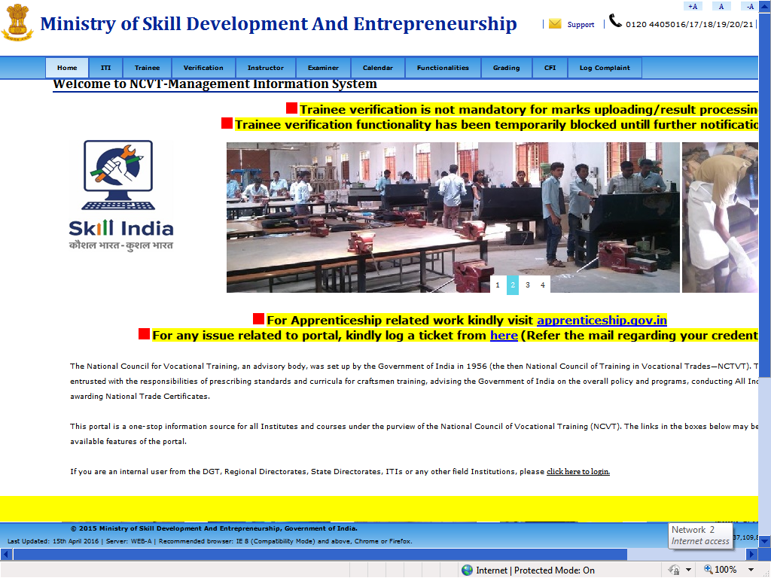

- Now click on Trainee tab and then click on Trainee Profile

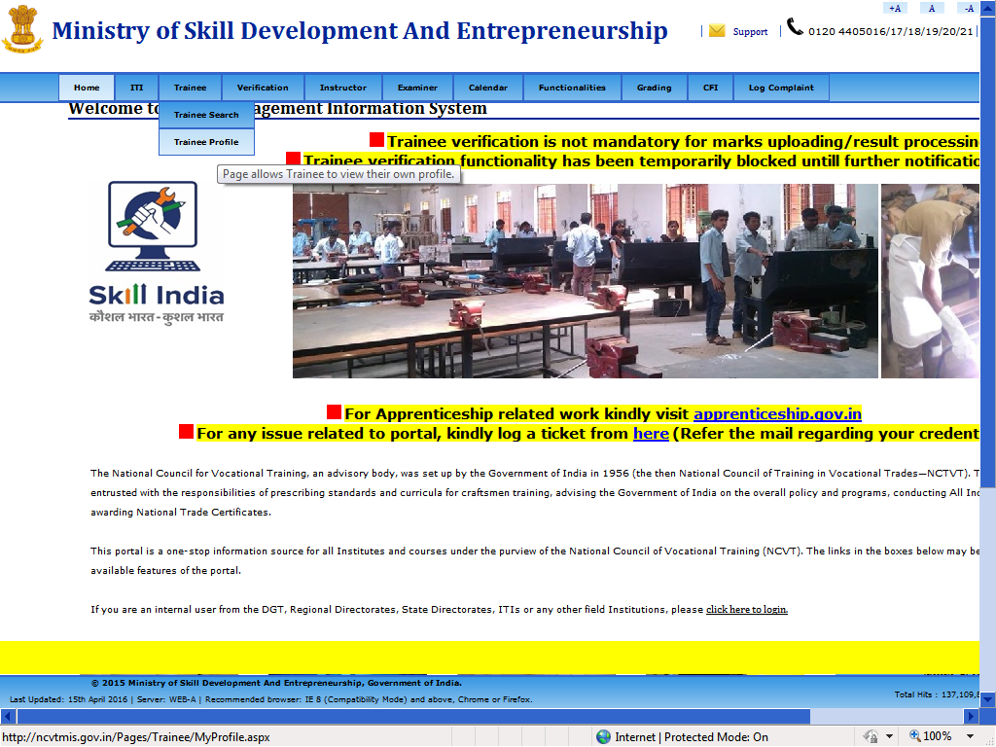

- Now enter the following Details
- Registration No:- It is a trainee roll no. only starting with R (Kindly use you’re roll number only by replacing starting 00 with R)
For example: If trainee Roll No. is: - 00160807001111
Then Registration No. is: - R160807001111
- Father/Guardian Name: - Enter the father name as mentioned in Exam hall ticket.
- Date of Birth: - Enter the DOB in dd-mmm-yyyy format.
- Enter image text: -Enter the image text as it is as displaying on the portal.

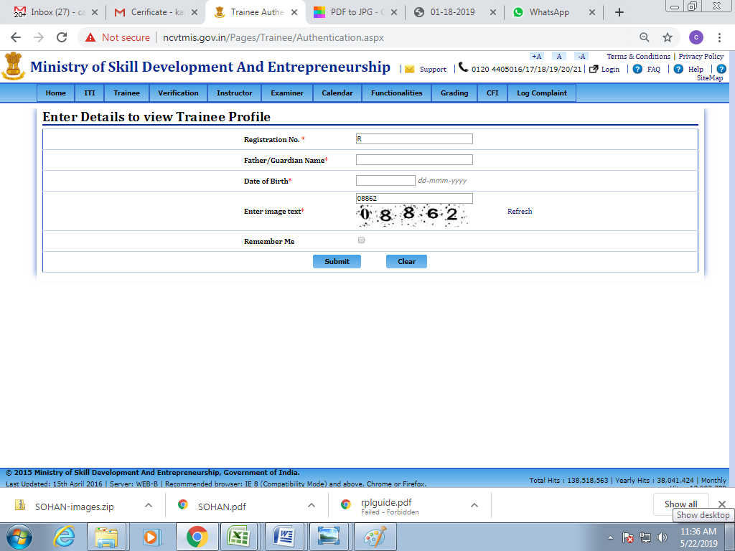

- Now click on Submit

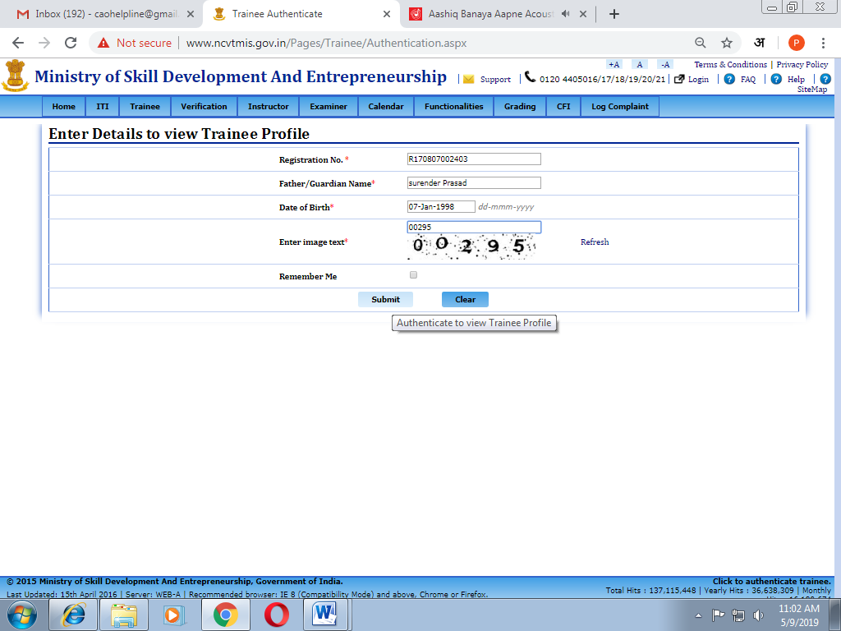

- Now trainee profile will open as below:-

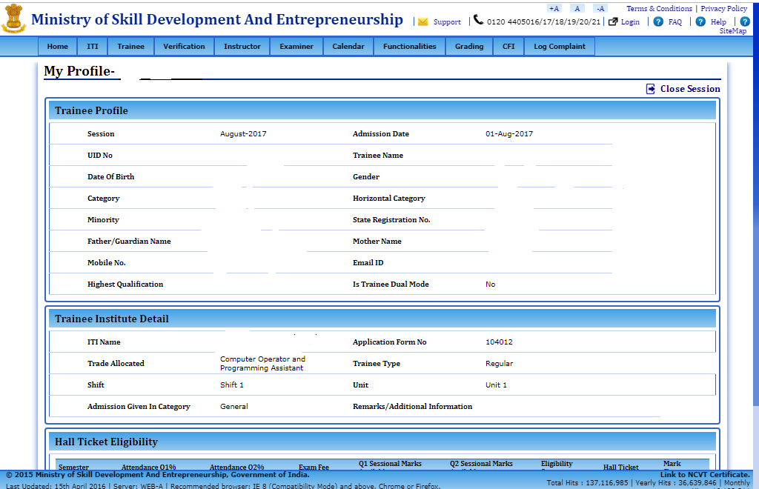

- Now Click on Print Certificate

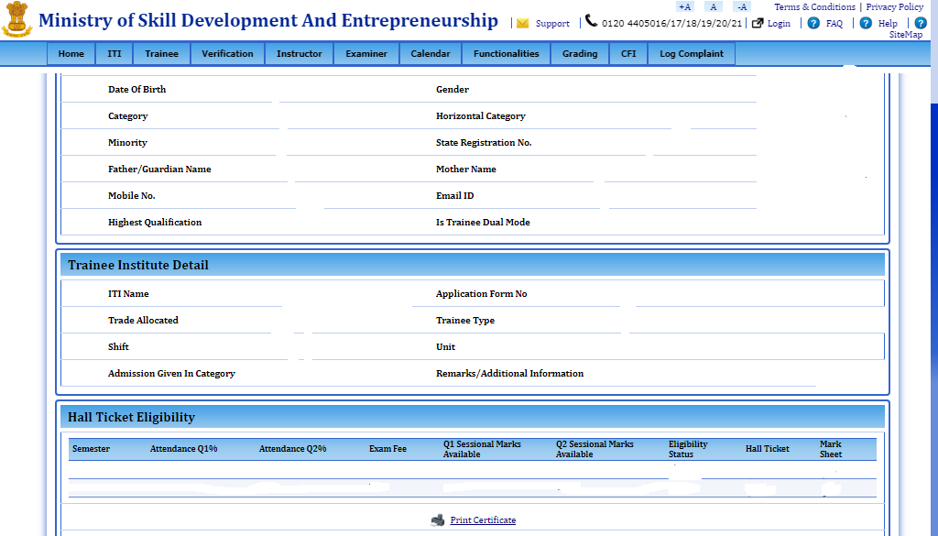

- Check the download section of your browser as a NTC in pdf file is being downloaded over there.

- Now open the file and print the certificate as displayed below:

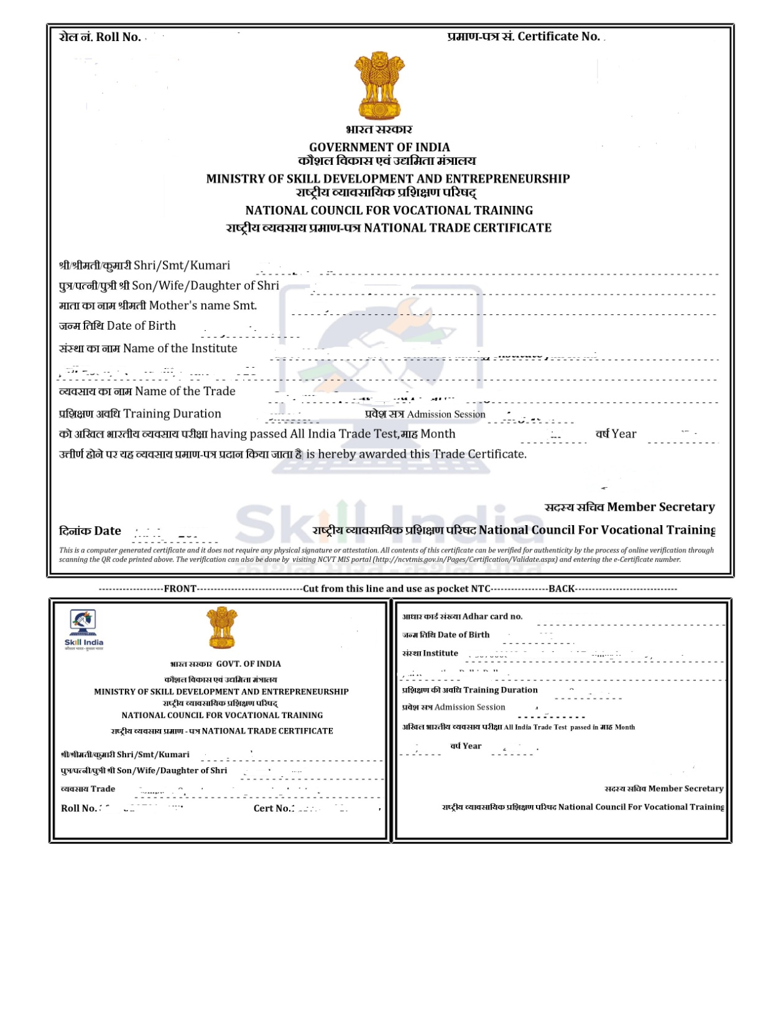
Two Year Engineering Trades

- TOOL & DIE MAKER (DIES & MOULDS) Tool and Die Makers build, repair and modify custom made prototypes or special tools, Dies, Moulds, Die casting Moulds and various types of mechanical devices. Dies and moulds are metal forms used for moulding plastics or other moulding material. Tool and Die Makers fabricate various parts, like pieces of a puzzle, which require perfect fitting. While this occupation is closely allied with the machinist trade and encompasses many of the same skills, Tool and Die Makers usually specialize in jobs spending more time in fitting and assembling precision components which are required for plastic injection moulds and die cast moulds. A Tool and Die maker’s work depends up on precise measurements and accuracy, as such math skills are important. Also, they must be able to read and interpret information from design drawings and specifications to fabricate all types of Dies and Moulds. Being mechanical minded is an additional skill. Plan and organize assigned work and detect & resolve issues during execution. Demonstrate possible solutions and agree tasks within the team. Communicate with required clarity and understand technical English, Sensitive to environment, self-learning and productivity

- TOOL & DIE MAKER (PRESS TOOLS, JIGS & FIXTURES) - & Die Maker (Press Tools, Jigs & Fixtures): Tool and Die Makers build, repair and modify custom made prototypes or special tools, Press Tools, Jigs, Fixtures and various types of mechanical devices. Press Tools are metal forms used for Sheet metal cutting and forming. Tool and Die Makers fabricate various parts, like pieces of a puzzle, which require perfect fitting. While this occupation is closely allied with the machinist trade and encompasses many of the same skills, Tool and Die Makers usually specialize in jobs spending more time in fitting and assembling precision components which are required for sheet metal cutting forms. A Tool and Die maker’s work depends on precise measurements and accuracy, as such math skills are important. Also, they must be able to read and interpret information from design drawings and specifications to fabricate all types of Press Tools Jigs and Fixtures. Being mechanical minded is an additional skill. Plan and organize assigned work; and detect and resolve issues during execution. Demonstrate possible solutions and agree tasks within the team. Communicate with required clarity and understand technical English, sensitive to environment, self-learning and productivity.

- DRAUGHTSMAN (CIVIL) - The course gives a wide knowledge on construction related manual and CAD drawings, Surveying, Materials, Concrete Technology, and Building Specialization in Construction. One can take gainful employment with construction Industry, Architectural firms / Designers / PWD etc.

- DRAUGHTSMAN (MECHANICAL) - Professional Knowledge subject is simultaneously taught in the same fashion to apply cognitive knowledge while executing task. In addition components like physical properties of engineering materials, interchangeability, method of expressing tolerance as per BIS Fits, different types of iron, properties and uses, special files, honing, metallurgical and metal working processes such as heat treatment, the various coatings used to protect metals, different bearing, working material with finished surface as aluminum, duralumin and stainless steel, topics related to non-ferrous metals, method of lubrication are also covered under theory part. At the end part of each semester, the trainees should express their skills by presenting project works. Total three projects need to be completed by the candidates in a group. In addition to above components the core skills components viz., workshop calculation & science, engineering drawing, employability skills are also covered. These core skills are essential skills which are necessary to perform the job in any given situation.

- ELECTRICIAN - Electrician General; installs, maintains and repairs electrical machinery equipment and fittings in factories, workshops power house, business and residential premises etc. Studies drawings and other specifications to determine electrical circuit, installation details etc. Positions and installs electrical motors, transformers, switchgears. Switchboards and other electrical equipment, fittings and lighting fixtures. Makes connections and solders terminals. Tests electrical installations and equipment and locates faults using mugger, test lamps etc. Repairs or replaces defective wiring, burnt out fuses and defective parts and keeps fittings and fixtures in working order. May do armature winding, draw wires and cables and do simple cable jointing. May operate, attend and maintain electrical motors, pumps etc. Electrical Fitter; fits and assembles electrical machinery and equipment such as motors, transformers, generators, switchgears, fans etc., Studies drawings and wiring diagrams of fittings, wiring and assemblies to be made.

- ELECTRONICS MECHANIC - Electronic Equipment Mechanic repairs electronic equipment, such as computers, industrial controls, transmitters, and tele-metering control systems following blueprints and manufacturer's specifications and using hand tools and test instruments. Tests faulty equipment and applies knowledge of functional operation of electronic units and systems to diagnose cause of malfunction. Tests electronic components and circuits to locate defects, using instruments, such as oscilloscopes, signal generators, ammeters and voltmeters. Replaces defective components and wiring and adjusts mechanical parts, using hand tools and soldering iron. Aligns, adjusts and calibrates testing instruments. Maintains records of repairs, calibrations and test.

- INFORMATION &COMMUNICATION TECHNOLOGY SYSTEM MAINTENANCE -The role of a Information & Communication Technology System Maintenance personnel is to support and maintain computer systems, desktops, and peripherals. This includes installing, diagnosing, repairing, maintaining, and upgrading all hardware and equipment while ensuring optimal workstation performance. The person will also troubleshoot problem areas in a timely and accurate fashion, and provide end user training and assistance where required. Install, maintain and setup network with computers, printers and other peripheral equipment as well as configure broadband equipment.

- INSTRUMENT MECHANIC - This course has been started with a view to train students in the vastly Emerging industries of India using new technologies like Petro-Chemical Engineering, Manufacturing Engineering, Aviation etc. To cope up with the modernization of Indian industry and quality control, the syllabus and objectives of teaching have been formulated to encompass the areas of computers, manufacturing engineering, robotics and industrial automation, which are now important areas of study. One takes employment with Govt. / Private Industries.

- MACHINIST GRINDER - Grinding experience will be in the field of “Tool” Grinding, Machinist (Grinder) setup and operates variety of machine tools, and fits and assembles parts to fabricate or repair machine tools and maintain industrial machines, applying knowledge of mechanics, shop mathematics, metal properties, layout, and machining procedures. The trainees, admitted after successful completion of their training, acquire the skills on various operations in different grinding machines Viz. Centre less grinder, Crankshaft Grinders, Internal & External Grinders, Tool & Cutter grinder apart from basic knowledge on machines. One can take Govt. / Private Employments.

- MECHANIC MOTOR VEHICLE - The course broadly covers the complete functioning, overhauling of Petrol & Diesel Engines of vehicles of all categories being fuelled by Petrol, Diesel & Gases The course has a good demand in the Automobile industry thereby giving advantage for either employment or self-employment.

- MECHANIC REFRIGERATION AND AIR CONDITIONER -The course gives an in-depth knowledge on Repair & Maintenance of Refrigerators, Centrally Air-conditioning system & Air-conditioners available in the market. On Successful completion, trainees can be absorbed in Railways, Govt. / Public Sector under takings apart from self-employment.

- FITTER - Fitter is a person who uses machine tools to make or modify parts, primarily metal parts, and a process known as machining. This is accomplished by using machine tools to cut away excess material such as a woodcarver cuts away excess wood to produce his work. The demand of fittings of various nature, Plumbing, Welding, Black smithy, Knowledge on various Lathes, drilling Machines, Sheet Metal Works etc. The fitter Workshops are equipped with modern and sophisticated Machineries, Equipment & Tools. The precision works are mainly handled by fitters in the Industries.

- MACHINIST - Machinists use machine tools, such as lathes, milling machines and grinders to produce precision metal parts. Although they may produce large quantities of one part, precision machinists often produce small batches or one-of-a-kind items. They use their knowledge of the working properties of metals and their skill with machine tools to plan and carry out the operations needed to make machined products that meet precise specifications. The parts that machinists make range from bolts to automobile pistons. Some machinists, often called production machinists, may produce large quantities of one part, especially parts requiring the use of complex operations and great precision. Many modern machine tools are computer numerically controlled (CNC) or CNC machines.

- PAINTER GENERAL - This trade broadly covers oil painting using spray gun and brushes, stenciling, Painting of walls-Layout process, Pigment, Process of pre-treatment of metal, surfaces, silk screen painting, Spray painting, color codes & identification of pipe lines as per international & Indian standard, Airless & electrostatic spraying, Rustburg electrostatic, blade coater, Method and application processes of car body finishing various types of systems of spray painting and Staving , methods of heat transfer, time temperature relation in a staving oven. The trainees in Painter (General) may work as painter, Automobile, Railways, Aircrafts and Medium, small industry or in government organizations.

- TURNER - The trainees admitted, after successful completion of their training acquire the skills on various operation in different Lathe machines and acquire the skills of Facing, Planning, Turning, Threading (Internal &External), Taper Turning etc. Apart from the conventional machines, they have exposure to acquire skills on CNC Machines, CAD & CAM.

- WIREMAN - Wireman, Light and Power installs various kinds of electrical wiring such as cleat, conduit, casing, concealed etc. in houses, factories, workshops and other establishments for light and power supply. Studies diagram and plan of wiring and marks light, power and other points accordingly. Fixes wooden pegs, sizes tubes, saws casings, etc. by common carpentry fitting and other processes, according to type of wiring needed. Erects switch boards and fixes switch box casings cleats, conduits ceiling roses, switches, meters etc. according to type and plan of wiring. Draws wire in two way or three-way wiring system as prescribed and makes electrical connections through plugs and switches to different points exercising great care for safety and avoiding short circuit and earthing at any stage of wiring. Fixes fuses and covers as per diagram and insulates all naked wires at diversions and junctions to eliminate chances of short circuit and earthing. Fits light brackets, holders, shades, tube and mercury lights, fans etc, and makes electrical connection as necessary. Tests checks installed wiring for leakage and continuity using megger, removes faults if any and certifies wiring as correct for connecting mains. Checks existing wiring for defects and restores current supply by replacing defective switches, plug sockets, blown fuse etc. or removing short circuits and faulty wiring as necessary. May repair simple electrical domestic appliances.

- TECHNICIAN MEDICAL ELECTRONICS - This course has been designated to provide an in depth knowledge of Digital Electronics, Communication equipment and various precisions medical & dental equipment’s viz. surgical diathermy, baby incubator, ventilator, pacemaker, ECG recorder. They also learn the operation of these electronics equipment and trouble shooting. After completion of training, one can take up job with the manufacturing and service industries of electronics equipment with advantages of being absorbed as biomedical technician by the medical equipment manufacturer.

- TECHNICIAN POWER ELECTRONICS SYSTEMS-The trade broadly covers the topics on different variety of This course is meant for the candidates who aspire to become a Technician to Maintain and Repair Power Electronic Equipment, trainee shall be able to handle different types of Electronic measuring Instruments, faults, computer hardware & networking, maintenance of SMPS, UPS, Inverter, solar power system and various analogue and digital circuits. Repair maintenance & installation of Electrical control of AC/DC machines. On successful completion of this course, the candidates shall be gain fully employed in leading industries or getting self-employed.

- MECHANIC CONSUMER ELECTRONIC APPLIANCES-This course is meant for the candidates who aspire to become a Technician to repair different Domestic and Consumer Appliances. The trainee shall be able to handle different types of Electronic measuring Instruments, faults, computer hardware & networking, maintenance of SMPS, UPS, Inverter, solar power system and various analogue and digital circuits. Installation & Repair maintenance of microcontroller based system, LED/ LCD TV, Cell phone (Mobile), Consumer electronics equipment’s like Washing Machine, Dish Washer, Mixer Grinder, water purifiers, Vacuum cleaner, Microwave oven, Immersion heater, Induction cook top, printers, home theatre system & CCTV etc. The candidates shall be gain fully employed in leading various industries like consumer/domestic electronics appliance & manufacturing industry or getting self-employed.

- INFORMATION TECHNOLOGY-Junior Software Developer; is one of the many entry level roles in the software industry including support and help desk, testing, user interaction design, maintenance, enhancement, development and documentation. Programming Assistant/Junior Software Engineer; installs, maintains and updates computer programs by making minor changes and adjustments to them under the guidance of computing professionals. Maintains and updates documents of computer programs and installations. Web Developer; is responsible for designing and maintaining web-based applications that include static and dynamic content. This includes the design, layout and coding of a website. They may work standalone or along with application/functional developers as part of the overall solution that includes a web based component. Media Developer-Application Development; is responsible for designing and improving the look and feel, functionality and graphics appeal of the developed application. They may work standalone or along with application/functional developers to improve the aesthetics of the application being developed. Data Communication Analyst/Network Administrator; researches, tests, evaluate, and recommends data communications hardware and software: Identifies areas of operation which need upgraded equipment, such as modems, fibre optic cables and telephone wires.

- SURVEYOR Topographical Surveyor, surveys land to determine out line, contours and relative position of control points (land marks) on tract of land, coast, harbor, etc. for preparing topographical and other maps and records. Establishes control points and pillars to do instrumentation work on ground to prepare maps. Provides identification marks on ground for photographs taken in aerial survey. Fixes position of control points on ground in relation to some permanent position and with reference to celestial bodies using the odolites and precise Ls, tachometer, digital plan meter etc. Adjusts and sets the odolites, compasses, plane tables, Ling instruments, Total station, GPS, DGPS and other modern instruments for survey, observes and records measurements and angles from three determined points (triangulation), locations to scale on proper sketch. Corrects margin of error due to worn-out tapes which become incorrect, and readings on instruments which are affected by environmental factors. Plan and organize assigned work and detect & resolve issues during execution in his own work area within defined limit. Demonstrate possible solutions and agree tasks within the team. Communicate with required clarity and understand technical English. Sensitive to environment, self-learning and productivity.

- ARCHITECTURAL DRAUGHTSMAN–Prepares drawings of buildings, parks, gardens, monuments etc. from sketches, designs or data for construction. Studies notes, sketches and other engineering data of buildings, parks, gardens, monuments etc. to be constructed. Draws sketches of required construction according to directions of architect to suit the purpose and environment; alters them if directed and gets them approved by him. Draws to scale drawings according to approved sketches showing plan, elevations, settings, arrangements etc. as necessary. May trace drawings and make blue prints. May prepare architectural designs, may prepare estimate of schedules for material and labour. May prepare model of construction work. May work as Draughtsman civil.

One Year Engineering Trades

- MECHANIC AUTO BODY REPAIR -Dent Remover/Auto Body Repair Technician/Denter Dent Remover; Panel Beater removes dents from sheet metal parts such as mudguards, body panels, tanks, containers, trunks by beating with mallets, smoothens surface for painting and other operations. Gets parts dismantled, examines dents caused by stress or accidents and starts beating from highest point on inner side with mallet to bring it back to original shape. Supports outer surface with soft metal-piece, wood or broader mallet to avoid distortion in reverse direction. Manipulates support and uniformly beats inner portion till damaged portion is reformed to original shape. May engage an assistant to hold support and guide him in manipulating it. May also scrape or lightly file outer surface to remove further defects, if any, for obtaining finer finish. Welder, Gas Welder, Gas fuses metal parts together using welding rod and oxygen acetylene flame. Examines parts to be welded, cleans portion to be joined, holds them together by some suitable device and if necessary makes narrow groove to direct flow of molten metal to strengthen joint. Gas Cutter; Flame Cutter cuts metal to required shape and size by gas flame either manually or by machine.

- MECHANIC AUTO BODY PAINTING- Painter, Spray/Painting Technician (Spray Painting) Painter Spray; Duco Painter applies decorative or protective materials such as paint, enamel or lacquer including synthetic paint on articles of wood, metal etc., using spray painting equipment. Selects and mixes paints to produce desired color consistency, strains and puts coating liquid into spray-gun tank, couples gun to air-hose and adjusts air pressure valves and nozzle. Presses trigger and directs spray of prime and finish coats of paint over surfaces and ensures smooth and even finish. Covers with tape areas not to be painted or where painting is to be done in second coloring. Cleans gun and hose with solvent before changing color and on completion of work. May prepare surfaces for painting, using scrapers, abrasives, chemical removers or other means. May be designated according to article coated or material used. Plan and organize assigned work and detect & resolve issues during execution in his own work area within defined limit. Demonstrate possible solutions and agree tasks within the team. Communicate with required clarity and understand technical English. Sensitive to environment, self-learning and productivity.

- CARPENTER- Carpenter, General makes, assembles, alters and repairs wooden structures and articles according to sample or drawing using hand or power tools or both. Studies drawing on sample to understand type of structure or article to be made and calculates quantity of timber required. Selects timber to suit requirements. Marks them to size using square, scriber etc. Saws, chisels and planes wooden pieces to required sizes and makes necessary joints such as half lap, Tenon mort ice, dove-tail etc. using saws, planes, mortising, chisels, drills and other carpentry hand or power tools as required. Checks parts frequently with square, foot rule, measuring tape etc. to ensure correctness. Assembles parts and secures them in position by screwing, nailing or doweling. Checks assembled structure with drawing or sample; rectifies defects, if any, and finishes it to required specifications. Alters, repairs or replaces components in case of old structures or articles in similar manner. May glue parts together. May smoothen and finish surface with sand paper and polish. May fix metal fittings to structure and polish. May fix metal fittings to structure or article made. May calculate cost of furniture. May sharpen his own tools.

- MECHANIC DIESEL-Diesel engine fundamentals and power generation. The trainees have to participate in hands-on work and begin repairing diesel engine vehicles. Mechanic, Diesel Engine; Oil Engine, Fitter repairs services and overhauls diesel or oil engines for efficient performance as prime mover to drive machinery and equipment. Examine engine to locate defects, using various tools and instruments. Dismantles or partly dismantles it to remove damaged or worn out parts and replaces or repairs them. Grinds valve and assembles parts, doing supplementary tooling and other functions as necessary to ensure accuracy of fit. Installs assembled or repaired engine in position and connects pulley or wheel to propulsion system. Starts engine, tunes it up and observes performance noting different meter readings such as temperature, fuel L, oil pressure, etc. and sets it to specified standard for optimum performance. Checks, adjusts and lubricates engine periodically and performs such other functions to keep engine in good working order. May solder or braze parts and service diesel fuel pumps and injectors. Additionally, since diesel engines are starting to incorporate electronic components, programs usually give students a chance to take courses in electrical systems and computer diagnostic software. Plan and organize assigned work and detect & resolve issues during execution in his own work area within defined limit. Demonstrate possible solutions and agree tasks within the team. Communicate with required clarity and understand technical English. Sensitive to environment, self-learning and productivity.

- INTERIOR DESIGN & DECORATION - Interior Designer Interior Designer planning designs, and furnishes interiors of residential, commercial, or industrial buildings. Interior designer to understand civil requirement & serve offer to do clean & functional environment Interior designer can design and estimate various types of residential & commercial interiors with color scheme. Makes sketches and diagrams or design keeping into consideration purpose, cost and preferences of client. Estimates material requirements and costs, and presents design to client for approval. Plans and designs interior environments also for boats, planes, buses, trains, and other enclosed spaces. Designers can used different interior software’s for making plan & designs. Decorator; Decorators coordinate the architect & civil engineer. Decorator is executing the concept of designing of interior designer. They have to know management, time line part, material part, consult the designer regarding the fabrication, design the aesthetic part. Furniture Designer Furniture Designer designs furniture line or individual pieces for manufacture according to knowledge of design trends. Studies market trends and customer needs and discusses design suggestions with production management and trade channels. Design & execute suitable furniture as per anthropometrics in different materials.

- PLUMBER - The trade broadly covers Basic Galvanized pipes Fitting, Cast iron pipes Fitting, PVC Pipe Fitting, SW Pipes Fitting, Water test, Pressure test, Smoke test, Ball test, Taps & Valves Fitting, Cutting / Threading / Bending / GI Pipes, Alkathene flanging / Jointing, Making service connections, Connecting house sewer to main, Fixing Sanitary Fixtures, Installing Water Pump, connecting supply pipe. Thus the trainees are prepared for employment with sanitary organizations, construction Industry and self-employment in both India & abroad.

- MECHANIC TWO & THREE WHEELER(FORMALLY MECHANIC MOTOR CYCLE): After successful completion of the above course, the trainee shall be able to perform the following skills with proper sequence. Repairs, services and overhauls motorcycles, auto rickshaws, scooters; etc., to keep them roadworthy. Examine motor cycle or scooter to locate faults by running engine in stationary position or by driving it on road. Dismantle parts such as engine, ignition system, dynamo forks, shock absorbers, gear box etc., as necessary. Grinds valves, sets timings, relines brakes, re-bushes steering mechanism, replaces worn out parts, assembles gear box clutch etc. Performs other tasks to affect repair, cleans and sets carburetor, fits driving chain, wheels silencer, kick, gear, clutch and brake levers and other accessories. Adjusts control cables for brake, clutch and accelerator, sets tappets and wheel alignment, tightens loose parts and makes necessary fittings and connections. Changes engine and gear box oil, starts engine and tunes it up. Tests performance of vehicle by driving on road and makes further adjustments to remove defects noticed if any. Assembles motor cycle or auto-rickshaws from previously dismantled parts. Auto Service Technician (two and three wheelers) is responsible for the repairing and routine servicing and maintenance (including electrical and mechanical aggregates) of two/three wheeler vehicles. Plan and organize assigned work and detect & resolve issues during execution in his own work area within defined limit. Demonstrate possible solutions and agree tasks within the team. Communicate with required clarity and understand technical English. Sensitive to environment, self-learning and productivity.

- WELDER - Welder while doing gas welding fuses metal parts together using welding rod and oxygen acetylene flame. Examines parts to be welded, cleans portion to be joined, holds them together by some suitable device and if necessary makes narrow groove to direct flow of molten metal to strengthen joint. Selects correct type and size of welding rod, nozzle etc. and tests welding, torch. Wears dark glasses and other protective devices while welding. Releases and regulates valves of oxygen and acetylene cylinders to control their flow into torch. Ignites torch and regulates flame gradually. Guides flame along joint and heat it to melting point, simultaneously melting welding rod and spreading molten metal along joint shape, size etc. and rectifies defects if any. Welder while doing Arc welding fuses metals using arc-welding power source and electrodes. Examines parts to be welded, cleans them and sets joints together with clamps or any other suitable device Welder, operates spot welding machine to joint metal sheet by resistance welding method. Feeds metal sheets to be welded according to type of machine and welds them by pressing paddle, or by automatic arrangements. Welder while doing gas cutting, cuts metal to require shape and size by gas flame either manually or by machine. Welder while doing gas brazing, joints metal parts by heating using flux and filler rods. Cleans and fastens parts to be joined face to face by wire brush. Welder while doing Gas Tungsten Arc welding also known as Tungsten Inert Gas (TIG) welding reads fabrication drawing, examines parts to be welded, cleans them and sets joints with clamps or any other suitable device

- MECHANIC AUTO ELECTRICAL & ELECTRONICS - A course which covers all Electrical/Electronic related works in an automobile which broadly covers basic miscellaneous electrical equipment’s& accessories of all type of vehicle Automobile, control system, power seats, power window system, heated windshield, electric door lock, lighting system, spark plug, ignition system cranking motor, alternator functioning system, sensor functioning, types of sensors, charging system, Alternator types, types of regulator, Alternator cooling, trouble diagnosis. The course has a good demand in the Automobile industry thereby giving advantage for either employment or self-employment.

One Year Non-Engineering Trades

- COMPUTER HARDWARE & NETWORK MAINTANANCE - Computer System Hardware Analyst/Hardware Engineer; analyses data processing requirements to plan data processing systems that provide system capabilities required for projected workloads and plans layout and installation of new system or modification of existing system. Confers with Data Processing and Project Managers to obtain information on limitations and capabilities of existing system and capabilities required for data processing projects and projected work load. Data Communication Analyst/Network Administrator; researches, tests, evaluates, and recommends data communications hardware and software: Identifies areas of operation which need upgraded equipment, such as modems, fiber optic cables and telephone wires. Conducts survey to determine user needs. Reads technical manuals and brochures to determine equipment which meets establishment requirements.

- COMMERCIAL ART(SCVT DESIGNATED TRADE) - The course aims at developing creative abilities, artistic skills and understanding of human psychology in respect of preparation of advertising designs and broadly covers basic design, letter inland typography, press layout, illustration, sketching, poster design and study of life, nature and objects. The trainees in Commercial Art can work as commercial artists/ visualizes in advertising agencies or in government organizations, as an Artist with a publishing/newspaper house and also as Art and Craft Teacher in teaching institutes. They can also work as Graphic Designer in TV and film industry and as an Artist in the computer field.

- COMPUTER OPERATOR & PROGRAMMING ASSISTANT (COPA) - Computer Operator operates computer and peripheral equipment to process business, scientific, engineering, or other data, according to operating instructions. Enters commands, using keyboard of computer terminal, and presses buttons and flips switches on computer and peripheral equipment, such as tape drive, printer, data communications equipment, and plotter, to integrate and operate equipment, following operating instructions and schedule. Loads peripheral equipment with selected materials, such as tapes and printer paper for operating runs, or oversees loading of peripheral equipment by Peripheral Equipment Operators. Enters commands to clear computer system and start operation, using keyboard of computer terminal. Observes peripheral equipment and error messages displayed on monitor of terminal to detect faulty output or machine stoppage. Enters commands to correct error or stoppage and resume operations. Notifies supervisor of errors or equipment stoppage. Clears equipment at end of operating run and reviews schedule to determine next assignment. Records problems which occurred, such as down time, and actions taken. May answer telephone calls to assist computer users encountering problem. May assist workers in classifying, cataloguing, and maintaining tapes. Programming Assistant installs, maintains and updates computer programs by making minor changes and adjustments to them under the guidance of computing professionals. Maintains and updates documents of computer programs and installations. Applies knowledge of principles and practices in the area of programming and computing in order to identify and solve problems arising in the course of their work. They may receive guidance from managers or professionals. May supervise other workers also.

- FOOD PRODUCTION (GENERAL) - Cook, Institutional; prepares, seasons and cooks soups, meats, vegetables, desserts and other foodstuff for consumption in hotels, restaurants and other establishments. Fries, boils, broils, roasts or steams vegetables, meats, fish and other food to prepare dishes listed on menu and prepare salads, sandwiches, cakes, fruit juices and other cold foods. Supervises dish washing and preparing of vegetables and other foodstuff for cooking. May specialize in preparing a particular cuisine such as Indian/Chinese/Continental or specialize in Garde manger/bakery and be designated accordingly. Cook, Domestic; prepares and cooks meals in private households. Plans menu according to own judgment or employer’s instructions and prepares soup, salad, breads, lentil, vegetables and meats. Cook, Ship Cook, Ship on board ship. Plans menu taking account of foods in season and local availability. Cooks, Other; prepare special food or dishes in private households or public eating places and include cooks not elsewhere classified, such as SWEET MASTER plans and prepares general and special sweet dishes, in hotels, restaurants and other such establishments. DIET COOK prepares special diets for people under medical restriction. TEA AND COFFEE MAKER brews and prepares beverages like coffee and tea in hotels, clubs or similar establishments and ensures proper cleanliness of stall.

- SEWING TECHNOLOGY - This course is meant for the candidates who aspire to become Sewing Machine operator, Assistant to Designer, Assistant worker in Boutique, Assistant to Sample Garment Designer and Assistant to Garment Sample Coordinator.

- DESKTOP PUBLISHING OPERATOR - Desktop Publishing Operator lays out pages, selects size and style of type, and enters text and graphics into computer to produce printed materials, such as advertisements, brochures, newsletters, and forms, applying knowledge of graphic art techniques and typesetting and using computer: Reviews layout and customer order. Enters text into computer, using input device such as mouse, keyboard, scanner, or modem. Scans artwork, using optical scanner which changes image into computer-readable form. Enters commands to position text and illustrations on page grid of computer monitor. Creates spaces between letters, columns, and lines, applying knowledge of typesetting, and enters commands, using input device. Arranges page according to aesthetic standards, layout specifications of Graphic Designer, and applying knowledge of layout and computer software. Prints paper or film copies of completed material. May alter illustration to enlarge, reduce, or clarify image. May operate automatic film developer to process photographs. May assemble artwork into paste-up and perform key lining manually.

- DIGITAL PHOTOGRAPHER - Digital Photographer takes photograph of persons, places, or other subjects, using various kinds of photographic equipment. Measures day light using exposing meter or arranges artificial lighting and holds or places camera at desired angle and distance from subject to be photographed. Focuses lens and adjusts lens opening and exposure time. Loads camera with film or plate. Presses lever to open lens shutter and exposes film or plate by pressing lever, allowing time, if for publication. Supplies series of pictures on selected topics, for writing feature articles in magazines. May develop films and print copies. Photographers and Image and Sound Recording Equipment Operators, Other take photographs of persons, places and objects and record sound for different purposes and include Photographers, Image and Sound Recording Equipment Operators not elsewhere classified. Photographer News; or Press Photographer photographs news events, persons or objects for use in news-papers, magazines and other publications. Photographer, Aerial; photographs objects, places and areas of vital importance from aeroplanes in flight, for use in surveys, planning, development and other scientific and military purposes. Digital photographical institutions; it will provide the familiarization with the institution, its importance of trade training & professional use of Digital camera into different types of uses into variety of interests of the Govt. and public sectors.

- FASHION DESIGN & TECHNOLOGY - Designer; Pattern Maker (Garments) develops, designs and makes pattern for new styles of men's, women's and children's garments. Studies existing styles, develops new ideas and draws out full scale drawing of garments on paper. Marks and cuts out paper patterns of different parts of garments. Gets cloth cut according to paper patterns and gets sample garment stitched as required. Tries garment on model and makes changes in pattern, if necessary. May make specifications and supervise production.

- HEALTH SANITARY INSPECTOR - Sanitary Inspector; Health Assistant takes measures to maintain and improve standard of public health in the specified area. Inspects houses, shops, factories, entertainment places, bazars, drains, night soil depots, rubbish depots, latrines, burial and cremation ground, etc., and undertakes public health activities such as disinfections, anti-malarial and anti-epidemic measures. Inspects hotels, restaurants, etc. to ensure that food and edibles sold are fit for public consumption. Attends to complaints regarding sanitation. Reports outbreak of infectious diseases to authorities and takes preventive measures. Attends courts for prosecution of individuals violating sanitation and public health regulations and performs inoculation work. Controls and supervises work of Sanitary Darogas. May maintain accounts and correspondence compile figures of births and deaths in his jurisdiction and may investigate causes of death. May be designated as Disinfecting Inspector, Food Inspector, Slaughter House Inspector, Mosquito Inspector, etc. according to nature of work performed.

- BASIC COSMETOLOGY-A Cosmetologist job role provides various types of beauty services, aware of the Beauty therapy, Health and hygiene, Safety & needs to be knowledgeable about beauty products. They must able to perform Basic Epilation, Manicure, Pedicure, Facial Treatments, Haircuts, Hair Styles, Hair Coloring, Straightening, Rebinding & Hair treatments. They are also able to demonstrate different types of makeup & basic corrective makeup. A cosmetologist must be able to perform and demonstrate Yogasana& Meditation in order to remain fit & active for long working hours as they have to work under pressure, be polite & patient. & recommend the asana to clients having common ailments. Demonstrate the operation of Beauty & Hair Equipment.

- DRESS MAKING -This Trade broadly covers knowledge on stitching garments of male, Female & children both Indian & Western designs. Dress Maker stitches together parts of garments such as dresses, blouses, jumpers, brassieres, pant, coat, shirts etc., according to instructions of Master Cutter. Stitches together parts by hand and machine. Inserts inner material, makes embroidery work, button-holes, etc., and attaches lining, lace, button, etc. Carries out alteration as directed. May press garments and supervise work of Sewer, Hand.

- STENOGRAPHY & SECRETARIAL ASSISTANT (ENGLISH/HINDI) - Trade involves taking dictation in shorthand and reproduces it on paper using computer and performs various other clerical duties to assist superiors. Maintain a good mannerism and professional approach with the boss.

- SECRETARIAL PRACTICE (ENGLISH): Perform routine clerical and administrative functions such as drafting correspondence, scheduling appointments, organizing and maintaining paper and electronic files, or providing information to callers.

- FOOD AND BEVERAGES SERVICE ASSISTANT: Steward, Hotel; supervises work of Dining Room Waiters Pantry Man and Room Service Waiter and ensures that guests are served promptly and courteously in dining room. Receives customers in dining hall and escorts them to tables and obtains orders from customers and ensures that food is served promptly by Waiters. Visits rooms, halls and other areas to ensure that they are kept clean and tidy. Ensures that glass, china and silver wares are in good order. Prepares dining halls for banquets and special occasions by decorating them with flower vases and arranging tables and chairs in pleasing fashions. Keeps record of any breakage of crockery or loss of cutlery. May keep kitchen equipment, crockery, cutlery etc., under his charge and issue them as needed. May purchase food supplies and kitchen equipment and check them for quality and quantity. May supervise storage and issue of supplies Waiter, Institutional/Food and Beverage Service-Steward: Bearer (Institutional) serves food, snacks, beverages to customers, guests in hotels, bars, and restaurants. Prepares table with clean linen, condiments containers, glasses, menu-card and obtains orders from customers Collects food, beverages, snacks etc., from kitchen according to customers' orders from Pantry Man and serves them. Waits on customers periodically for additional requirements, of food etc Removes used plates, cups, saucers from table and presents bill to customers and collects cash and hands it to Cashier. Is designated as WAITER (dining room) if employed in serving food in dining rooms and LOUNGE WAITER if engaged for serving beverages and snacks in lounge.

- TEXTILE DESIGNING (SCVT DESIGNATED TRADE) -The trade broadly covers the topics on different variety of fabrics and their structures, design, bleaching, dying, block printing, screen making & printing, traditional Indian designs and basic design of weaving etc. On successful completion, the trainees can be absorbed with leading garment manufactures, textile designers etc. in both India & abroad.

- SURFACE ORNAMENTATION TECHNIQUES (EMBROIDERY):This course is meant for the candidates who aspire to become Tracing experts, Hand Embroider, Zig-Zag Machine Operator, Aari Embroider, Motif Maker, Entrepreneur& Design Coordinate to Fashion Designer.

PROVISION OF LATERAL ENTRY SCHEME FOR ADMISSION IN DELHI POLYTECHNICS AND B.VOC
LATERAL ENTRY SCHEME: According to the AICTE, provision of lateral entry in Institute of Technology (Formally known as Polytechnics) exists only for those Engineering Trades of ITI that have entry qualification of class 10th and are of two years (4 Sem.) duration. However, ITI pass outs of trades for which the entry L qualification for admission to ITI is 8th pass or the duration of ITI trade is less than Two Year shall not be considered for lateral entry.

As per guidelines of CET-2018 for admissions in Institute of Technology (Formally known as Polytechnics), the lateral entry of candidates passing out from Industrial Training Institutions located in Delhi & affiliated to NCVT / SCVT is available. These trainees will be eligible for admission in Second Year (Third Semester) of Full-Time Diploma Engineering courses in analogous disciplines against 10% supernumerary seats earmarked for them subject to regulations or guidelines issued by the AICTE or the Government of NCT of Delhi.

Eligibility for Lateral Entry to 2nd Year Diploma: 12th Science with Vocational / Technical or
10th + (2 year ITI) with appropriate specialization.
Candidates passing 12th Science or 12th Science with Vocational or 12th Science with Technical or
10th + (2 year ITI) with appropriate specialization in that order shall be eligible for admission to second year (Third Semester) Diploma courses of appropriate disciplines.

ITI Trades which are eligible for Lateral entry admission in Analogous Diploma Course’s as per CET Delhi 2019.
TRADE | ANALOGOUS DIPLOMA COURSES
Mechanic Motor Vehicle | Automobile Engineering
Electrician, Instrument Mechanic, Refrigeration & Air-conditioning Mechanic | Electrical Engineering
Surveyor, Draughtsman (Civil) | Civil Engineering, Civil Engineering (Construction Technology), Architectural Assistantship, Civil Engineering (PHEE)
Instrument Mechanic, Mechanic Medical Electronics, Information Technology & Electronic Maintenance System, Electronics Mechanic. | Electronics & Communication Engineering. Electronics Engineering. (Digital Electronics), Electronics Engineering (Medical Electronics)
Instrument Mechanic, Ref. & Air-conditioning Mechanic, Draughtsman (Mechanical), Tool and die maker (Press Tools Jigs and Fixtures), Tool & Die Maker (Die &Moulds), Turner, Fitter, Machinist and Machinist Grinder. | Mechanical Engineering, Mechanical Engineering (Maintenance Engineering), Production Engineering.
Tool & Die Maker (Press Tools Jigs & Fixtures) Tool & Die Maker (Die &Moulds) | Tool & Die Making

Bachelor of Vocation (B.Voc): ITI passed out trainees are also eligible for direct admission in Bachelor of Vocation (B.Voc) in their relevant discipline course conducted by Guru Govind Singh Indraprastha University (IPU). For eligibility candidates may refer to IPU website.

Admission for Academic Courses under NIOS –ITI Scheme )

Trainees who are pursuing ITI (regular course of two years Craftsmen Training Scheme (CTS)) under NCVT, or has passed ITI two years Course earlier can undertake NIOS-ITI Education course for completing Secondary or Senior Secondary qualification.

The learners who have already completed or pursuing two years NSQF compliant courses from any ITI under CTS of NCVT would be eligible for admission with NIOS for secondary or senior secondary certification.

NIOS will accept credit transfer of up to three core subjects successfully completed by a trainee in any of the regular courses under 2 years of Craftsmen Training Scheme (CTS) of NCVT pursued in an ITI and will offer two or more courses in the following groups to complete the requirement for Secondary/Senior Secondary Certification.
- One language subject of NIOS
- Any one of the other academic subjects offered by NIOS

Eligibility Criteria for 10th and 12th under ITI Scheme

a) For Secondary (10th ) Admission: The learners joining/completed the two year course in ITI under CTS of NCVT after class VIII would be eligible to enroll simultaneously with NIOS for secondary course with one language and one academic subject being offered by NIOS.

b) For Senior Secondary (12th ): Admission The learners joining/completed the two year course in ITI under CTS of NCVT after class X would be eligible to enroll simultaneously with NIOS for secondary course with one language and one academic subject being offered by NIOS.

*The above information is derived from prospectus of NIOS is only for reference and the candidate is requested to confirm the same from NIOS for further information/changes/modifications if any. (https://nios.ac.in/media/documents/ProspectusforITILearners.pdf)

List of Recognized Boards of Secondary Education

ITI Delhi follows NIOS recognized boards for admission purpose. Valid boards for admission in ITI Delhi are as follows. In case of any clarification or if candidates qualifying board is not featuring in below mentioned lists then he/she may contact help desk at any government ITI OR email CAO atcaohelpline@gmail.com.

STATE: ANDHRA PRADESH
1. Andhra Pradesh Board of Intermediate Education, Hyderabad
2. Andhra Pradesh Board of Secondary Education, Hyderabad
3. Andhra Pradesh Open School Society, SCERT Campus, Hyderabad

STATE: ASSAM
1. Assam Higher Secondary Education Council, Bamunimaidan, Guwahati
2. Assam Board of Secondary Education, Guwahati
3. Assam Higher Secondary Education Council, Assam State Open School Bamunimaidan, Guwahati

STATE: BIHAR
1. Bihar Intermediate Education Council, Patna
2. Bihar School Examination Board, Patna
3. Bihar Sanskrit Shiksha Board, Patna
4. Bihar Board of Open Schooling & Examination, Patna

STATE: CHHATISGARH
1. Chhattisgarh Board of Secondary Education, Raipur
2. Chhattisgarh Board of Secondary Education & State Open School, Raipur
3. Chhattisgarh Madarsa Board, Chhattisgarh

STATE: DELHI/ ALL INDIA BOARDS
1. National Institute of Open Schooling (formerly National Open School), New Delhi
2. Central Board of Secondary Education, Delhi
3. Council for Indian School Certificate Examinations, New Delhi
4. Rashtriya Sanskrit Sansthan, New Delhi.
5. Directorate of Army Education, New Delhi.
6. Jamia Millia Islamia, New Delhi.
7. Jamia Millia Hamdard University. New Delhi

STATE:GOA
1. Goa Board of Secondary & Higher Secondary Education, Goa

STATE: GUJARAT
1. Gujarat Secondary & Higher Secondary Education Board, Gandhi Nagar
2. Gujarat State Open School, Gandhi Nagar, Gujarat

STATE: HARYANA
1. Haryana Board of Education, Hansi Road, Bhiwani
2. Haryana Open School, Bhiwani

STATE: HIMACHAL PRADESH
1. Himachal Pradesh Board of School Education, Dharamshala
2. Himachal Pradesh State Open School, Dharamsala, Kangra

STATE: JAMMU & KASHMIR
1. J&K State Board of School Education, Jammu
2. J&K State Open School, Srinagar
STATE: JHARKHAND
1. Jharkhand Academic Council, Ranchi
STATE: KARNATAKA
1. Karnataka Board of the Pre-University Education, Bangalore
2. Karnataka Secondary Education Examination Board, Bangalore
3. Karnataka Open School, J.S.S. Maha VidyaPeeth, Mysore

STATE:KERALA
1. Kerala Board of Public Examinations, Pareeksha Bhawan, Thiruvananthpuram
2. Kerala Board of Higher Secondary Education,Thiruvananthapuram
3. Kerala State Open School, Thiruvananthapuram

STATE: MAHARASHTRA
1. Maharashtra State Board of Secondary and Higher Secondary Education, Pune

STATE: MADHYA PRADESH
1. Madhya Pradesh Board of Secondary Education, Bhopal
2. M.P. State Open School, Bhopal
3. Madhya Pradesh Madarsa Board, Madhya Pradesh

STATE: MANIPUR
1. Manipur Council of Higher Secondary Education, Imphal
2. Manipur Board of Secondary Education, Imphal

STATE: MEGHALAYA
1. Meghalaya Board of School Education, Meghalaya

STATE:MIZORAM
1. Mizoram Board of School Education Chaltlan, Aizawl

STATE: NAGALAND
1. Nagaland Board of School Education, Kohima

STATE: ODISHA
1. Odisha Council of Higher Secondary Education Bhubaneswar
2. Odisha Board of Secondary Education, Cuttack

STATE: PUNJAB
1. Punjab School Education Board, Mohali

STATE: RAJASTHAN
1. Rajasthan Board of Secondary Education, Ajmer
2. Rajasthan State Open School, Jaipur
3. Banasthali Vidyapith, Banasthali, Rajasthan

STATE: TAMIL NADU
1. Tamil Nadu Board of Secondary Education, Chennai
2. Tamil Nadu Board of Higher Secondary Education, Chennai
3. Tamil Nadu State Open School, Chennai
STATE: TRIPURA
1. Tripura Board of Secondary Education, Agartala, Tripura West

STATE: UTTAR PRADESH
1. U.P. Board of High School & Intermediate Education, Allahabad
2. Board of Madrasa Education, Uttar Pradesh
3. Aligarh Muslim University, Aligarh.
4. Sampurnanand Sanskrit Vishwavidyalaya, Varanasi (Poorva Madhyama Examination)

STATE: UTTARAKHAND
1. Uttarakhand Vidhyaleye Shiksha Parishad (UBSE), Ramnagar, Nanital.
2. Gurukul Kangri Vishwavidyalaya, Haridwar.

STATE: WEST BENGAL
1. West Bengal Board of Secondary Education, Calcutta
2. West Bengal Council of Higher Secondary Education, Calcutta
3. West Bengal Council for Rabindra Open Schooling
4. West Bengal Board of Madrasa Education

OTHER INSTITUTES RECOGNISED
1. IGCSE Programme from University of Cambridge (International Exam) five passes with grade A, B, C, D & E.
2. International Baccalaureate - Asia Pacific
3. Edexel Board

Any recognized Board of foreign countries
For learners who possess a High School/Secondary Certificate from any Foreign Board/University are required to attach a certificate from Association of Indian Universities (AIU) to the effect that the examination passed is equivalent to the Secondary Examination.
Other boards/universities may be added to this list once we get to know of them.

ACHIEVMENTS OF DEPARTMENT

Department of Training & Technical Education has entered into Industrial collabrations with the following organizatios/ instititutions/ Companies :
- DAIKIN AIR-CONDITIONING INDIA PVT. LIMITED (DAIPL): To impart training to the students of RAC trade. DAIPL is organizing Training of Trainers programme to the teachers.

- MARUTI SUZUKI INDIA LIMITED (MSIL):- MSIL has upgraded ITI Pusa and ITI Mangolpuri under PPP through IMC and provided tools equipment and machineries to the Institute. MSIL is organizing Training of Trainers programme to the teachers and training for students as well. They have also signed a MOU with DTTE for implementation of DST in Fitter and Machinist trades at ITI Pusa.

- SAMSUNG INDIA ELECTRONICS PVT. LTD: - Samsung will run Advanced Repair and Skill Enhancement Training Programme for students of ITI at ITI Dheerpur.

- SIEMENS LIMITED: To spread the benefits of skill up-gradation, Skill development, Instructors Training and consistently services to bridge the gaps across the skilled man powers for industries.

- UNDP: Actively promote the participation of women in the labour force through apprenticeship programme, skill training, Employment and self employment.
- TATA STRIVE & SIEMENS LTD. : To provide dual system training in the electrical sector in all Government ITIs & to provide traiing on entreprenurship skills. Also help for placement of students.
- TATA MOTORS:- TATA Motors has upgraded ITIs under PPP through IMC and provided tools equipment and machineries to the Institute ITI Jahangir puri and ITI Nand Nagri.

- SHEELA FOAM: Sheela Foam is associated with Jijabai ITI For Women Siri Fort under PPP.

- JJ IMPEX & MARUTI SUZUKI INDIA LIMITED:-A tripartite MoU was signed for ITI Arab Ki Sarai, GNCTD to provide advanced training facilities for the trainees of Automobile trade.

- JJ IMPEX, AXALTA PAINTS & MARUTI SUZUKI INDIA LIMITED: - A quadripartite MoU was signed for ITI Arab Ki Sarai, GNCTD to provide advanced training facilities for the trainees of auto body paint and auto body repair trade.

- ORIENTAL INSURANCE CO. LIMITED: - Equipped a modern lab for the trainees of electronics trade at ITI Pusa.

- HYUNDAI MOTORS INDIA LIMITED:- MoU has been signed for ITI Jail Road and Pusa Institute of technology for providing infrastructural and technological support to establish a lab and on job training for the trainees of automobile trade.

- HOTEL CROWNE PLAZA:-MoU was signed for providing expertise to set up the labs and to provide on job training to the trainees of hospitality trade at ITI Mangol Puri.

- JAQUAR FOUNDATION: -MoU was signed to upgraded facilities in the Plumbing field at ITI Narela & Jahangir Puri through active participation of the industry.

- TATA POWER DDL: MoU was signed for providing expertise to set up the labs and to provide on job training to the trainees of Electrician & Electronics trade at ITI DheerPur.

- TOYOTA KIRLOSKER: MoU was signed for providing expertise to set up the labs and to provide on job training to the trainees of Automobile trade at ITI DheerPur.

- VOLTAS LIMITED: MoU was signed for providing expertise to set up the labs and to provide on job training to the trainees of Ref. & A/c trade at ITI DheerPur.

- CISCO SYSTEM: MoU was signed for providing expertise to set up the labs and to provide on job training to the trainees of COPA & Information Tech./ CHN trade at ITI DheerPur.

- SCIENTECH: MoU was signed for providing expertise to set up the labs and to provide on job training to the trainees of Electronics & Instrumentation trade at ITI DheerPur..

- MAHINDRA & MAHINDRA: MoU was signed for providing expertise to set up the labs and to provide on job training to the trainees of Automobile trade at ITI MayurVihar.

- M/S SPARK MINDA GROUP, GREATER NOIDA, GAUTAM BUDH NAGAR, UTTAR Pradesh is providing training to trainees of ITI AKS for Trade Tool and Die Maker (Press tools jigs and fixtures) under DST.

- Honda Motorcycles and Scooters India Pvt Ltd (HMSI): A MOU was signed between DTTE and HMSI to impart training to ITI students of ITI Nand Nagri and ITI Jaffarpur.

- Havells India Limited: MoU was signed for providing expertise to set up the labs and to provide on job training to the trainees of Electrician Trade at ITI Pusa.

- LG Electronics Inc: - is providing training to trainees of ITI PUSA for Trade Electronics Mechanic and Mechanic Ref. & Air-conditioning Trades.

- Times of India (Teach India):- has taken initiative of improvement of Spoken English and soft skill of trainees in various institute of Delhi.

- Hero MotoCorp Limited: - -A MoU was signed for ITI Arab Ki Sarai, GNCTD to provide advanced training facilities for the trainees of two wheeler trades.

- M/s Maruti Suzuki India Ltd (MSIL)& M/s. Rana Motors (Under Proposal) - This MOU will create state of the art training facilities for the trainees of Mechanic Auto Electrician & Electronics trade meant to prepare workforce for Hybrid & Electric Vehicles which are proposed to be launched by M/s MSIL in near future.

- TVS Motors ltd:-A MoU was signed for ITI Jail Road, GNCTD to provide advanced training facilities for the trainees of two wheeler trades.

- Hotel Crown plaza Okhla:-A MOU was signed between DTTE and Hotel Crown Plaza Okhla to impart training to ITI students of ITI Jail Road for trainees of Trade Food Production and Food & Beverages Service Assistant.

NOTE: the candidate may contact respective ITI for updated details regarding association with industries.
ANNEXURE – I
FORM OF MEDICAL CERTIFICATE

(To be signed by Registered Medical Practitioner)

(TO BE SUBMITTED AT THE TIME OF ADMISSION)

I certify that I have carefully examined Sh./Smt./Km. ………….………….………………………...
Son/daughter/Wife of Shri ………………………………………………………………….... whose signature is given below. As a result of his/her examination I certify that nothing adverse has been found which may disqualify him/her from admission to a technical institution under the Government of Delhi. I have to further add that:

- His/her eyes appear to be ……………………………………
- His/her heart & lungs are clear ……………………………..
- His/her weight is ……………………………….
- His/her height is ……………………………….
- He/she does not wear glass/wear glass with vision. …………………
- He/she has not have any disease, mental and bodily infirmity, which will make him/her, unfit in the near future for an active life and training.

Mark of identification …………………………….
Signature of the candidate …………………………

………..…………………………………

Name & Signature of the
Medical Officer with seal
& Registration no……………….

ANNEXURE – II
CHARACTER CERTIFICATE

(To be submitted at the Time of Admission)

Certified that I know Mr./Ms./…………………………………………………………... Son/daughter of Shri…..……………………………………………………………………………………………………………. Resident of ……………………………………………………………………………. from the last ……….…….………….years ……………….months. He/she bears a good moral character and is of ………………….nationality. He/ She is not related to me.

Place:
Signature
Date :
___________________________
Name (in Capital Letters)

Designation & Address with Stamp

This certificate should be from any one of the following:

  - Principal/Head Master of the recognized School/ College/ Institution where the candidate studied last;
  - Gazette Officer of Central or State Government;
  - Members of Parliament or State Legislature belonging to the constituency where the candidate or his parent/ guardian is ordinarily resident;
  - Sub-Divisional Magistrates/ Officers;
  - Tehsildars or Naib/ Deputy Tehsildars authorized to exercise magisterial powers;
  - Block Development Officer;
  - Self-attested certificate by the candidate is also valid.

ANNEXURE – III
PROHIBITION OF RAGGING
(Self declaration to be submitted at the time of admission)

I,_____________________son / daughter of Sh. ___________________resident of _________________________________________ hereby declare that I am aware of the law regarding prohibition of ragging as well as the punishments, and that, if found guilty of the offence of ragging and/or abetting ragging, I am liable to be punished appropriately

Place: Signature of the Candidate
Date: Name of the candidate:

I, ___________________________Father/Guardian of Mr. /Ms._____________________ resident of ______________________________________________________________hereby declare that I am aware of the law regarding prohibition of ragging and I agree to abide by the punishment meted out to my ward in case the latter is found guilty of ragging.

Signature of Parent/Guardian Name of Parent/Guardian

ANNEXURE – IV
UNDERTAKING
(To be submitted at the Time of Admission)
- I am liable to be struck off from the roll of Institution without notice in case I remain absent for 10 consecutive days without information / sanction of leave, unsatisfactory progress in the training, short of attendance below 50 %, failing in the aptitude test, Committing breach of discipline in the Institution.
- I shall get two sets of prescribed uniform stitched within seven days from the day of reporting at admitted institute positively and shall wear the same daily right from my residence & till reaching back to the residence.
- I shall have no objection in attending Institution as per the existing or changed timing by the institute as per shift timing.
- I shall maintain at least 80% attendance in each subject for making me eligible for appearing in the each examination.
- In case the trade in which I have got admission is not affiliated with National Council of Vocational Training or de-affiliated by National Council of Vocational Training, DGT, Ministry of Labor at any stage/reason, I have no objection to appear in the examination conducted and certified by State Council of Vocational Training.
- I have no objection if I will be transferred to any other Institute due to any administrative reason whatsoever.
- I will not carry/use mobile phone in the ITI campus.
- I hereby declare that I am aware of the law regarding prohibition of ragging as well as the punishments, and that, if found guilty of the offence of ragging and/or abetting ragging, I am liable to be punished as per guideline issued by the Honorable Supreme Court of India .
- I will attend the Industrial visit / On-Job Training during the training period at various Industries at my own risk. In case of any accident, mis-happening or riots, I/We will not hold the Institute/Industry responsible for the same.
In case, I/We fail to abide myself as stated above, the Principal/Head of the Institute is empowered to take disciplinary action against me as per rules.
Yours faithfully
………………………………………….. ………………………………………………..
(Full Signature of Parent/Guardian) (Full Signature)

Name:……………………..………………………(Block Letters) Name:……………………………………………(Block Letters)

Relation …………………………………….. Trade ……………..………………………………. Roll No. ………..……………

ANNEXURE – V
CERTIFICATEFOR AVAILING ADMISSIONAGAINST J&KMIGRANT QUOTA

(To be submitted at the Time of Verification/Admission)

Certified that Shri/Km/Smt. ……………………………………………………………… Son/Daughter/Wife of Shri/Smt…………………………………………… Resident of ……………………………………………………………is registered as migrant from Jammu & Kashmir having Registration number …………………………………………dated……………………………………
It is also certified that Shri/Km/Smt………………………………………………………………………..……………
is registered in Delhi as J&K Migrant ……………………………………………………………..………………………………………

Name & Signature of Deputy Commissioner/
Competent Authority(Office Stamp)

PLACE:
DATE:

ANNEXURE-VI
CERTIFICATE FOR AVAILING ADMISSION AGAINSTDIVYANG /
PERSON WITH DISABILITIES QUOTA (FROM National Career Service)

(TO BE SUBMITTED AT THE TIME OF VERIFICATION/ADMISSION)

PHOTOGRAPH
OF
CANDIDATE

This is to certify that I have examined Mr/Ms…………………………………………………………… Son/Daughter/Wife of Shri.…………………………………………………………………………………….is Person with Disabilities due to …………………………………………………………………………… and the percentage of disorder is …………………………………….……………..He/she is fit for undergoing all these Trade(s) ………………………………………………………………………………………………………….only, at Industrial Training Institutes of Delhi without any special concessions and exemptions.

Signature of the Candidate

Name& Signature of the Officer In-charge,
National Career Services,
9-11 Vikas Marg,
Karkardooma, Delhi–110092

ANNEXURE-VII
CERTIFICATE FOR AVAILINGADMISSIONAGAINSTDEFENCE QUOTA OFFICE OF THE ZILA/RAJYASAINIKBOARD

This is to certify that Sh/Ms.………………………………………………………………………Son/daughter of Shri.………………………resident of……….……………………………………………… the above named officer/ JCO/ OR pertains to the category marked below:-(Select one from below)
- Killed in Action on……………………………………………………....………during ……………………………….

- Wards of serving personnel & ex-servicemen disabled in action and boarded out from service ……………………………..during……………………….

- Widows/wards of defense personnel who died in peacetime with death attributable to military service.

- Wards of disabled in services and boarded out with disability attributable to military service…………………………

- Wards of ex-servicemen and serving personnel who are in receipt of Gallantry Awards (……………………………………………)

- Wards of ex-servicemen.

- Wives of:
  - Defense personnel disabled in action and boarded out from services.
  - Defense personnel disabled in services and boarded out with disability attributable to military services.
  - Ex-servicemen and serving personnel who are in receipt of gallantry awards.

- Wards of serving personnel.
- Wives of serving personnel.
Category above)

His/her Ex-Serviceman/Widow Identity Card No. is……………………………………………….

NO. …………………………………/RSB SECRETARY
(Round stamp of Office) (Zila/Rajya Sainik Board)

ANNEXURE -VIII
CERTIFICATE OF 8th CLASS MARK-SHEET

(Must be submitted at the time of verification/admission in case seeking admission on the basis of 8th class mark-sheet only)

CERTIFICATE

Certified that Sh./Ms………………………………………………………….. Son/Daughter/Wife of Sh…………………………………………………………… was a bonafide student of this school and has passed 8th class from this school in the year ……………………. and obtaining …………………. Marks out of ………………… marks.

Signature……………………..
Principal/Head Master
(Rubber stamp of school)
Date:

ANNEXURE -IX
CERTIFICATE FROM B.D.O

(Must be submitted at the time of verification/admission
in case seeking admission on the basis Rural Area.)

CERTIFICATE

It is certified that Shri/Smt _________________________________________________

Son/Daughter/wife of Shri_____________________________________________________
____________
Resident of Village ________________________, P.O. ______________________________
___
Tehsil _________________________ District ___________________________ is a bonafied resident of Rural Area of Delhi.
He/ She has passed his/her 8th / 10th class examination from the School ______________
_________________________________________ which is also situated in rural area of Delhi.

This certificate is being issued on the basis of_______________________________________.

Dated____________ (Signature & Stamp of BDO/Tehsildar)

ANNEXURE -X
CERTIFICATE FOR ADMISSION IN ITI’S UNDER STAFF-WARD QUOTAWORKING IN D.T.T.E. DELHI

- Employee Details:-

1. Full Name of the Employee (BLOCK letters)_____________________________________
- Place of Posting_______________________________________________________________
- Designation and Department/Section_____________________________________________
- Date of Birth ________________ Date of Superannuation___________________________
- Nature of Employment: Permanent / Probation/Retired/Deceased/Other (Pl. specify): ____________________________________________________

- Particulars of the candidate in respect of whom certificate is required:-

  - Full Name of Son/Daughter (Block Letter)___________________________________
- Date of Birth of Son/Daughter _____________________________________________
- Whether the name of the Son/Daughter has been declared in Official family records? Yes/No
- Candidate Registration No. __________________________________
It is certified that the information furnished by me is correct. In case any information is proved false subsequently, the admission of my wards shall be cancelled. In addition an administrative action as per rules action may be initiated against me for providing any false information or any information is concealed by me in this respect.

Date: ___________ Signature ____________________
Full Name of the Employee _____________________
(C) Certification by Head of Office:-
This certificate is issued for the purpose of his/her son/daughter’s admission in Delhi Govt. Industrial Training Institute in one of the various course(s) running under DTTE for the academic session 2019-20.
It is further certified that the above Officer/Official is non transferable employee of this office/department working under the post of …………………………………………………….……………………………

Date: ___________ Name & Signature of HOO Place:
New Delhi with Seal & Date
_____________________________________________________________________________
NOTE:- This application form should be submitted at the time of Candidate Verification
ANNEXURE- XI
PRE-ONLINE CHOICE FILLING PRO FORMA
(May be filled before submission of online admission form to ease the online choice filling option)
Choice Priority No. | Name of Trade | Name of ITI | SCVT/NCVT
1
2
3
4
5
6
7
8
9
10
11
12
13
14
15
16
17
18
19
20
21
22

ANNEXURE -XII
SELF DECLARATION FOR SEEKING ADMISSION AGAINST MINORITY QUOTA
(To be submitted at the time of counseling / admission s/ verification of documents by candidates seeking admission)

DECLARATION

I, ____________________________Son/Daughter/of________________________

Resident of (full address) __________________________________________________
______________________________________________________________________
hereby declare that I belong to the___________________________________________
(Muslims/Sikhs/Christians/Buddhists/Jains and Zoroastrians (Parsis) which is a notified minority community as per Section 2(c) of National Commission for Minorities Act, 1992).

Date:__________

Place:_________

Signature of Candidate: ______________

Name of Candidate: _________________

ANNEXURE -XIII
CERTIFICATE FOR ADMISSION IN ITI’S UNDER DG/DP CATEGORY

- Employee Details:-

1. Full Name of the Employee (BLOCK letters)_____________________________________
2. Place of Posting_______________________________________________________________
3. Designation and Department/Section_____________________________________________
4. Date of Birth ________________ Date of Superannuation___________________________
5 Nature of Employment: Permanent / Probation/Retired/Deceased/Other (Pl. specify): ____________________________________________________

- Particulars of the candidate in respect of whom certificate is required:-

      - Full Name of Son/Daughter (Block Letter)___________________________________
      - Date of Birth of Son/Daughter _____________________________________________
      - Whether the name of the Son/Daughter has been declared in Official family records? Yes/No
      - Candidate Registration No. __________________________________
It is certified that the information furnished by me is correct. In case any information is proved false subsequently, the admission of my son/daughter shall be cancelled. In addition an administrative action as per rules action may be initiated against me for providing any false information or any information is concealed by me in this respect.

Date: ___________ Signature ____________________
Full Name of the Employee _____________________
(C) Certification by Head of Office:-
This certificate is issued for the purpose of his/her son/daughter’s admission in Delhi Govt. Industrial Training Institute in one of the various course(s) running under DTTE for the academic session 2019-20.
It is further certified that the above Officer/Official is an employee of this office/department working under the post of …………………………………………………….……………………………

Date: ___________ Name & Signature of HOO Place:
New Delhi with Seal & Date
_____________________________________________________________________________
NOTE:- This application form should be submitted at the time of Candidate Verification

ANNEXURE -XIV
CERTIFICATE FOR ADMISSION IN ITI’S UNDER EWS CATEGORY

Government of ………………….
(Name & Address of the authority issuing the certificate)

INCOME & ASSEST CERTIFICATE TO BE PRODUCED BY ECONOMICALLY WEAKER SECTIONS
Certificate No.________ Date:-_____________
VALID FOR THE YEAR _______
This is to certify that Shri/Smt./Kumari____________son/daughter/wife of _________________________permanent residence of____________________________ _________________,village/Street ____________________Post Office_______________________District_____________________in the State/Union Territory_________________PinCode______________whose photograph is attested below belongs to Economically Weaker Sections, since the gross annual income* of his/her family ** is below Rs. 8 lakh(Rupees Eight Lakh only ) for the financial year __________. His/her family does not own or possess any of the following assets***:
- 5 acres of agricultural land and above;
- Residential flat of 1000sq. ft. and above;
- Residential plot of 100 sq. yard and above in notified municipalities;
- Residential plot of 200 sq. yard and above in areas other than the notified municipalities.

2. Shri/Smt. /Kumari __________________belong to the ___________________caste which is not recognized as a Scheduled Caste, Scheduled Tribe and Other Backward Classes(Central List)
Recent Passport size attested photograph of the applicant.
Signature with seal of Office________________
Name ___________________
Designation_________________

*Note1: Income covered all sources i.e. salary, agriculture, business, profession, etc.
**Note 2: The term “Family” for this purpose include the person, who seeks benefit of reservation, his/her parents and siblings below the age of 18 years as also his/her spouse and children below the age of 18 years.
***Note 3: The property held by a “Family” in different locations or different places/cities have been clubbed while applying the land or property holding test to determine EWS status.
MAP WITH ITIs LOCATION

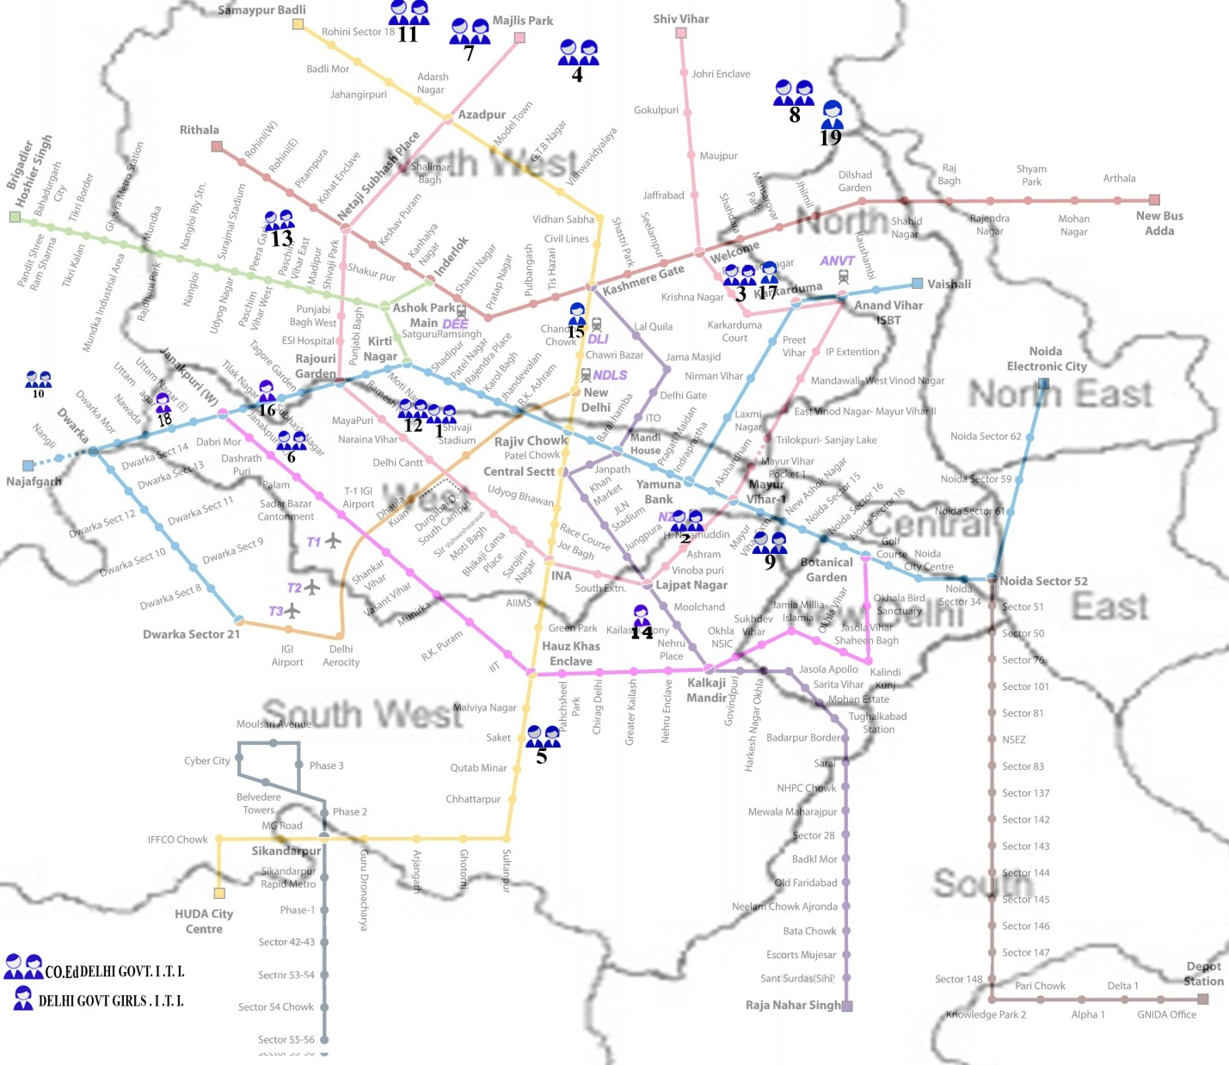
 | Department of Training & Technical Education
 | List of Industrial Training Institute's in Delhi
 | S. No | Name of Government ITI's |  | S. No | Name of Government ITI's
 | 1 | ITI, Pusa |  | 11 | Lala Hans Raj Gupta ITI, Narela
 | 2 | ITI, Arab-Ki-Sarai |  | 12 | Veer Savarkar Basic Training Centre, Pusa
 | 3 | ITI, Shahdara |  | 13 | ITI Mangolpuri
 | 4 | Sir C.V. Raman ITI, DheerPur |  | 14 | Jija Bai ITI for Women Siri Fort
 | 5 | ITI, Malviya Nagar |  | 15 | Savitri Bai Phule ITI for Women, Mori Gate
 | 6 | ITI, Jail Road |  | 16 | ITI for Women, Tilak Nagar
 | 7 | ITI, Jahangir Puri |  | 17 | ITI for Women, Vivek Vihar
 | 8 | ITI, Nand Nagri |  | 18 | Extension Centre of ITI Jail Road, Hastsal
 | 9 | Dr. H.J. Bhabha ITI, Mayur Vihar |  | 19 | Multi Sectorial Development Plan for Minority Women, ITI, Nand Nagri Campus, Delhi
 | 10 | Ch. Brahm Prakash ITI, Jaffarpur
 | REVISED Tentative Schedule for Online Admission 2019

S. No | Activities | Tentative Date | Day | No. of Days
1 | Date of Start of Online Candidate  Registration, Fee submission & Choice Filling at http://www.itidelhiadmissions.nic.in | 10-June-19 | Monday | 21 Days
2 | Date of Start of Candidate document Verification (AT ANY GOVT ITI) | 11-June-19 | Tuesday | 21 Days
3 | Last Date of Online Candidate Registration, Fee submission at http://www.itidelhiadmissions.nic.in | 07-July-19 | Sunday
4 | Last Date For Candidate document Verification (AT ANY GOVT ITI) & Choice Filling | 08-July-19 | Monday
5 | Tentative Rank Display at Online Admission Portal http://www.itidelhiadmissions.nic.in | 10-July-19 | Wednesday
6 | Submission of objections/correction by Candidate at his/her document verifying Govt. ITI, against Tentative Rank | 11-July-19, 12-July-19 | Thursday, Friday | 2 days
7 | Final Rank Display at Online Admission Portal http://www.itidelhiadmissions.nic.in | 16-July-19 | Tuesday
8 | Publish of FIRST round Seat Allotment Result | 22-July-19 | Monday
9 | First round Reporting at allotted ITIs | 23-July-19 to 25-July-19 | Tuesday, Wednesday, Thursday, | 3 days
10 | Display of vacant seat position after first round of Reporting. | 26-July-19 | Friday
11 | Reshuffling of trades/ITI choices by candidates at Online Admission Portal | 27-July-19 to 29-July-19 | Saturday, Sunday, Monday | 3 days
12 | Publish of SECOND round Seat Allotment Result | 02-Aug-19 | Friday
13 | SECOND round Reporting as per allotted seats list | 05-Aug-19 to 07-Aug-19 | Monday, Tuesday, Wednesday | 3 days
14 | Display of vacant seat position after second round of seat allotment | 08-Aug-19 | Thursday
15 | Reshuffling of trades/ITI choices by candidates at Online Admission Portal | 08-Aug-19 to 12-Aug-19 | Thursday, Friday, Saturday, Sunday | 4 days
16 | Publish of THIRD round Seat Allotment Result | 16-Aug-19 | Friday
17 | THIRD round Reporting as per allotted ITIs | 19-Aug-19 to 21-Aug-19 | Monday, Tuesday, Wednesday | 3 days
18 | Display of vacant seat position after third round of seat reporting at Online Admission Portal | 22-Aug-19 | Thursday
19 | Reshuffling of trades/ITI choices by candidates at Online Admission Portal | 22-Aug-19 to 25-Aug-19 | Thursday ,Friday, Saturday, Sunday | 4 days
20 | Publish of FOURTH round Seat Allotment Result | 28-Aug-19 | Wednesday
21 | FOURTH round Reporting as per allotted seats list | 29-Aug-19 to 30-Aug-19 | Thursday, Friday | 2 days

Note: This is only tentative schedule and subject to change w/o prior notice. Any change in the Schedule will be displayed on the website. So candidates are requested to visit the website frequently for further updates.
If needed more online counseling rounds can be conducted to fill up the vacant seats.
No offline admission will be performed.

This Information Bulletin is only for guidance of candidates seeking Online Admission in Government ITIs of Delhi. The contents are likely to change without notice. This does not constitute legal document. For obtaining further information /details, institute/TTE website may be checked.

.

Department of Training & Technical Education,
Muni Maya Ram Marg, Pitampura, Delhi-110 034
Online Admission Portal: https://itidelhiadmissions.nic.in

